**HCMC UNIVERSITY OF TECHNOLOGY AND EDUCATION**

**FACULTY FOR HIGH QUALITY TRAINING**

**🙞 🙞 🕮** **🙜 🙜**



**GRADUATION THESIS**

**BUILDING MERN STACK**

**BASED E-COMMERCE WEBSITE**

**PHAN THANH HOAI**

**Student ID: 16110075**

**NGUYEN THANH DAT**

**Student ID: 17110120**

**Major: SOFTWARE TECHNOLOGY**

**Advisor: Ph.D LE VINH THINH**

Ho Chi Minh City, January 2022

**HCMC UNIVERSITY OF TECHNOLOGY AND EDUCATION**

**FACULTY FOR HIGH QUALITY TRAINING**

**🙞 🙞 🕮** **🙜 🙜**



**GRADUATION THESIS**

**BUILDING MERN STACK**

**BASED E-COMMERCE WEBSITE**

**PHAN THANH HOAI**

**Student ID: 16110075**

**NGUYEN THANH DAT**

**Student ID: 17110120**

**Major: SOFTWARE TECHNOLOGY**

**Advisor: Ph.D LE VINH THINH**

Ho Chi Minh City, January 2022

|  |  |
| --- | --- |
|  | THE SOCIALIST REPUBLIC OF VIETNAM  **Independence – Freedom– Happiness**  --------  *Ho Chi Minh City, January 03, 2022* |

# **GRADUATION PROJECT ASSIGNMENT**

|  |  |
| --- | --- |
| Student name: PHAN THANH HOAI | Student ID: 16110075 |
| Student name: NGUYEN THANH DAT | Student ID: 17110120 |
| Major: Information Technology | Class: 17110CLST3 |
| Advisor: Ph.D LE VINH THINH | Phone number: 0938 252 222 |
| Date of assignment: August 23, 2021 | Date of submission: January 03, 2022 |
| 1. Project title: Building Mern Stack based e-commerce website. | |
| 2. Content of the project: Research & implement the theories of the technology, algorithm apply to the project:   * Front-end: ReactJS * Back-end: Express * Database: MongoDB Atlas * Build E-commerce website using MERN Stack. * Use Alan AI build voice assistant. | |
| 3. Final product: E -commerce website | |
| **CHAIR OF THE PROGRAM**  *(Sign with full name)* | **ADVISOR**  *(Sign with full name)* |

|  |  |
| --- | --- |
|  | THE SOCIALIST REPUBLIC OF VIETNAM  **Independence – Freedom– Happiness**  --------  *Ho Chi Minh City, January 03, 2022* |

**ADVISOR’S EVALUATION SHEET**

Student name: PHAN THANH HOAI Student ID: 16110075

Student name: NGUYEN THANH DAT Student ID: 17110120

Major: Information Technology

Project title: Building Mern Stack based e-commerce website.

Advisor: Ph.D LE VINH THINH

**EVALUATION**

1. Content of the project:

.................................................................................................................................

.................................................................................................................................

1. Strengths:

.................................................................................................................................

.................................................................................................................................

1. Weaknesses:

.................................................................................................................................

.................................................................................................................................

1. Approval for oral defense? *(Approved or denied)*

.................................................................................................................................

1. Overall evaluation: (Excellent, Good, Fair, Poor)

.................................................................................................................................

6. Mark: ………………. (*in words*: .....................................................................)

*Ho Chi Minh City, month day , year*

**ADVISOR**

*(Sign with full name)*

|  |  |
| --- | --- |
|  | THE SOCIALIST REPUBLIC OF VIETNAM  **Independence – Freedom– Happiness**  --------  *Ho Chi Minh City, January 03, 2022* |

# **PRE-DEFENSE EVALUATION SHEET**

Student name: PHAN THANH HOAI Student ID: 16110075

Student name: NGUYEN THANH DAT Student ID: 17110120

Major: Information Technology

Project title: Building Mern Stack based e-commerce website.

Name of Reviewer: .....................................................................................................

**EVALUATION**

1. Content and workload of the project

............................................................................................................................................

2. Strengths:

............................................................................................................................................

............................................................................................................................................

3. Weaknesses:

............................................................................................................................................

............................................................................................................................................

4. Approval for oral defense? *(Approved or denied)*

............................................................................................................................................

5. Overall evaluation: *(Excellent, Good, Fair, Poor)*

............................................................................................................................................

6. Mark: ……………. (*in words*: ....................................................................................)

*Ho Chi Minh City, month day , year*

**REVIEWER**

*(Sign with full name)*

|  |  |
| --- | --- |
|  | THE SOCIALIST REPUBLIC OF VIETNAM  **Independence – Freedom– Happiness**  --------  *Ho Chi Minh City, January 03, 2022* |

# **EVALUATION SHEET OF**

# **DEFENSE COMMITTEE MEMBER**

Student name: PHAN THANH HOAI Student ID: 16110075

Student name: NGUYEN THANH DAT Student ID: 17110120

Major: Information Technology

Project title: Building Mern Stack based e-commerce website.

Name of Defense Committee Member: ......................................................................

EVALUATION

1. Content and workload of the project

.................................................................................................................................

.................................................................................................................................

2. Strengths:

.................................................................................................................................

.................................................................................................................................

3. Weaknesses:

.................................................................................................................................

.................................................................................................................................

4. Overall evaluation: *(Excellent, Good, Fair, Poor)*

.................................................................................................................................

5. Mark: ………………. (*in words*: ......................................................................)

*Ho Chi Minh City, month day , year*

**COMMITTEE MEMBER**

*(Sign with full name)*

# **ACKNOWLEDGEMENTS**

**🙞 🙞 🕮** **🙜 🙜**

Firstly, we are very grateful to HCMC University of Technology and Education in general and Faculty For High Quality Training in particular for creating a good environment to study well which helps us to reach the new technical knowledge and skills. Furthermore, helps us to promote our own knowledge and accomplished tasks well. I believe that the knowledge acquired during the past time will help us have a solid foundation for the graduation project research process but also valuable luggage for us to enter life confidently and firmly. In this semester, we have completed the graduation project " Building Mern Stack based e-commerce website.".

Secondly, we would sincerely appreciate Mr. Le Vinh Thinh helping our completion of the project who is really enthusiastic about guiding theories as well as programming skills, especially how to solve problems. Once again we are eternally grateful for everything you’ve taught us and we wish you have a lot of heaths.

With the conditions of time and limited experience of student, this report cannot avoid defects. We look forward to receiving your advice and comments so that we can improve the actual system in the future.

And finally, We wish nothing but the best for everybody.

We are sincerely grateful!

*Ho Chi Minh City, January 03, 2022*

**STUDENTS**

Phan Thanh Hoai Nguyen Thanh Dat

# **ABSTRACTS**

**🙞 🙞 🕮** **🙜 🙜**

As you all know, any business in the world has its proprietary name, specific characteristics and the own trademark to they can approach their all customers even though they're far away. They can approach customers through the way to create their own website to help them give their products and services to customers lively at that time. Furthermore, it's also an easy way to buying and selling products but also does not take the most time. On the other hand, help marketing strategy quickly and does not take the most time. For individuals, the website brings full necessary products information and easy to choose items.

**ABBREVIATION LIST**

|  |  |
| --- | --- |
| **UC** | Use case |
| **SA** | Super Admin |
| **Admin** | Administrator |
| **SD** | Sequence Diagram |
| **UI** | User Interface |
| **AI** | Administrator Interface |
| **ERD** | Entity Relationship Diagram |
| **TC** | Test Case |

**TABLE OF CONTENTS**

**GRADUATION PROJECT ASSIGNMENT** I

**ADVISOR’S EVALUATION SHEET** II

**PRE-DEFENSE EVALUATION SHEET** III

**EVALUATION SHEET OF** IV

**DEFENSE COMMITTEE MEMBER** IV

**ACKNOWLEDGEMENTS** V

**ABSTRACTS** VI

**TABLE OF CONTENTS** 2

**LIST OF FIGURES** 6

**LIST OF TABLES** 9

**CHAPTER 1: INTRODUCTION** 11

**1.1.** **Rationale** 11

**1.2.** **Objectives** 11

**1.3.** **Contents** 12

**1.4.** **Research methods** 12

**1.5.** **Practical scientific significance** 12

**CHAPTER 2: FUNDAMENTALS** 13

**2.1.** **Introduction to the Technical Stack** 13

**2.1.1.** **What is the Technical Stack?** 13

**2.1.2.** **List of the top Stacks** 13

**2.2.** **Introduction to the MERN stack.** 14

**2.2.1.** **What is the MERN stack?** 14

**2.2.2.** **How does the MERN Stack work?** 14

**2.2.3.** **Why use the MERN Stack?** 15

**2.3.** **Introduction to the MongoDB** 16

**2.3.1.** **What is the MongoDB?** 16

**2.3.2.** **What is the MongoDB Atlas?** 16

**2.3.3.** **Why use the MongoDB?** 17

**2.4.** **Introduction to the Express** 17

**2.4.1.** **What is the Express** 18

**2.4.2.** **Feature of Express** 18

**2.4.3.** **Why use the Express** 19

**2.5.** **Introduction to the ReactJS** 19

**2.5.1.** **What is the ReactJS?** 19

**2.5.2.** **Why use the ReactJS?** 20

**2.5.3.** **What is the JSX?** 21

**2.5.4.** **What is the Virtual Dom?** 21

**2.5.5.** **What is the Hooks?** 22

**2.5.6.** **Should I learn ReactJS?** 22

**2.6.** **Introduction to the NodeJS** 22

**2.6.1.** **What is the NodeJS?** 22

**2.6.2.** **What can NodeJS do?** 22

**2.6.3.** **What is a NodeJS file?** 22

**2.6.4.** **Why use the NodeJS?** 23

**2.7.** **Introduction to the Redux** 23

**2.7.1.** **What is the Redux?** 23

**2.7.2.** **What is the Redux Thunk?** 24

**2.7.3.** **How Redux works?** 24

**2.7.4.** **Why use the Redux?** 25

**2.8.** **Introduction to the PayPal** 25

**2.8.1.** **What is the PayPal?** 25

**2.8.2.** **Why uses the PayPal?** 26

**2.9.** **Introduction to the Alan AI** 26

**2.9.1.** **What is the Alan AI?** 26

**2.9.2.** **Why uses the Alan AI?** 26

**2.10.** **Introduction to the Alan AI** 26

**2.10.1.** **Introduction to the Momo** 27

**2.10.2.** **Why use the Momo** 27

**CHAPTER 3: SURVEYS AND USER REQUIREMENTS** 28

**3.1.** **Reality survey** 28

**3.1.1.** **Websites** 28

**3.1.2.** **Conclusion** 33

**3.2.** **User Requirement** 34

**3.2.1.** **The function of Guest** 34

**3.2.2.** **The function of User** 35

**3.2.3.** **The function of Administrator** 38

**3.2.4.** **Use Case Diagram** 40

**3.2.5.** **Use Case Description** 43

**3.3.** **Non – Functional Requirements** 109

**CHAPTER 4: SYSTEM DESIGN** 110

**4.1.** **System architecture** 110

**4.2.** **Class Diagram** 111

**4.3.** **Sequence Diagram** 112

**4.3.1.** **<SD001> SearchProductByName** 112

**4.3.2.** **<SD002> Login** 113

**4.3.3.** **<SD003> ViewDetailProduct** 114

**4.3.4.** **<SD004> Register** 115

**4.3.5.** **<SD005> AddProductToCart** 116

**4.3.6.** **<SD006> ViewCart** 116

**4.3.7.** **<SD007> ViewOrder** 117

**4.3.8.** **<SD008> UpdateOrder** 118

**4.3.9.** **<SD009> DeleteProductInCart** 119

**4.3.10.** **<SD010> ChangePassword** 120

**4.3.11.** **<SD011> Payment** 121

**4.3.12.** **<SD012> ViewInfomationProfile** 122

**4.3.13.** **<SD013> DeleteCategory** 123

**4.3.14.** **<SD014> AddProduct** 124

**4.3.15.** **<SD015> DeleteProduct** 124

**4.3.16.** **<SD016> UpdateProduct** 125

**4.3.17.** **<SD017> AddCategory** 125

**4.3.18.** **<SD018> UpdateCategory** 126

**4.3.19.** **<SD019> UpdateInfomation** 126

**4.3.20.** **<SD020> FilterByCategory** 127

**4.3.21.** **<SD021> FilterByPrice** 127

**4.4.** **Entity Relationship Diagram** 128

**4.4.1.** **ERD** 128

**4.4.2.** **Database Description** 129

**4.5.** **Activity Diagram** 132

**4.5.1.** **Activity Diagram Buy Product** 132

**4.5.2.** **Activity Diagram Check Order** 133

**4.5.3.** **Activity Diagram Add Product** 134

**4.5.4.** **Activity Diagram Update Product** 135

**4.5.5.** **Activity Diagram Delete Product** 136

**4.6.** **Screen Interface** 137

**4.6.1.** **Administrator Interface** 137

**4.6.2.** **User Interface** 145

**CHAPTER 5: IMPLEMENT AND TESTING** 159

**5.1.** **Tools in Project** 159

**5.2.** **Technology in Project** 159

**5.3.** **Setup** 159

**5.4.** **Testing** 160

**CHAPTER 6: CONCLUSION** 162

**6.1.** **Result** 162

**6.2.** **Strengths** 162

**6.3.** **Drawbacks** 162

**6.4.** **Future Works** 163

**REFERENCES** 164

# **LIST OF FIGURES**

*Figure 1: Software Stack Reworked* 12

*Figure 2: MERN Stack* 13

*Figure 3: MongoDB* 15

*Figure 4: Express* 17

*Figure 5: ReactJS* 19

*Figure 6: Structure Redux* 24

*Figure 7: The website https://www.thegioididong.com* 28

*Figure 8: Thegioididong store page* 28

*Figure 9: The website https://gearvn.com/* 29

*Figure 10: GEARVN Product List* 29

*Figure 11: GEARVN Detailed Product* 30

*Figure 12: GEARVN Cart* 30

*Figure 13: The website https://www.phongvu.vn* 31

*Figure 14: PHONGVU Product List* 31

*Figure 15: PHONGVU Cart* 32

*Figure 16: Use Case Diagram - User* 40

*Figure 17: Use Case Diagram - Admin* 41

*Figure 18: UC Guest – Register* 42

*Figure 19: UC Guest – Login* 44

*Figure 20: UC Guest - View Product List* 46

*Figure 21: UC Guest View Product Details* 47

*Figure 22: UC Guest Filter Product by Category* 49

*Figure 23: UC Guest Filter Product by Price* 50

*Figure 24: UC Guest Search Product.* 52

*Figure 25: UC Guest Send Message* 53

*Figure 26: UC Guest Add product to Cart* 55

*Figure 27: UC Guest View Cart* 56

*Figure 28: UC Guest Remove Product from Cart* 58

*Figure 29: UC Guest Add the number of Product.* 59

*Figure 30: UC User Logout* 61

*Figure 31: UC User Edit Profile* 62

*Figure 32: UC User Add to Wishlist* 64

*Figure 33: US User Remove Product from Wishlist* 66

*Figure 34: UC User Send Feedback* 67

*Figure 35: UC User Place Orders* 69

*Figure 36: UC User Order Tracking* 70

*Figure 37: UC User Cancel Order* 72

*Figure 38: UC User Comment Product* 73

*Figure 39: UC User Rating Product* 75

*Figure 40: UC User Payment* 77

*Figure 41: UC Admin Login* 79

*Figure 42: UC Admin Logout* 81

*Figure 43: UC Admin Add Category* 82

*Figure 44: UC Admin Update Category* 84

*Figure 45: UC Admin Block Category* 86

*Figure 46: UC Admin Unblock Category* 88

*Figure 47: UC Admin Add Product* 89

*Figure 48: UC Admin Update Product* 91

*Figure 49: UC Admin Block Product* 93

*Figure 50: UC Admin Unblock Product* 95

*Figure 51: UC Admin Import Goods* 96

*Figure 52: UC Admin Change Order Status* 98

*Figure 53: UC Admin Delete Order* 100

*Figure 54: UC View detailed order* 102

*Figure 55: UC View Statistical Page* 103

*Figure 56: UC Add Panel* 105

*Figure 57: Website Architecture* 109

*Figure 58: System architecture* 109

*Figure 59: Class Diagram* 110

*Figure 60: SD SearchProductByName* 111

*Figure 61: SD Login* 112

*Figure 62: SD ViewDetailProduct* 113

*Figure 63: SD Register* 114

*Figure 64: SD AddproductToCart* 115

*Figure 65: SD ViewCart* 115

*Figure 66: SD ViewOrder* 116

*Figure 67: SD UpdateOrder* 117

*Figure 68: SD DeleteProductInCart* 118

*Figure 69: SD ChangePassword* 119

*Figure 70: SD Payment* 120

*Figure 71: SD ViewInformationProfile* 121

*Figure 72: SD DeleteCategory* 122

*Figure 73: SD AddProduct* 123

*Figure 74: SD DeleteProduct* 123

*Figure 75: SD UpdateProduct* 124

*Figure 76: SD AddCategory* 124

*Figure 77: SD UpdateCategory* 125

*Figure 78: SD UpdateInfomation* 125

*Figure 79: SD FilterByCategory* 126

*Figure 80: SD FilterByPrice* 126

*Figure 81: Entity Relationship Diagram* 127

*Figure 82: Activity diagram - Buy Product* 131

*Figure 83: Activity diagram – Check Order* 132

*Figure 84: Activity diagram – Add Product* 133

*Figure 85: Activity diagram – Update Product* 134

*Figure 86: Activity diagram – Delete Product* 135

*Figure 87: Administrator - Login Page* 136

*Figure 88: Administrator - Dashboard Page* 137

*Figure 89: Administrator - Category Page* 138

*Figure 90: Administrator - Product Page* 139

*Figure 91: Administrator - Order Page* 139

*Figure 92: Administrator – Add Category Page* 140

*Figure 93: Administrator – Add Product Page* 142

*Figure 94: Administrator – Update Order Page* 143

*Figure 95: User - Home Page 01* 144

*Figure 96: User - Home Page 02* 145

*Figure 97: User – Login page* 146

*Figure 98: User – Register Page* 148

*Figure 99: User - Details Product Page* 150

*Figure 100: User - Cart Page* 152

*Figure 101: User - Checkout Page 01* 153

*Figure 102: User - My Order Page* 155

*Figure 103: User - Wishlist Page* 156

*Figure 104: User - Infomation Page* 156

# **LIST OF TABLES**

*Table 1: List of the top Stacks* 12

*Table 2: The function of Guest* 34

*Table 3: The function of User* 36

*Table 4: The function of Administrator* 39

*Table 5: <Guest> Register* 43

*Table 6: <Guest> Login* 45

*Table 7: <Guest> View Product List* 47

*Table 8: <Guest> View Detailed Product* 48

*Table 9: <Guest> Filter Product by Category* 50

*Table 10: <Guest> Filter Product by Color* 52

*Table 11: <Guest> Search Product* 53

*Table 12: <Guest> Send Message* 55

*Table 13: <Guest> View Cart* 58

*Table 14: <Guest> Remove Product from Cart* 59

*Table 15: <Guest> Add the number of product.* 60

*Table 16: <User> Logout* 62

*Table 17: <User> Edit Profile* 64

*Table 18: <User> Add to Wishlist* 65

*Table 19: <User> Remove Product from Wishlist* 67

*Table 20: <User> Send Feedback* 68

*Table 21: <User> Place Orders* 70

*Table 22: <User> Order Tracking* 72

*Table 23: <User> Cancel Order* 73

*Table 24: <User> Comment Product* 75

*Table 25: <User> Rating Product* 76

*Table 26: <User> Payment* 78

*Table 27: <Admin> Login* 80

*Table 28: <Admin> Logout* 82

*Table 29: <Admin> Add Category* 84

*Table 30: <Admin> Update Category* 86

*Table 31: <Admin> Block Category* 87

*Table 32: <Admin > unblock Category* 89

*Table 33: <Admin> Add Product* 91

*Table 34: <Admin> Update Product* 93

*Table 35: <Admin> Block product* 94

*Table 36: <Admin> Unblock Product* 96

*Table 37: <Admin> Import Goods* 98

*Table 38: <Admin> Change Order Status* 100

*Table 39: <Admin> Delete Order* 101

*Table 40: <Admin> View Detailed Order.* 103

*Table 41: <Admin> View Statistical Page* 104

*Table 42: <Admin> View Add Panel* 106

*Table 43: <Admin> Delete Panel* 108

*Table 44: Product Table* 128

*Table 45: User Table* 129

*Table 46: Category Table* 130

*Table 47: Order Table* 130

*Table 48: Statistical Table* 130

*Table 49: <AI> Login Page* 137

*Table 50: <AI> Dashboard Page* 138

*Table 51: <AI> Category Page* 138

*Table 52: <AI> Product Page* 139

*Table 53: <AI> Order Page* 140

*Table 54: <AI> Add Category Page* 141

*Table 55: <AI> Add Product Page* 143

*Table 56: <AI>* *Update Order Page* 143

*Table 57: <UI> Home Page 01* 145

*Table 58: <UI> Home Page 02* 146

*Table 59: <UI> Login Page* 147

*Table 60: <UI> Register Page* 149

*Table 61: <UI> Details Product Page* 151

*Table 62: <UI> Cart Page* 153

*Table 63: <UI> Checkout Page* 154

*Table 64: <UI> My Order Page* 155

*Table 65: <UI> Wishlist Page* 156

*Table 66: <UI> Infomation Page* 157

*Table 67: Tools in Project* 158

*Table 68: Technology in Project* 158

*Table 69: Test Case* 160

**CHAPTER 1: INTRODUCTION**

* 1. **Rationale**

People's quality of life is improving day by day, the demand for buying and selling is increasing. Grasping those needs, we decided to build an e-commerce website - mobile device items. The purpose of building this website is to create tools for customers to easily make purchases, saving time. Businesses can approach and sell many products to customers. Moreover, the website is built in a simple, user-friendly manner, which enhances the experience and makes it easy for them to use. There many ways in many programming languages to build such a website: Java, PHP, C#, and in this topic, we use JavaScript.

JavaScript’s flavor is overpowered by Typescript popularity. What can we say, TypeScript is definitely way past being a top JavaScript trend and we can talk about a standard now and an obvious choice for the vast majority of software development projects. Thanks to that, its application will meet the management and operation needs of a sales website easily and conveniently. Make your business easier and more efficient, it will meet the management and operation needs of a sales website easily and conveniently. Make your business easier and more efficient

* 1. **Objectives**

In this graduate project, we tried to concentrate on researching MERN Stack technology and its effect on the development of the programming industry now. Furthermore. Researching about it also helps us to understand more deeply. From there we can build a website having full basic functions as the others, and that functions are below:

* Introducing products and items of the website
* Support the customers chat with admin by messenger connection
* Purchased items & Online payment
* Support the system owner to manage the products
* Support the system owner to manage the orders & users
  1. **Contents**
* Find out the MERN Stack technology
* Find out how to manage the databases on Mongo Atlas
* Find out the Express with the MVC model
* Find out the React Framework & Redux model
* Find out the NodeJS
* Find out the Heroku to deploy API
* Find out the Netlify to deploy a website
  1. **Research methods**
* Researching documents, websites and video related to applied technologies
* Refer to the videos it describes regarding the model applied in the graduate project
* Consult with instructors and classmates
  1. **Practical scientific significance**

The website's user interface is designed to be simple, making it easier for users to navigate and use the site when they purchase products.

**CHAPTER 2: FUNDAMENTALS**

2. 1. **Introduction to the Technical Stack**
      1. **What is the Technical Stack?**

The Technical Stack, also known as the Solution Stack, is a collection of technologies used to build and run a single application [1].

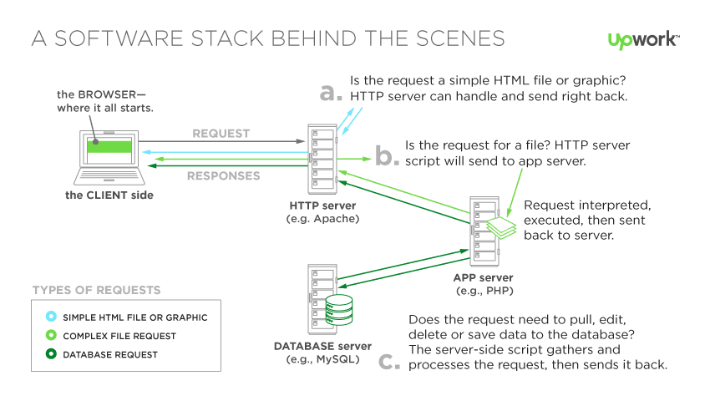

*Figure 1: Software Stack Reworked*

* + 1. **List of the top Stacks**

|  |  |
| --- | --- |
| **TECHNICAL STACK** | **TECHNOLOGIES** |
| LAMP Stack | Linux, Apache, MySQL, PHP |
| WISA Stack | Window, IIS, SQL Server, ASP.NET |
| MEAN | Mongo DB, Express, Angular, NodeJS |
| MERN | Mongo DB, Express, React, NodeJS |

*Table 1: List of the top Stacks*

* 1. **Introduction to the MERN stack.**
     1. **What is the MERN stack?**

The MERN stack is a software stack comprised of four open-source technologies. So M stands for MongoDB and it's a database solution, E stands for Express, this is the framework for NodeJS and building NodeJS applications, R stands for of ReactJS and this is a browser-side JavaScript library, help us build great UI and N stands for NodeJS which is a server-side JavaScript runtime and environment where JavaScript can be executed outside the browser. Combining these 4 technologies creates a MERN Stack [2].

* + 1. **How does the MERN Stack work?**

The MERN architecture allows you to easily construct a 3-tier architecture (frontend, backend, database) entirely using JavaScript and JSON.

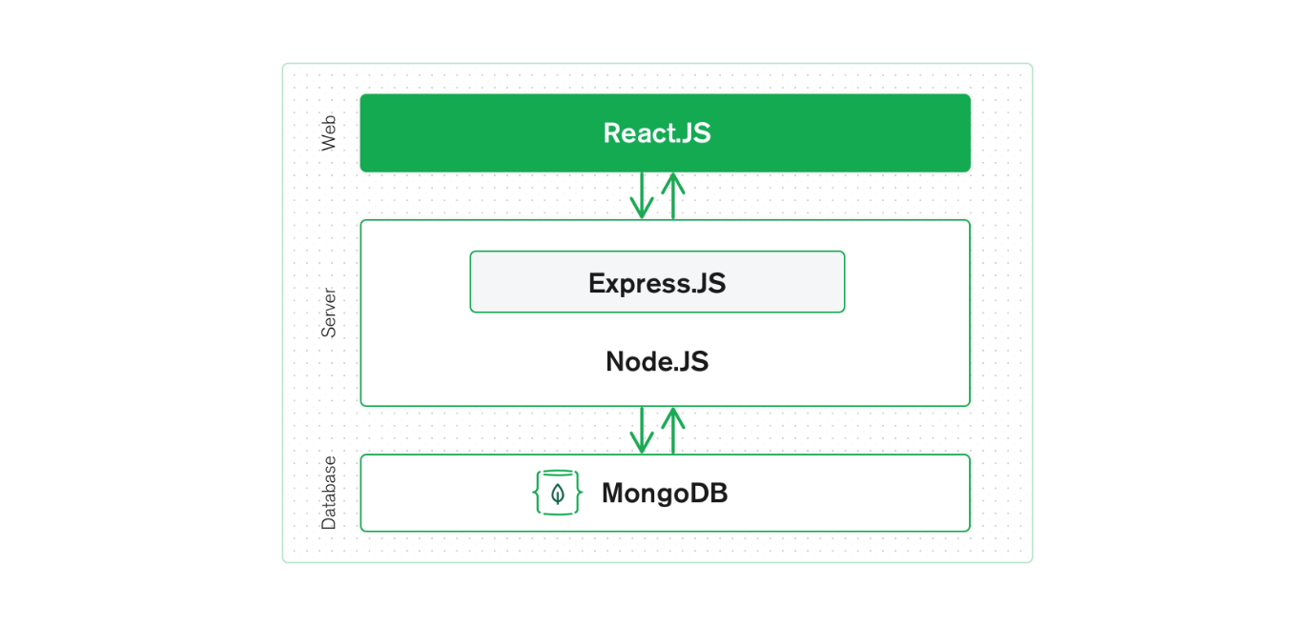

*Figure 2: MERN Stack*

At each client, react does the processing and creates the user interface, and React also executes the single-page-application on each client.

At the server, NodeJS and Express are responsible for handling logic, business, and authentication.

MongoDB on the server is responsible for organizing and storing data.

Client and server will communicate by sending requests and responses. Request and Response send implicitly by AJAX technology to help users do not need to reload the website.

MERN is the stack of choice for today’s web developers looking to move quickly, particularly for those with React.js experience.

* + 1. **Why use the MERN Stack?**

The big advantage is the separation of concern of we have a separate front-end and a separate back-end and therefore if we’re working in each part of our team can focus on the front-end, back-end

Allow us to build a powerful front-end which is a single page application give experience offers a great user.

The MERN stack uses a common JavaScript language for both client-side and server-side, making website development accessible.

NodeJS capable of running on both Linux, windows and OS X so it is not OS dependent.

MERN stack uses JSON as an exchange data type between all components, so there is no need for additional libraries to convert data during the interaction between the client and the server side.

MongoDB capable of managing a large amount of data, can add new properties to the tables without updating the entire table.

The technologies used in the MERN stack are all free and open source.

The large user community is convenient for learning experiences or answering questions [4].

* 1. **Introduction to the MongoDB**
     1. **What is the MongoDB?**

MongoDB is a document – oriented, no sequel (No SQL) database.

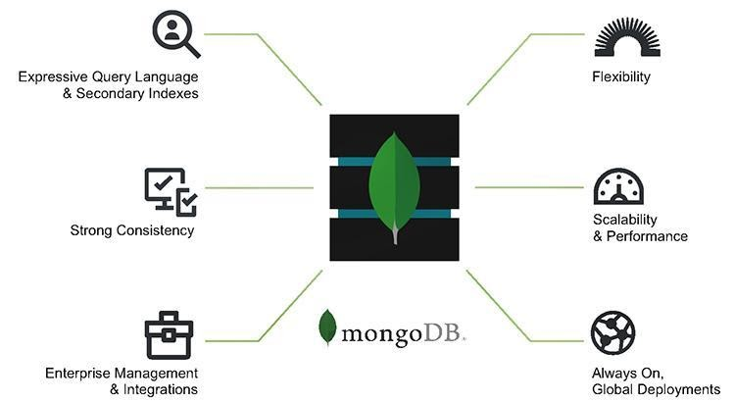

*Figure 3: MongoDB*

* + 1. **What is the MongoDB Atlas?**

MongoDB Atlas is a paid service that allows users to store application data in the cloud.

MongoDB Atlas is built on best-in-class automation and proven practices that help provide continuous availability, elastic scalability, fast performance, and support with regulatory compliance. It is the easiest way to try out MongoDB for free on AWS, Google Cloud, and Azure [3].

Features of MongoDB Atlas:

* Fully managed database lifecycle backed by uptime SLA
* Elastic deployments with on-demand vertical & horizontal scaling
* Multi-cloud, global data distribution at the click of a button
* Enterprise-grade security controls and compliance offerings
* Advanced data privacy protection with client-side encryption
* Auto-pilot capabilities such as auto-scale and auto-generated tuning guidance
* Integrated full-text search powered by Lucene
* Automated data archival to Queryble cloud storage
* Real-time triggers for building event-driven data infrastructures
* Embedded live migration service enables data migrations with minimal downtime
  + 1. **Why use the MongoDB?**
* MongoDB use data is Document JSON should be easy in the access out
* flexible when it comes to storage
* Data contained in MongoDB is usually not bound together
* Insert, delete or update, you won't lose too much time like in RDBMS.
* MongoDB is easily extensible
* The _id field will always be automatically indexed, so information retrieval speed will always be at peak performance.
* we have a data query, the write will be saved to the memory cache. Then the query will go faster without you having to read from the hard drive.
* MongoDB query speed is always faster than the administrative database system.
* Thanks to a large enough amount of data, the test for MongoDB insert speed will be 100 times faster than MySQL.
  1. **Introduction to the Express**
     1. **What is the Express**

Express is a modular web application framework for NodeJS. It provides powerful features for web or mobile development. Express Js supports HTTP and middleware methods creating an extremely powerful and easy-to-use API [5].

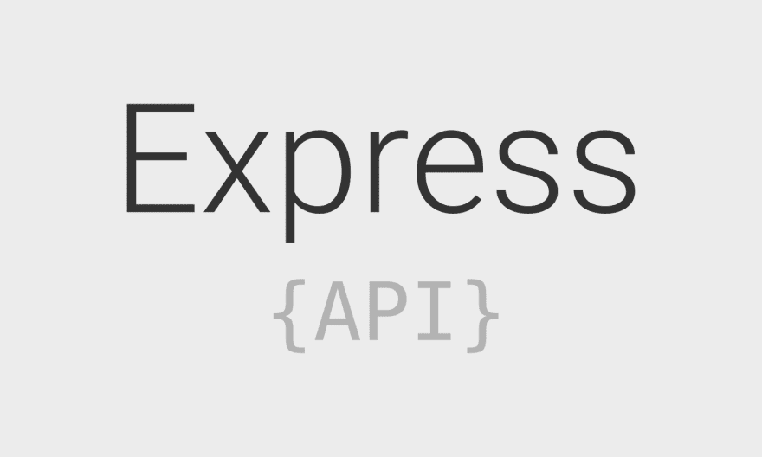

*Figure 4: Express*

* + 1. **Feature of Express**

Faster server-side development: Express.js provides many commonly used features of Node.js in the form of functions that can be readily used anywhere in the program. This removes the need to code for several hours and thus saves time [6].

Middleware: Middleware is a part of the program that has access to the database, client request, and the other Middleware. It is mainly responsible for the systematic organization of different functions of Express.js.

Routing: Express provides a highly advanced routing mechanism which helps to preserve the state of the webpage with the help of their URLs.

Templating: Express provides templating engines that allow the developers to build dynamic content on the web pages by building HTML templates on the server-side.

Debugging: Debugging is crucial for the successful development of web applications. Express makes debugging easier by providing a debugging mechanism that has ability to pinpoint the exact part of the web application which has bugs.

* + 1. **Why use the Express**
* It is easy to learn because many front-end users are already familiar with JavaScript so they don’t have to learn a new language in order to learn Express
* This makes backend development much easier for front-end developers using Express
* The Express.js framework is very simple to customize and use as per the needs.
* Express.js provides a flexible middleware module. It is mainly useful for doing extra tasks on response and request.
* Set up intermediate classes to return HTTP requests.
* Define router allows use with different actions based on HTTP method and URL.
* Allows returning HTML pages based on parameters.
  1. **Introduction to the ReactJS**

1. * 1. **What is the ReactJS?**

React JS is a JavaScript library used in web development to build interactive elements on websites. But if you’re not familiar with JavaScript or JavaScript libraries, that’s not a helpful definition so let’s take a step back and deal with those terms first [7].



*Figure 5: ReactJS*

* + 1. **Why use the ReactJS?**

React is a JavaScript library that specializes in helping developers build user interfaces, or UIs. In terms of websites and web applications, UIs are the collection of on-screen menus, search bars, buttons, and anything else someone interacts with to USE a website or app.

Before React JS, developers were stuck building UIs by hand with vanilla JavaScript (developer speak for the raw JavaScript language on its own) or with less UI-focused React predecessors like jQuery. That meant longer development times and plenty of opportunities for errors and bugs. So, in 2011, Facebook engineer Jordan Walke created React JS specifically to improve UI development.

In addition to providing reusable React library code (saving development time and cutting down on the chance for coding errors), React comes with two key features that add to its appeal for JavaScript developers:

* JSX
* Virtual Dom
  + 1. **What is the JSX?**

At the heart of any basic website are HTML documents. Web browsers read these documents and display them on your computer, tablet, or phone as web pages. During this process, browsers create something called a Document Object Model (DOM), a representational tree of how the web page is arranged. Developers can then add dynamic content to their projects by modifying the DOM with languages like JavaScript.

JSX (short for JavaScript extension) is a React extension that makes it easy for web developers to modify their DOM by using simple, HTML-style code. And—since React JS browser support extends to all modern web browsers—JSX is compatible with any browser platform you might be working with.

* + 1. **What is the Virtual Dom?**

If you’re not using React JS (and JSX), your website will use HTML to update its DOM (the process that makes things change on screen without a user having to manually refresh a page). This works fine for simple, static websites, but for dynamic websites that involve heavy user interaction it can become a problem (since the entire DOM needs to reload every time the user clicks a feature calling for a page refresh).

However, if a developer uses JSX to manipulate and update its DOM, React JS creates something called a Virtual DOM. The Virtual DOM (like the name implies) is a copy of the site’s DOM, and React JS uses this copy to see what parts of the actual DOM need to change when an event happens (like a user clicking a button).

Let’s say a user enters a comment in a blog post form and pushes the Comment button. Without using React JS, the entire DOM would have to update to reflect this change (using the time and processing power it takes to make this update). React, on the other hand, scans the Virtual DOM to see what changed after a user action (in this case, a comment being added) and selectively updates that section of the DOM only.

This kind of selective updating takes less computing power and less loading time, which might not sound like much when you’re talking about a single blog comment, but—when you start to think about all the dynamics and updating associated with even a slightly complex website—you’ll realize it adds up to a lot.

* + 1. **What is the Hooks?**

Hooks are a new addition in React 16.8. They let you use state and other React features without writing a class.

* + 1. **Should I learn ReactJS?**

Hooks are a new addition in React 16.8. They let you use state and other React features without writing a class.

* 1. **Introduction to the NodeJS**

1. * 1. **What is the NodeJS?**

* Node.js is an open-source server environment.
* Node.js is free.
* Node.js runs on various platforms (Windows, Linux, Unix, Mac OS X)
* Node.js uses JavaScript on the server.
  + 1. **What can NodeJS do?**
* Node.js can generate dynamic page content.
* Node.js can create, open, read, write, delete, and close files on the server.
* Node.js can collect form data.
* Node.js can add, delete, modify data in your database.
  + 1. **What is a NodeJS file?**
* Node.js files contain tasks that will be executed on certain events.
* A typical event is someone trying to access a port on the server.
* Node.js files must be initiated on the server before having any effect.
* Node.js files have extension .Js.
  + 1. **Why use the NodeJS?**

Node.js uses asynchronous programming.

A common task for a web server can be to open a file on the server and return the content to the client.

**Here is how PHP or ASP handles a file request:**

* Sends the task to the computer's file system.
* Waits while the file system opens and reads the file.
* Returns the content to the client.
* Ready to handle the next request.

**Here is how Node.js handles a file request:**

* Sends the task to the computer's file system.
* Ready to handle the next request.
* When the file system has opened and read the file, the server returns the content to the client.

Node.js eliminates the waiting, and simply continues with the next request.

Node.js runs single-threaded, non-blocking, asynchronously programming, which is very memory efficient.

* 1. **Introduction to the Redux**

1. * 1. **What is the Redux?**

Redux is a predictable state container designed to help you write JavaScript apps that behave consistently across client, server, and native environments and are easy to test.

With Redux, the state of your application is kept in a store, and each component can access any state that it needs from this store.

* + 1. **What is the Redux Thunk?**

Redux Thunk is a Middleware that allows you to write Actions that return a function instead of a plain JavaScript object by delaying the action to be passed to the reducer.

Redux Thunk is used to handle complex asynchronous logic that requires access to the Store or simply retrieving data like an Ajax request.

* + 1. **How Redux works?**

Redux is based on a flux structure proposed by Facebook, following a unidirectional data flow model to avoid overlapping calls.

All states are kept in one place, the store, and the views get the changes from the store to display.

Events from the view must send action to update the state in the store.

The Reducer relies on actions to update the state in the store.

State is a plain JavaScript object, it cannot be modified directly, it must create new object for reducer to return.

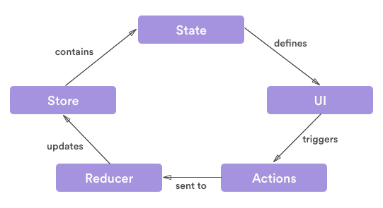

*Figure 6: Structure Redux*

* + 1. **Why use the Redux?**
* Lightweight, easy-to-integrate library
* Easy-to-read code
* Simple, easy to learn
* Return the result of the middleware function inside the component
  1. **Introduction to the PayPal**

1. * 1. **What is the PayPal?**

PayPal is simply understood as an intermediary service for international payments and money transfers over the Internet. With PayPal, you can pay when shopping online abroad or receive payments from abroad sent to Vietnam [8].

It can be considered as an electronic wallet or similar as Internet Banking of banks: you can transfer - withdraw to another PayPal account, pay for online purchases if the seller supports PayPal, or receive money. international payments.

PayPal was founded in 1998, headquartered in San Jose, California, USA. Founded by Peter Thiel. PayPal works on e-commerce through the Internet, and it charges a fee when you transfer or withdraw money

* + 1. **Why uses the PayPal?**
* Extremely secure payment system.
* Wide network of systems, used all over the world quickly and conveniently.
* Good and fast customer service support.
* Limit disclosure of bank account information, because each time you make a payment, you do not have to enter an international payment card number (VISA, Mastercard) because you provided PayPal when registering to create an account.
  1. **Introduction to the Alan AI**

1. * 1. **What is the Alan AI?**

Alan AI enables applications and websites to have direct human-like voice conversations with their users by adding a conversational voice UX to any application leveraging the existing UI. Users of these applications can then use their natural voice to ask questions, complete the tasks and workflows. [9].

Alan AI’s innovation of the contextual language understanding, personalized named recognition and smooth dynamic dialogues enables every application with a deterministic voice experience for its users.

* + 1. **Why uses the Alan AI?**
* Enable human-like interface on your app
* Increase app adoption through voice onboarding
* Engage users’ attention to decrease app abandonment
* Provide a personalized voice experience for every user
  1. **Introduction to the Alan AI**

1. * 1. **Introduction to the Momo**

MoMo is a financial application that allows transferring and receiving money extremely fast, easy to use and absolutely safe. MoMo Wallet helps you make purchases and sales anytime, anywhere and completely free via mobile phones.

MoMo is the main service of Online Mobile Services Joint Stock Company (M-Service for short) established in 2007. M-Service is a FinTech company operating mainly in the field of mobile payments (mobile) payment) under the brand name MoMo.

* + 1. **Why use the Momo**
* Bank guarantee: Money in MoMo account is guaranteed by Vietcombank and the bank linked to your account MoMo is licensed and managed by the State Bank of Vietnam.
* Online multi-layer security grid: Every step of your transaction is encrypted and protected by MoMo instantly. MoMo self locking handle if k is used within 5 minutes and use technology better to automatically identify and block suspicious transactions.
* Support multi- location 24/7: Center CCU of MoMo ready to serve 24/7, including holidays to support customers.
* Pass a reasonable international: MoMo achieve authentication security world PCI DSS level highest for manufacturers Services - set of standards difficult in the field of finance bank by the Board of Standards reasonable Privacy consists of units like VISA, MasterCard and compliance pose[10].

**CHAPTER 3: SURVEYS AND USER REQUIREMENTS**

3. 1. **Reality survey**

Nowadays most people have approached information technology, its strong development and practical applications in life have helped us take a new step forward which is to promote economic development making the trend of the world economy become globalized, especially people's demand for services in buying and selling goods become increase in terms of quantity and quality. There are many leading corporations in the world that are constantly expanding the scale of their goods and services to commercialize them on the internet. Based on that we can see the importance of e-commerce, one-click right at your computer connected to the internet can bring you many things that you need without spending too much time. Realizing its benefits along with a passion for learning, we have researched and built a website Build E-commerce Website to serve people's clothing shopping needs.

The website's operating criterion is to serve the needs of buying mobile devices online, giving them great experiences when accessing the website and high-quality products..

3. 1. 1. **Websites**

Next, we conducted a survey of the three most popular Electronic sales websites that are used by many people today.

* + - 1. **THEGIOIDIDONG**

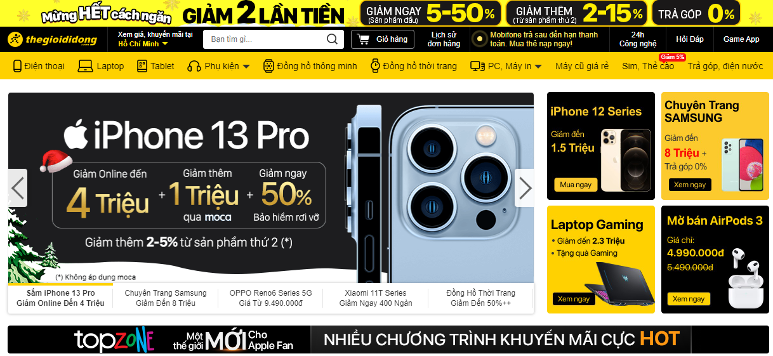

*Figure 7: The website https://www.thegioididong.com*

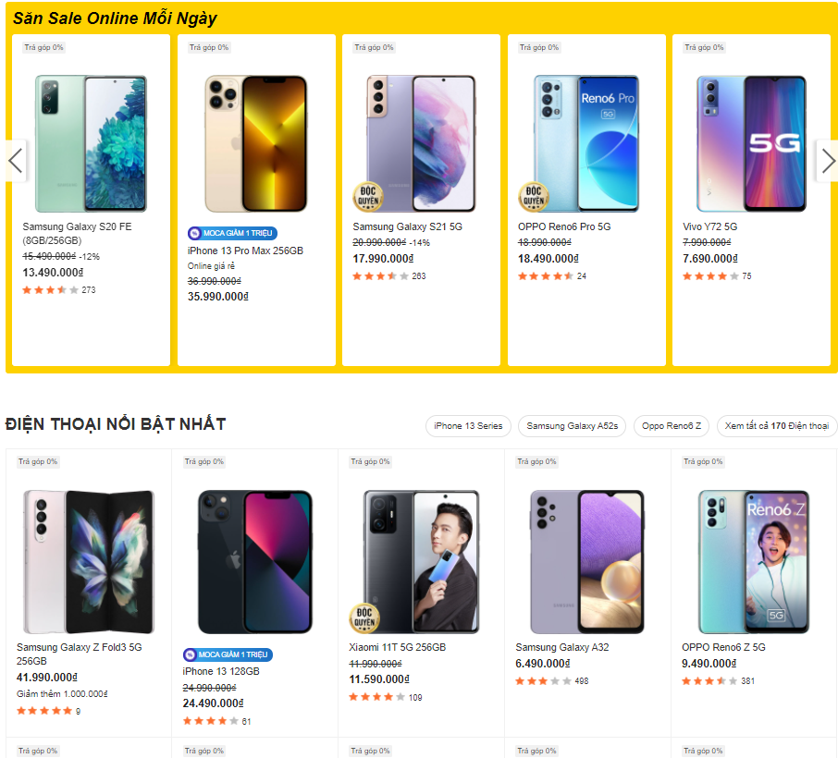

*Figure 8: Thegioididong store page*

* + - 1. **GEARVN**

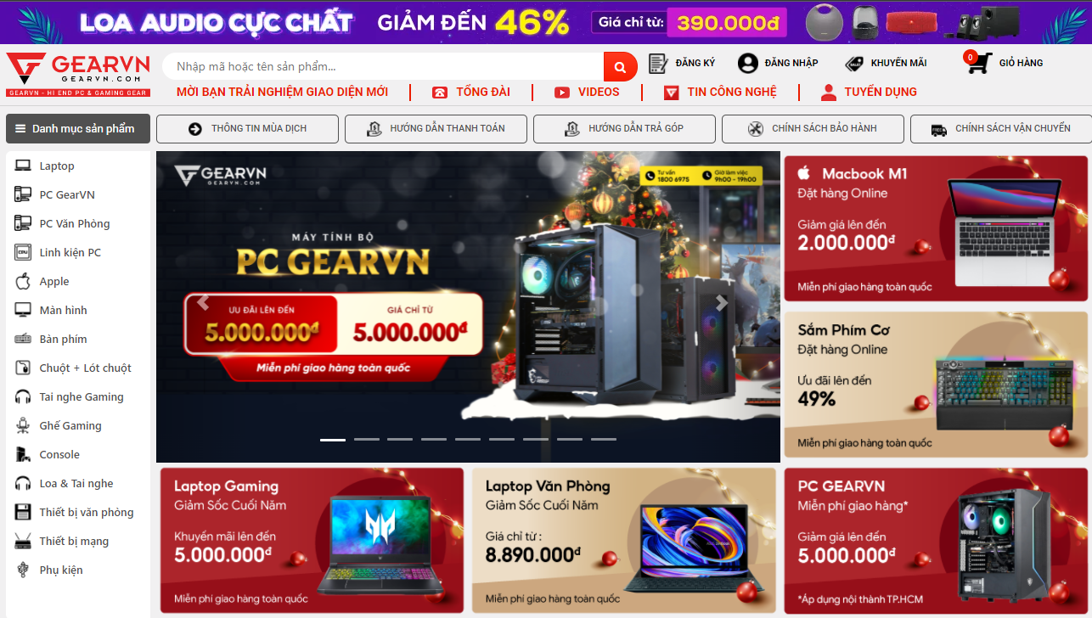

*Figure 9: The website https://gearvn.com/*

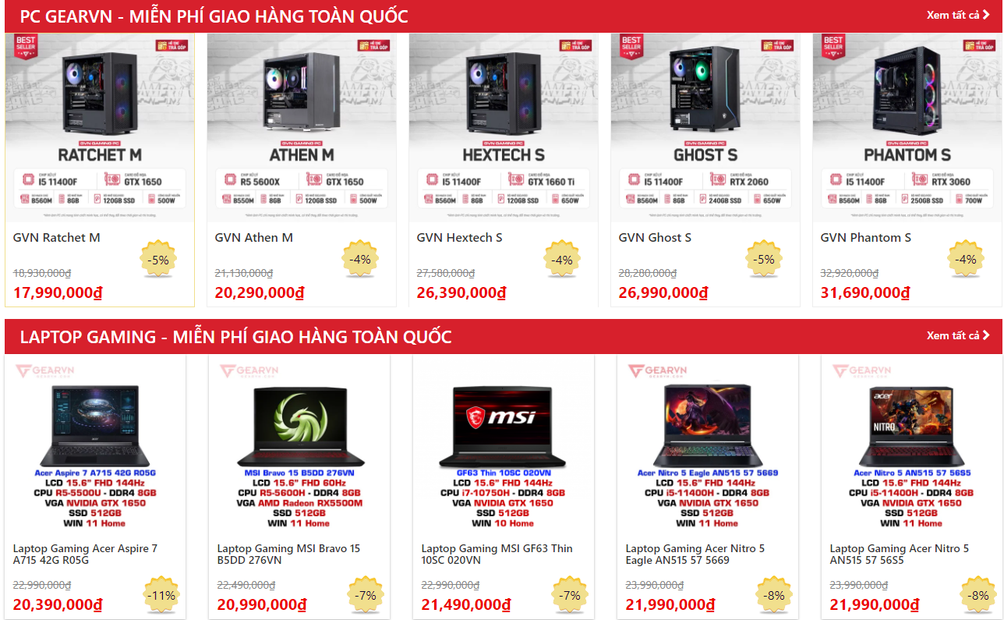

*Figure 10: GEARVN Product List*

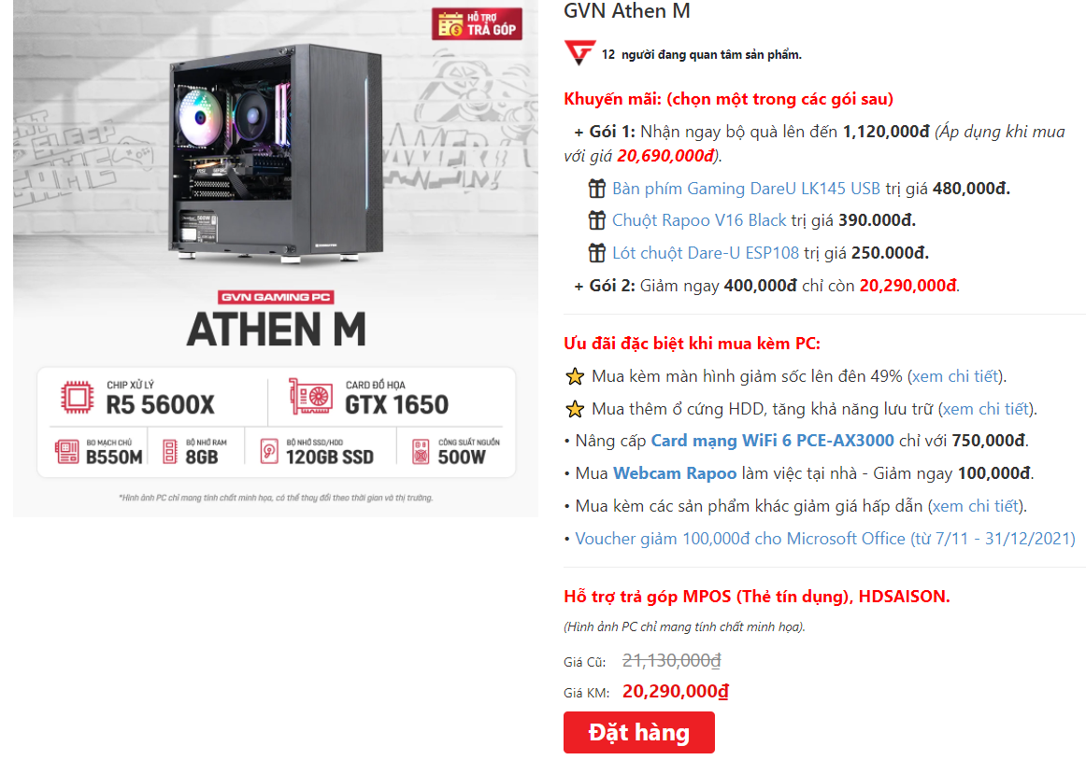

*Figure 11: GEARVN Detailed Product*

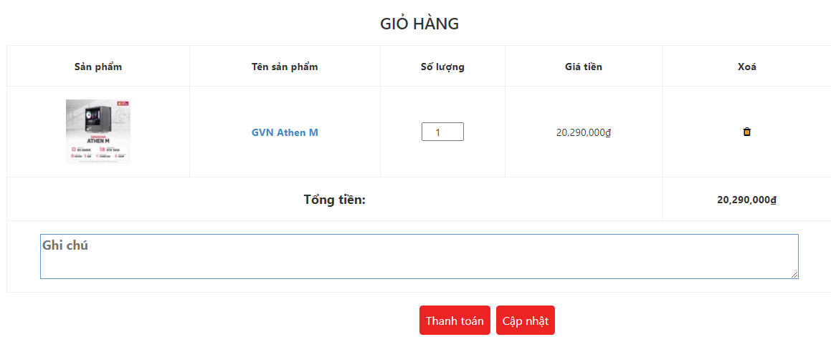

*Figure 12: GEARVN Cart*

* + - 1. **PHONGVU**

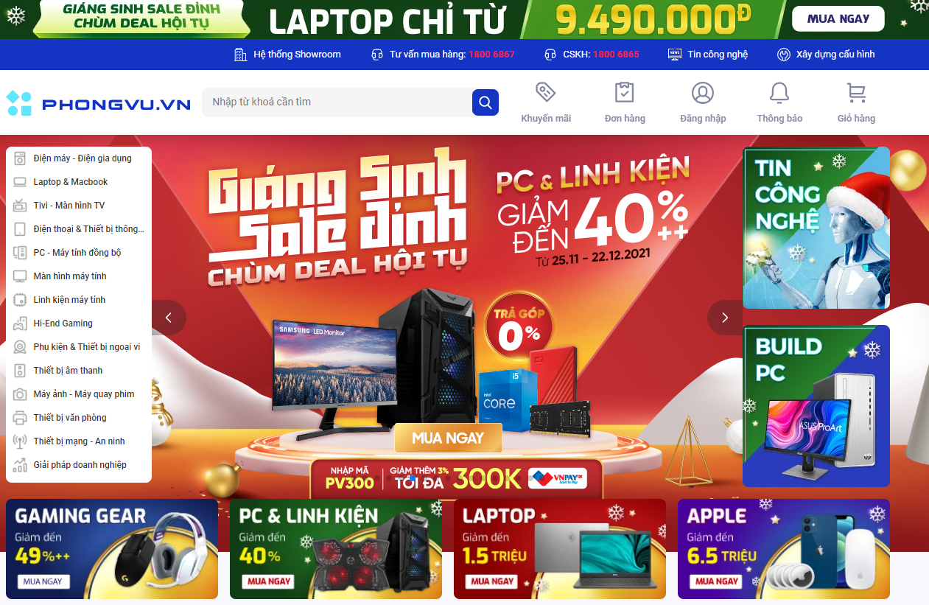

*Figure 13: The website https://www.phongvu.vn*

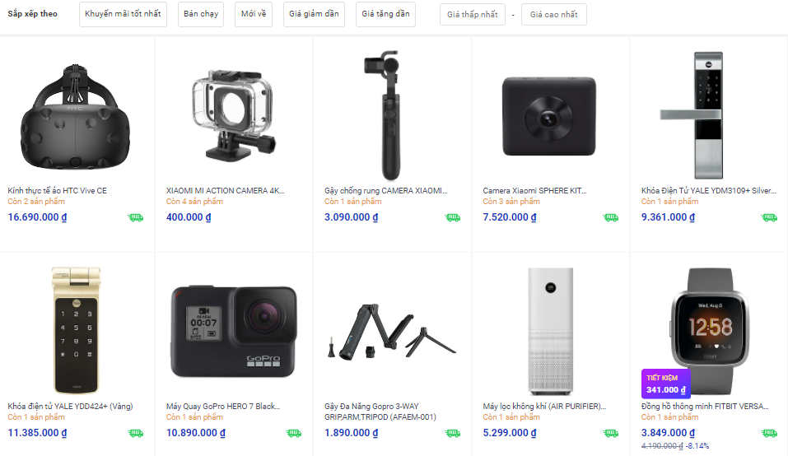

*Figure 14: PHONGVU Product List*

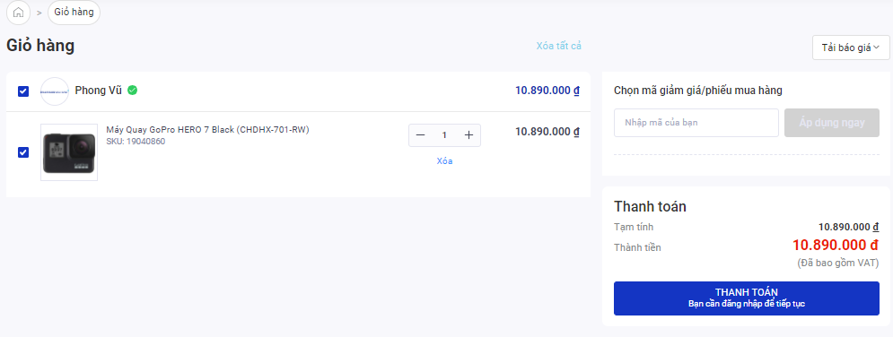

*Figure 15: PHONGVU Cart*

* + 1. **Conclusion**

Through the actual survey, we found that there are many websites with similar features in the aspect of end-users that users can select products, search for products by tags or keywords, suggest many items related to what are looking for, add the product to cart or to wishlist, compare list, order, checkout, get discount code, track order, contact with admin by messenger, cancel orders, view user's personal information. In addition, users also want a stable, smooth, lag-free website, easy to use, user-friendly, allowing registration, login and privacy security, secure online payment, they want the items on the website to be of the right quality and delivered in the right quantity. About the business side, ensure the system's stable operation so that they can update information & product prices daily, strictly manage orders, and send users promotional codes.

Most of the functions are the same, integrating a voice assistant or a game to get points to a electronic sales website is a difficult thing not all websites can do. Besides, an easy-to-use interface and a website that integrates many features will certainly attract more customers and that is also the decision of whether the clothing business succeeds or fails.

* 1. **User Requirement**

Based on what we learned, we identified the main actors interacting in the system are:

* The guest: They can interact with the system but cannot purchase items, rates and comments
* The user: They are similar to guests but more than that they have an account and make purchases items
* The administrator: This is an actor who manages a website that can manage everything. For example manage category, product, user…

  2. 1. **The function of Guest**

|  |  |  |
| --- | --- | --- |
| **Ordinary**  **numbers** | **Function** | **Description** |
| 1 | Register | This function allows guests to register for an account to become a user of the system |
| 2 | Filter product by category | This function helps guests to find products by category |
| 3 | Filter product by price | This function helps guests to find products by price |
| 4 | Search product | This function helps guests to find products by product name |
| 5 | View list products | This function helps guests to view a variety of products |
| 6 | View detailed product | This function helps guests to view detailed products. |
| 7 | Search product by voice | This function helps guests to find product by voice. |
| 8 | View product of category by voice | This function helps guests to view product of category by voice |
| 9 | Open cart by voice | This function helps guests to view cart by voice |
| 10 | Close cart by voice | This function allows guests to close cart by voice |
| 11 | Add products to cart | This function allows guests to add products to cart |
| 12 | Add products to cart by voice | This function allows guests to add products to cart by voice |
| 13 | Remove products from cart | This function allows guests to remove products from cart |
| 14 | Remove products from cart by voice | This function allows guests to remove products from cart by voice |
| 15 | Click to increase the number of products | This function helps guests to increase the number of quantity |
| 16 | Send feedback | This function helps guests to send their feedback to admin |

*Table 2: The function of Guest*

* + 1. **The function of User**

|  |  |  |
| --- | --- | --- |
| **Ordinary**  **numbers** | **Function** | **Description** |
| 1 | Login | This function allows users to login into the system |
| 2 | Edit profile | This function allows users to edit their personal information |
| 3 | Filter product by category | This function helps guests to find products by category |
| 4 | Filter product by price | This function helps guests to find products by price |
| 5 | Search product | This function helps guests to find products by product name |
| 6 | View list products | This function helps guests to view a variety of products |
| 7 | View detailed product | This function helps guests to view detailed products. |
| 8 | Search product by voice | This function helps guests to find product by voice. |
| 9 | View product of category by voice | This function helps guests to view product of category by voice |
| 10 | Open cart by voice | This function helps guests to view cart by voice |
| 11 | Close cart by voice | This function allows guests to close cart by voice |
| 12 | Add products to cart | This function allows guests to add products to cart |
| 13 | Add products to cart by voice | This function allows guests to add products to cart by voice |
| 14 | Remove products from cart | This function allows guests to remove products from cart |
| 15 | Remove products from cart by voice | This function allows guests to remove products from cart by voice |
| 16 | Click to increase the number of products | This function helps guests to increase the number of quantity |
| 17 | Send feedback | This function helps guests to send their feedback to admin |
| 18 | Add product to wishlist | This function helps guests to add product to wishlist |
| 19 | Place the orders | This function allows users place the orders |
| 20 | Payment the order | This function allows users to pay for orders |
| 21 | Order tracking | This function helps users to track orders |
| 22 | Cancel the orders | This function allows users to cancel orders |
| 23 | Comment & rating the product | This function allows users to comment & rating the product purchased |

*Table 3: The function of User*

* + 1. **The function of Administrator**

|  |  |  |
| --- | --- | --- |
| Ordinary  numbers | Function | Description |
| 1 | Login | This function allows admin to login into the system |
| 2 | Add categories | This function allows admin to add categories to the system |
| 3 | Update categories | This function allows admin to update categories to the system |
| 4 | Delete categories | This function allows admin to categories products to the system |
| 5 | Add products | This function allows admin to add products to the system |
| 6 | Update products | This function allows admin to update products to the system |
| 7 | Delete products | This function allows admin to delete products to the system |
| 8 | View detailed product | This function allows users to view detailed product |
| 9 | Block products | This function allows users to block product |
| 10 | Unblock products | This function allows users to unblock product |
| 11 | Add users | This function allows admin to add users to the system |
| 12 | Update users | This function allows admin to update users to the system |
| 13 | Delete users | This function allows admin to categories users to the system |
| 14 | Block users | This function allows users to block user |
| 15 | Unblock users | This function allows users to unblock user |
| 16 | Add vouchers | This function allows admin to add vouchers to the system |
| 17 | Update vouchers | This function allows admin to update vouchers to the system |
| 18 | Delete vouchers | This function allows admin to delete vouchers to the system |
| 19 | Filter product by keyword | This function helps users to find categories, products, tag, size by keyword |
| 20 | View statistics | This function allows the admin to know statistics about revenue, quantity sold of each product, best-seller products, which products are in stock, which products are out of stock, number of orders not yet accepted or completed. |
| 21 | Import goods | This function allows users to import goods |
| 22 | Change status the orders | This function allows admin to change status of orders: not accept, packed, delivery, complete, cancel |
| 23 | Delete the orders | This function allows admin to delete orders |

*Table 4: The function of Administrator*

* + 1. **Use Case Diagram**
       1. **Module End-User**

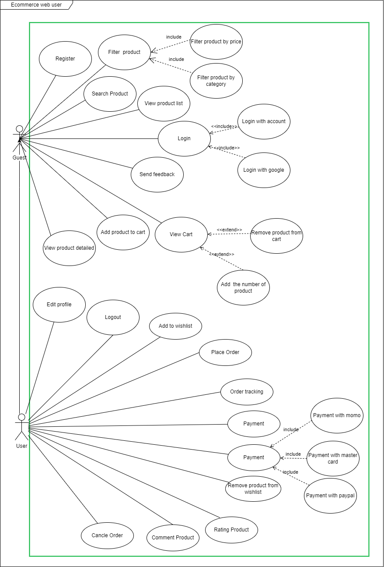

*Figure 16: Use Case Diagram - User*

* + - 1. **Module Administrator**

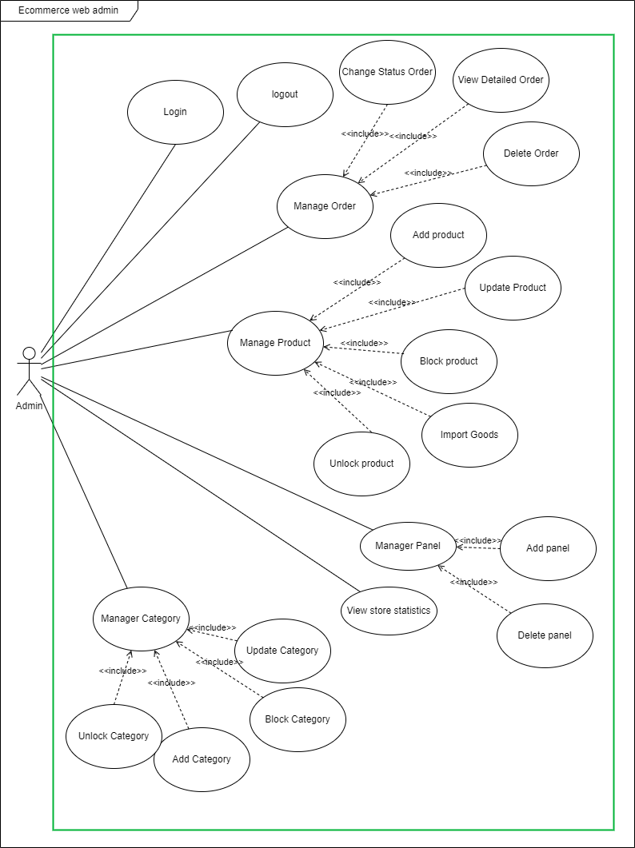

*Figure 17: Use Case Diagram - Admin*

* + 1. **Use Case Description**
       1. **Guest**
          1. **<Guest> Register**

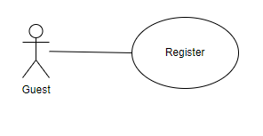

*Figure 18: UC Guest – Register*

|  |  |  |  |
| --- | --- | --- | --- |
| **USE CASE - GUEST_01** | | | |
| **Use Case No.** | GUEST_01 | **Use Case Version** | 2.0 |
| **Use Case Name** | Register | | |
| **Author** | ThanhHoai | | |
| **Date** | 20/06/2021 | **Priority** | Normal |
| **Actor:**   * The guest   **Summary:**   * Allows the guest can register an account.   **Goal:**   * The guest registers an account on the system.   **Triggers:**   * The guest clicks the register button on the login screen.   **Preconditions:**   * N/A.   **Post Conditions:**   * **Success:** The system will have an account. * **Fail**: The system shows error messages.   **Main Success Scenario:**   |  |  |  | | --- | --- | --- | | **Step** | **Actor Action** | **System Response** | | 1 | The guest needs access to the website |  | | 2 | The guest click to Register button | The system redirects to the Register screen. | | 3 | Customer enter first name, last name, email, password and click to the Register button. | The system creates a new account  The system redirects to the main view. |   **Alternative Scenario:** N/A  **Exceptions:**   |  |  |  | | --- | --- | --- | | **No** | **Cause** | **System Response** | | 1 | The internet is lost | The system shows the message Please! Check your internet connection | | 2 | This name already exists | The system shows the message Name already exists | | 3 | Any box is empty | The system shows the message  Please! Fill in your full information |   **Relationships:** N/A  **Business Rules:**   * The length of the character must not exceed 50 characters | | | |

*Table 5: <Guest> Register*

* + - * 1. **<Guest> Login**

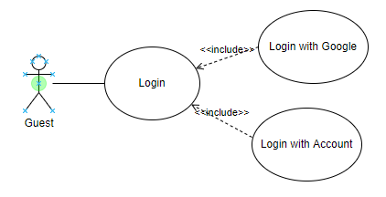

*Figure 19: UC Guest – Login*

|  |  |  |  |
| --- | --- | --- | --- |
| **USE CASE - GUEST_02** | | | |
| **Use Case No.** | GUEST_02 | **Use Case Version** | 2.0 |
| **Use Case Name** | Login | | |
| **Author** | ThanhHoai | | |
| **Date** | 20/06/2021 | **Priority** | Normal |
| **Actor:**   * The guest.   **Summary:**   * Allows the guest to login to the system.   **Goal:**   * The guest can login to the system.   **Triggers:**   * The guest clicks Login button on the login screen.   **Preconditions:**   * The guest needs to enter the correct password & id number   **Post Conditions:**   * **Success:** The guest is redirected to the home screen. * **Fail**: System show error messages.   **Main Success Scenario:**   |  |  |  | | --- | --- | --- | | **Step** | **Actor Action** | **System Response** | | 1 | The guest needs access to the login page | The login page is displayed | | 2 | The guest enters the id & password | The id & password is displayed of each the textbox | | 3 | The guest clicks on the Login button | The home screen is displayed |   **Alternative Scenario:** N/A  **Exceptions:**   |  |  |  | | --- | --- | --- | | **No** | **Cause** | **System Response** | | 1 | The internet is lost | The system shows the message Please! Check your internet connection | | 2 | Any box is empty | The system shows the message Please! Fill in your full information |   **Relationships:** N/A  **Business Rules:**   * Email: must not be empty * Password: must not be empty | | | |

*Table 6: <Guest> Login*

* + - * 1. **<Guest> View Product List**

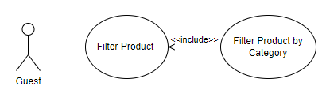

*Figure 20: UC Guest - View Product List*

|  |  |  |  |
| --- | --- | --- | --- |
| **USE CASE - GUEST_03** | | | |
| **Use Case No.** | GUEST_03 | **Use Case Version** | 2.0 |
| **Use Case Name** | View Product List | | |
| **Author** | ThanhHoai | | |
| **Date** | 20/06/2020 | **Priority** | Normal |
| **Actor:**   * The guest   **Summary:**   * Allows the guest to view all products displayed on the website.   **Goal:**   * The guest can visit the website & view products.   **Triggers:**   * N/A.   **Preconditions:**   * N/A   **Post Conditions:**   * **Success:** The system will display product list. * **Fail**: The system shows error messages.   **Main Success Scenario:**   |  |  |  | | --- | --- | --- | | **Step** | **Actor Action** | **System Response** | | 1 | The guest needs access to the website |  |   **Alternative Scenario:** N/A  **Exceptions:**   |  |  |  | | --- | --- | --- | | **No** | **Cause** | **System Response** | | 1 | The internet is lost | The system shows the message Please! Check your internet connection |   **Relationships:** N/A  **Business Rules:** N/A | | | |

*Table 7: <Guest> View Product List*

* + - * 1. **<Guest> View Detailed Product**

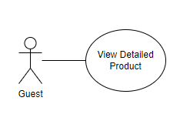

*Figure 21: UC Guest View Product Details*

|  |  |  |  |
| --- | --- | --- | --- |
| **USE CASE - GUEST_04** | | | |
| **Use Case No.** | GUEST_04 | **Use Case Version** | 2.0 |
| **Use Case Name** | View Detailed Product | | |
| **Author** | ThanhHoai | | |
| **Date** | 20/06/2020 | **Priority** | Normal |
| **Actor:**   * The guest.   **Summary:**   * Allows the guest can view the detailed product.   **Goal:**   * The guest views the detailed product on the system.   **Triggers:**   * The guest clicks the view icon button on the product screen.   **Preconditions:** N/A  **Post Conditions:**   * **Success:** The system will display the detailed product. * **Fail**: The system show error messages.   **Main Success Scenario:**   |  |  |  | | --- | --- | --- | | **Step** | **Actor Action** | **System Response** | | 1 | The guest needs access to the website |  | | 2 | The guest clicks the Details button or product image on the home screen. | The system display the detail product. |   **Alternative Scenario:** N/A  **Exceptions:**   |  |  |  | | --- | --- | --- | | **No** | **Cause** | **System Response** | | 1 |  | The system shows the message Please check your internet connection when the internet is lost. |   **Relationships:** N/A  **Business Rules:** N/A | | | |

*Table 8: <Guest> View Detailed Product*

* + - * 1. **<Guest> Filter Product by Category**

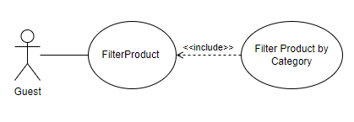

*Figure 22: UC Guest Filter Product by Category*

|  |  |  |  |
| --- | --- | --- | --- |
| **USE CASE - GUEST_05** | | | |
| **Use Case No.** | GUEST_05 | **Use Case Version** | 2.0 |
| **Use Case Name** | Filter Product by Category | | |
| **Author** | ThanhHoai | | |
| **Date** | 20/06/2021 | **Priority** | Normal |
| **Actor:**   * The guest.   **Summary:**   * Allows the guest can filter the search products by category.   **Goal:**   * The guest filters the search products by category.   **Triggers:**   * The guest checks the checkboxes corresponding to its category.   **Preconditions:**   * The guest logged into the system successfully.   **Post Conditions:**   * **Success:** The guest filters the search products by category. * **Fail**: The system display error messages.   **Main Success Scenario:**   |  |  |  | | --- | --- | --- | | **Step** | **Actor Action** | **System Response** | | 1 | The guest clicks the Store on header website | The store screen is displayed | | 2 | The guest checks the checkboxes corresponding to its category | The products displayed corresponding to its category |   **Alternative Scenario:** N/A  **Exceptions:**   |  |  |  | | --- | --- | --- | | **No** | **Cause** | **System Response** | | 1 | The internet is lost | The system shows the message Please! Check your internet connection |   **Relationships:** N/A  **Business Rules:** N/A | | | |

*Table 9: <Guest> Filter Product by Category*

* + - * 1. **<Guest> Filter Product by Price**

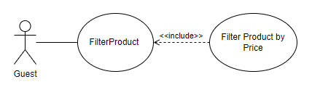

*Figure 23: UC Guest Filter Product by Price*

|  |  |  |  |
| --- | --- | --- | --- |
| **USE CASE - GUEST _06** | | | |
| **Use Case No.** | GUEST_06 | **Use Case Version** | 2.0 |
| **Use Case Name** | Filter Product by Price | | |
| **Author** | ThanhHoai | | |
| **Date** | 20/06/2021 | **Priority** | Normal |
| **Actor:**   * The guest.   **Summary:**   * Allows the guest can filter the search products by Price.   **Goal:**   * The guest filters the search products by Price.   **Triggers:**   * The guest drag the price bar as you like.   **Preconditions:**   * The guest logged into the system successfully.   **Post Conditions:**   * **Success:** The guest filters the search products by Price. * **Fail**: The system display error messages.   **Main Success Scenario:**   |  |  |  | | --- | --- | --- | | **Step** | **Actor Action** | **System Response** | | 1 | The guest clicks the Store on header website | The store screen is displayed | | 2 | The guest Drag the price bar as you like | The products displayed corresponding to its price |   **Alternative Scenario:** N/A  **Exceptions:**   |  |  |  | | --- | --- | --- | | **No** | **Cause** | **System Response** | | 1 | The internet is lost | The system shows the message Please! Check your internet connection |   **Relationships:** N/A  **Business Rules:** N/A | | | |

*Table 10: <Guest> Filter Product by Color*

* + - * 1. **<Guest> Search Product**

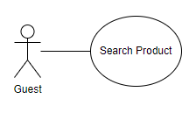

*Figure 24: UC Guest Search Product.*

|  |  |  |  |
| --- | --- | --- | --- |
| **USE CASE - GUEST_07** | | | |
| **Use Case No.** | GUEST_07 | **Use Case Version** | 2.0 |
| **Use Case Name** | Search Product | | |
| **Author** | ThanhHoai | | |
| **Date** | 20/06/2021 | **Priority** | Normal |
| **Actor:**   * The guest.   **Summary:**   * Allows the guest can filter the search products by the keywords.   **Goal:**   * The guest filters the search products by the keywords.   **Triggers:**   * The guest enters the keywords in input.   **Preconditions:**   * The guest logged into the system successfully.   **Post Conditions:**   * **Success:** The guest filters the search products by keyword. * **Fail**: The system display error messages.   **Main Success Scenario:**   |  |  |  | | --- | --- | --- | | **Step** | **Actor Action** | **System Response** | | 1 | The guest clicks the Store on header website | The store screen is displayed | | 2 | The guest enters the keywords in the input | The products displayed corresponding to its keyword |   **Alternative Scenario:** N/A  **Exceptions:**   |  |  |  | | --- | --- | --- | | **No** | **Cause** | **System Response** | | 1 | The internet is lost | The system shows the message Please! Check your internet connection |   **Relationships:** N/A  **Business Rules:** N/A | | | |

*Table 11: <Guest> Search Product*

* + - * 1. **<Guest> Send Message**

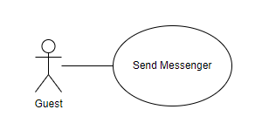

*Figure 25: UC Guest Send Message*

|  |  |  |  |
| --- | --- | --- | --- |
| **USE CASE - GUEST_8** | | | |
| **Use Case No.** | GUEST_8 | **Use Case Version** | 2.0 |
| **Use Case Name** | Send Message | | |
| **Author** | ThanhHoai | | |
| **Date** | 20/06/2021 | **Priority** | Normal |
| **Actor:**   * The guest.   **Summary:**   * Allows the guests can send message to contact with admin.   **Goal:**   * The guests add email on the system successfully.   **Triggers:**   * The guests click the Message chatbot on any screen.   **Preconditions:**   * The guests logged into the system successfully. * The guest have an account Facebook & logged it successfully.   **Post Conditions:**   * **Success:** The system redirect guest to Facebook and then chat with admin. * **Fail**: The system show error messages.   **Main Success Scenario:**   |  |  |  | | --- | --- | --- | | **Step** | **Actor Action** | **System Response** | | 1 | The guests clicks messenger of Facebook | The system redirect guest to Facebook page |   **Alternative Scenario:** N/A  **Exceptions:**   |  |  |  | | --- | --- | --- | | **No** | **Cause** | **System Response** | | 1 | The internet is lost | The system shows the message Please! Check your internet connection |   **Relationships:** N/A  **Business Rules:** N/A | | | |

*Table 12: <Guest> Send Message*

* + - * 1. **<Guest> Add product to Cart**

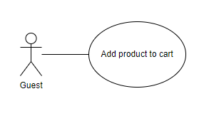

*Figure 26: UC Guest Add product to Cart*

|  |  |  |  |
| --- | --- | --- | --- |
| **USE CASE - GUEST_9** | | | |
| **Use Case No.** | GUEST_9 | **Use Case Version** | 2.0 |
| **Use Case Name** | Add product to Cart | | |
| **Author** | ThanhHoai | | |
| **Date** | 20/06/2021 | **Priority** | Normal |
| **Actor:**   * The guest.   **Summary:**   * Allows the guest can add products to cart.   **Goal:**   * The guest adds to cart successfully.   **Triggers:**   * The guest clicks the Add to Cart button on detailed product screen.   **Preconditions:** N/A  **Post Conditions:**   * **Success:** The products are added successfully. * **Fail**: The system show error messages.   **Main Success Scenario:**   |  |  |  | | --- | --- | --- | | **Step** | **Actor Action** | **System Response** | | 1 | The guest clicks the Detail button on the product screen | The detail product screen displays | | 2 | The guest clicks the Add to cart button on detail product screen | The product is added successfully |   **Alternative Scenario:** N/A  **Exceptions:**   |  |  |  | | --- | --- | --- | | **No** | **Cause** | **System Response** | | 1 | The internet is lost | The system shows the message Please! Check your internet connection |   **Relationships:** N/A  **Business Rules:** N/A | | | |

*Figure 37: <Guest> Add to Cart*

* + - * 1. **<Guest> View Cart**

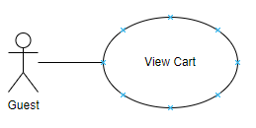

*Figure 27: UC Guest View Cart*

|  |  |  |  |
| --- | --- | --- | --- |
| **USE CASE - GUEST_10** | | | |
| **Use Case No.** | GUEST_10 | **Use Case Version** | 2.0 |
| **Use Case Name** | View Cart | | |
| **Author** | ThanhHoai | | |
| **Date** | 20/06/2021 | **Priority** | Normal |
| **Actor:**   * The guest.   **Summary:**   * Allows the guest view cart.   **Goal:**   * The guest view cart.   **Triggers:**   * The guest clicks the Cart icon on the home page.   **Preconditions:**   * N/A   **Post Conditions:**   * **Success:** Show all product in cart. * **Fail**: The system shows error messages.   **Main Success Scenario:**   |  |  |  | | --- | --- | --- | | **Step** | **Actor Action** | **System Response** | | 1 | Guest clicks icon cart. | The cart screen displays |   **Alternative Scenario:** N/A  **Exceptions:**   |  |  |  | | --- | --- | --- | | **No** | **Cause** | **System Response** | | 1 | The internet is lost | The system shows the message Please! Check your internet connection |   **Relationships:** N/A  **Business Rules:** N/A | | | |

*Table 13: <Guest> View Cart*

* + - * 1. **<Guest> Remove Product from Cart**

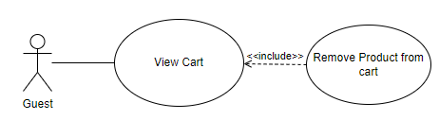

*Figure 28: UC Guest Remove Product from Cart*

|  |  |  |  |
| --- | --- | --- | --- |
| **USE CASE - GUEST_11** | | | |
| **Use Case No.** | GUEST_11 | **Use Case Version** | 2.0 |
| **Use Case Name** | Remove Product from Cart | | |
| **Author** | ThanhHoai | | |
| **Date** | 20/06/2021 | **Priority** | Normal |
| **Actor:**   * The guest.   **Summary:**   * Allows the guest to remove product in cart.   **Goal:**   * The guest removes product in cart.   **Triggers:**   * The guest clicks the X icon on the cart page.   **Preconditions:**   * There is at least 1 product in the cart   **Post Conditions:**   * **Success:** Products are deleted out the cart. * **Fail**: The system shows error messages.   **Main Success Scenario:**   |  |  |  | | --- | --- | --- | | **Step** | **Actor Action** | **System Response** | | 1 | Guest clicks icon cart. | The cart screen displays | | 2 | Guest click remove button | The items is deleted out successfully |   **Alternative Scenario:** N/A  **Exceptions:**   |  |  |  | | --- | --- | --- | | **No** | **Cause** | **System Response** | | 1 | The internet is lost | The system shows the message Please! Check your internet connection |   **Relationships:** N/A  **Business Rules:** N/A | | | |

*Table 14: <Guest> Remove Product from Cart*

* + - * 1. **<Guest> Add the number of Product**

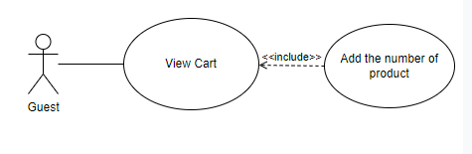

*Figure 29: UC Guest Add the number of Product.*

|  |  |  |  |
| --- | --- | --- | --- |
| **USE CASE - GUEST_12** | | | |
| **Use Case No.** | GUEST_12 | **Use Case Version** | 2.0 |
| **Use Case Name** | Add the number of product | | |
| **Author** | ThanhHoai | | |
| **Date** | 20/06/2021 | **Priority** | Normal |
| **Actor:**   * The guest.   **Summary:**   * Allows the guest to add the number of product in cart.   **Goal:**   * The guest add the number of product in cart.   **Triggers:**   * The guest clicks the ^ icon on the cart page.   **Preconditions:**   * There is at least 1 product in the cart   **Post Conditions:**   * **Success:** Products are deleted out the cart. * **Fail**: The system shows error messages.   **Main Success Scenario:**   |  |  |  | | --- | --- | --- | | **Step** | **Actor Action** | **System Response** | | 1 | Guest clicks icon cart. | The cart screen displays | | 2 | Guest click add the number button | The items is add the number successfully |   **Alternative Scenario:** N/A  **Exceptions:**   |  |  |  | | --- | --- | --- | | **No** | **Cause** | **System Response** | | 1 | The internet is lost | The system shows the message Please! Check your internet connection |   **Relationships:** N/A  **Business Rules:** N/A | | | |

*Table 15: <Guest> Add the number of product.*

* + - 1. **User**
         1. **<User> Logout**

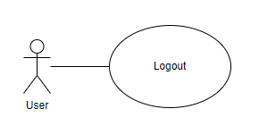

*Figure 30: UC User Logout*

|  |  |  |  |
| --- | --- | --- | --- |
| **USE CASE - USER_01** | | | |
| **Use Case No.** | USER_01 | **Use Case Version** | 2.0 |
| **Use Case Name** | Logout | | |
| **Author** | ThanhHoai | | |
| **Date** | 20/06/2021 | **Priority** | Normal |
| **Actor:**   * The user.   **Summary:**   * Allows users log out from the system.   **Goal:**   * The user logout successfully.   **Triggers:**   * The user clicks to the Logout button in the menu.   **Preconditions:**   * The user logged into the system successfully.   **Post Conditions:**   * **Success:** The system redirects to login screen. * **Fail**: System show error messages.   **Main Success Scenario:**   |  |  |  | | --- | --- | --- | | **Step** | **Actor Action** | **System Response** | | 1 | The user clicks button Logout | The login screen displays |   **Alternative Scenario:** N/A  **Exceptions:**   |  |  |  | | --- | --- | --- | | **No** | **Cause** | **System Response** | | 1 | The internet is lost | The system shows the message Please! Check your internet connection |   **Relationships:** N/A  **Business Rules:**   * After member sends logout request, system redirects to login screen. | | | |

*Table 16: <User> Logout*

* + - * 1. **<User> Edit Profile**

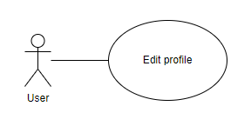

*Figure 31: UC User Edit Profile*

|  |  |  |  |
| --- | --- | --- | --- |
| **USE CASE - USER_02** | | | |
| **Use Case No.** | USER_02 | **Use Case Version** | 2.0 |
| **Use Case Name** | Edit Profile | | |
| **Author** | ThanhHoai | | |
| **Date** | 20/06/2021 | **Priority** | Normal |
| **Actor:**   * The user.   **Summary:**   * Allows the user can edit profile.   **Goal:**   * The users edit on the system.   **Triggers:**   * The users click the Edit Profile button on profile screen.   **Preconditions:**   * The users logged into the system successfully.   **Post Conditions:**   * **Success:** The system will edit profile successfully. * **Fail**: The system show error messages.   **Main Success Scenario:**   |  |  |  | | --- | --- | --- | | **Step** | **Actor Action** | **System Response** | | 1 | The users click the Profile button on the home screen | The profile screen displays | | 2 | The users click the Edit profile button on profile screen | The edit popup is displayed | | 3 | The users enter the information to update on a form |  | | 4 | The users clicks on the OK button | The profile is updated successfully |   **Alternative Scenario:** N/A  **Exceptions:**   |  |  |  | | --- | --- | --- | | **No** | **Cause** | **System Response** | | 1 | The internet is lost | The system shows the message Please! Check your internet connection | | 2 | Any box is empty | The system shows the message  Please! Fill in your full information |   **Relationships:** N/A  **Business Rules:**   * The length of the character must not exceed 50 characters. | | | |

*Table 17: <User> Edit Profile*

* + - * 1. **<User> Add to Wishlist**

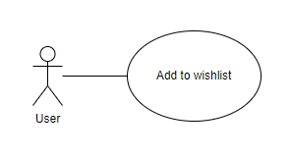

*Figure 32: UC User Add to Wishlist*

|  |  |  |  |
| --- | --- | --- | --- |
| **USE CASE - USER_03** | | | |
| **Use Case No.** | USER_03 | **Use Case Version** | 2.0 |
| **Use Case Name** | Add to Wishlist | | |
| **Author** | ThanhHoai | | |
| **Date** | 20/06/2021 | **Priority** | Normal |
| **Actor:**   * The user.   **Summary:**   * Allows the users can add products to wishlist.   **Goal:**   * The users add to wishlist successfully.   **Triggers:**   * The guest clicks the Heart icon button on detailed product screen.   **Preconditions:** N/A  **Post Conditions:**   * **Success:** The products are added to wishlist successfully. * **Fail**: The system show error messages.   **Main Success Scenario:**   |  |  |  | | --- | --- | --- | | **Step** | **Actor Action** | **System Response** | | 1 | The guest clicks the Heart icon | The product is added wishlist succesfully |   **Alternative Scenario:** N/A  **Exceptions:**   |  |  |  | | --- | --- | --- | | **No** | **Cause** | **System Response** | | 1 | The internet is lost | The system shows the message Please! Check your internet connection |   **Relationships:** N/A  **Business Rules:** N/A | | | |

*Table 18: <User> Add to Wishlist*

* + - * 1. **<User> Remove Product from Wishlist**

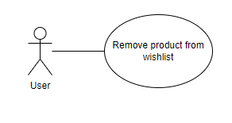

*Figure 33: US User Remove Product from Wishlist*

|  |  |  |  |
| --- | --- | --- | --- |
| **USE CASE - USER_4** | | | |
| **Use Case No.** | USER_4 | **Use Case Version** | 2.0 |
| **Use Case Name** | Remove Products from Wishlist | | |
| **Author** | ThanhHoai | | |
| **Date** | 20/06/2021 | **Priority** | Normal |
| **Actor:**   * The user.   **Summary:**   * Allows the users can remove products out wishlist.   **Goal:**   * The users remove products from wishlist successfully.   **Triggers:**   * The guest clicks the X icon button wishlist screen.   **Preconditions:**   * There is at least 1 product in the wishlist   **Post Conditions:**   * **Success:** The products are added to wishlist successfully. * **Fail**: The system show error messages.   **Main Success Scenario:**   |  |  |  | | --- | --- | --- | | **Step** | **Actor Action** | **System Response** | | 1 | The guest clicks the X icon | The product is removed from wishlist successfully. |   **Alternative Scenario:** N/A  **Exceptions:**   |  |  |  | | --- | --- | --- | | **No** | **Cause** | **System Response** | | 1 | The internet is lost | The system shows the message Please! Check your internet connection |   **Relationships:** N/A  **Business Rules:** N/A | | | |

*Table 19: <User> Remove Product from Wishlist*

* + - * 1. **<User> Send Feedback**

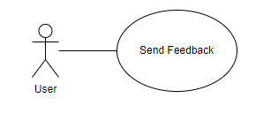

*Figure 34: UC User Send Feedback*

|  |  |  |  |
| --- | --- | --- | --- |
| **USE CASE - USER_05** | | | |
| **Use Case No.** | USER_05 | **Use Case Version** | 2.0 |
| **Use Case Name** | Send Feedback | | |
| **Author** | ThanhHoai | | |
| **Date** | 20/06/2021 | **Priority** | Normal |
| **Actor:**   * The user.   **Summary:**   * Allows the users can send feedback.   **Goal:**   * The users send feedback on the system successfully.   **Triggers:**   * The users click the Send button on contact screen.   **Preconditions:**   * The users logged into the system successfully.   **Post Conditions:**   * **Success:** The system will send feedback successfully. * **Fail**: The system show error messages.   **Main Success Scenario:**   |  |  |  | | --- | --- | --- | | **Step** | **Actor Action** | **System Response** | | 1 | The users input subject, content | The subject & content is displayed | | 2 | The users clicks Send | The system sends feedback successfully |   **Alternative Scenario:** N/A  **Exceptions:**   |  |  |  | | --- | --- | --- | | **No** | **Cause** | **System Response** | | 1 | The internet is lost | The system shows the message Please! Check your internet connection |   **Relationships:** N/A  **Business Rules:** N/A | | | |

*Table 20: <User> Send Feedback*

* + - * 1. **<User> Place Orders**

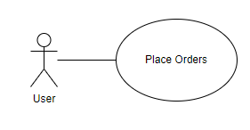

*Figure 35: UC User Place Orders*

|  |  |  |  |
| --- | --- | --- | --- |
| **USE CASE - USER_06** | | | |
| **Use Case No.** | USER_06 | **Use Case Version** | 2.0 |
| **Use Case Name** | Place The Orders | | |
| **Author** | ThanhDat | | |
| **Date** | 20/06/2021 | **Priority** | Normal |
| **Actor:**   * The user.   **Summary:**   * Allows users purchase the items on the website.   **Goal:**   * The users order the items successfully.   **Triggers:**   * The user put the items on the cart then they will pay it.   **Preconditions:**   * There is at least 1 item in the cart.   **Post Conditions:**   * **Success:** The product is purchased successfully. * **Fail**: System show error messages.   **Main Success Scenario:**   |  |  |  | | --- | --- | --- | | **Step** | **Actor Action** | **System Response** | | 1 | The users add items to cart | The cart appears items just add | | 2 | The user click Check out button | The check out display. | | 3 | The user enter address, phone number. | The information just enter will display on each box | | 4 | The users can click Place Order button or PayPal to payment | The system appears the successful alert & send email confirm to user |   **Alternative Scenario:** N/A  **Exceptions:**   |  |  |  | | --- | --- | --- | | **No** | **Cause** | **System Response** | | 1 |  | The system shows the message Please check your internet connection when the internet is lost. | | 2 | Cart is empty |  |   **Relationships:** N/A.  **Business Rules:**   * Must successfully purchase at least one product. | | | |

*Table 21: <User> Place Orders*

* + - * 1. **<User> Order Tracking**

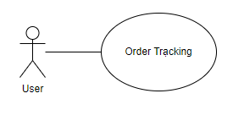

*Figure 36: UC User Order Tracking*

|  |  |  |  |
| --- | --- | --- | --- |
| **USE CASE - USER_07** | | | |
| **Use Case No.** | USER_07 | **Use Case Version** | 2.0 |
| **Use Case Name** | Order Tracking | | |
| **Author** | ThanhHoai | | |
| **Date** | 20/06/2021 | **Priority** | Normal |
| **Actor:**   * The user   **Summary:**   * Allow users track all their the order.   **Goal:**   * The users track all the orders   **Triggers:**   * User click My order button on any screen.   **Preconditions:**   * Logged in successfully   **Post Conditions:**   * **Success:** The system displays all order & status order. * **Fail**: The system show error messages.   **Main Success Scenario:**   |  |  |  | | --- | --- | --- | | **Step** | **Actor Action** | **System Response** | | 1 | User clicks button My order | The orders screen displays. |   **Alternative Scenario:**  **Exceptions:**   |  |  |  | | --- | --- | --- | | **No** | **Cause** | **System Response** | | 1 |  | The system shows the message Please check your internet connection when the internet is lost. |   **Relationships:** N/A  **Business Rules:** N/A | | | |

*Table 22: <User> Order Tracking*

* + - * 1. **<User> Cancel Order**

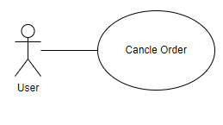

*Figure 37: UC User Cancel Order*

|  |  |  |  |
| --- | --- | --- | --- |
| **USE CASE - USER_08** | | | |
| **Use Case No.** | USER_08 | **Use Case Version** | 2.0 |
| **Use Case Name** | Cancel Order | | |
| **Author** | ThanhDat | | |
| **Date** | 20/12/2020 | **Priority** | Normal |
| **Actor:**   * The user   **Summary:**   * Allows users to cancel orders.   **Goal:**   * The users cancel orders on the website   **Triggers:**   * The users click cancel button order screen.   **Preconditions:**   * Logged in successfully * Have to order at least one item & it’s status are not accept or packed   **Post Conditions:**   * **Success:** The users cancel the orders successfully * **Fail**: System show error messages.   **Main Success Scenario:**   |  |  |  | | --- | --- | --- | | **Step** | **Actor Action** | **System Response** | | 1 | The user clicks button My orderbutton | The order screen displays | | 2 | The user click button cancel | The user cancel order successfully |   **Alternative Scenario:** N/A  **Exceptions:**   |  |  |  | | --- | --- | --- | | **No** | **Cause** | **System Response** | | 1 |  | The system shows the message Please check your internet connection when the internet is lost. |   **Relationships:** N/A  **Business Rules:** N/A | | | |

*Table 23: <User> Cancel Order*

* + - * 1. **<User> Comment Product**

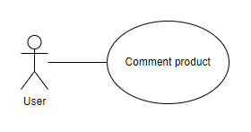

*Figure 38: UC User Comment Product*

|  |  |  |  |
| --- | --- | --- | --- |
| **USE CASE - USER_9** | | | |
| **Use Case No.** | USER_9 | **Use Case Version** | 2.0 |
| **Use Case Name** | Comment Product | | |
| **Author** | ThanhHoai | | |
| **Date** | 20/06/2021 | **Priority** | Normal |
| **Actor:**   * The user.   **Summary:**   * Allow users to comment on products they have just purchased.   **Goal:**   * The users can comment on the product they just bought.   **Triggers:**   * User click My order button on any screen.   **Preconditions:**   * Logged in successfully * The order has a complete status.   **Post Conditions:**   * **Success:** User commented on the product successfully. * **Fail**: The system show error messages.   **Main Success Scenario:**   |  |  |  | | --- | --- | --- | | **Step** | **Actor Action** | **System Response** | | 1 | User clicks button My order | The orders screen displays. | | 2 | User clicks on review the product on the table. | The details product screen displays. |   **Alternative Scenario:**  **Exceptions:**   |  |  |  | | --- | --- | --- | | **No** | **Cause** | **System Response** | | 1 |  | The system shows the message Please check your internet connection when the internet is lost. |   **Relationships:** N/A  **Business Rules:** N/A | | | |

*Table 24: <User> Comment Product*

* + - * 1. **<User> Rating Product**

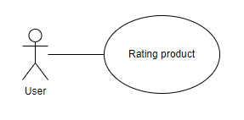

*Figure 39: UC User Rating Product*

|  |  |  |  |
| --- | --- | --- | --- |
| **USE CASE - USER_10** | | | |
| **Use Case No.** | USER_10 | **Use Case Version** | 2.0 |
| **Use Case Name** | Rating Product | | |
| **Author** | ThanhHoai | | |
| **Date** | 20/06/2021 | **Priority** | Normal |
| **Actor:**   * The user.   **Summary:**   * Allow users to rating on products they have just purchased.   **Goal:**   * The users can rating on the product they just bought.   **Triggers:**   * User click My order button on any screen.   **Preconditions:**   * Logged in successfully * The order has a complete status.   **Post Conditions:**   * **Success:** User rated on the product successfully. * **Fail**: The system show error messages.   **Main Success Scenario:**   |  |  |  | | --- | --- | --- | | **Step** | **Actor Action** | **System Response** | | 1 | User clicks button My order | The orders screen displays. | | 2 | User clicks on review the product on the table. | The details product screen displays. |   **Alternative Scenario:**  **Exceptions:**   |  |  |  | | --- | --- | --- | | **No** | **Cause** | **System Response** | | 1 |  | The system shows the message Please check your internet connection when the internet is lost. |   **Relationships:** N/A  **Business Rules:** N/A | | | |

*Table 25: <User> Rating Product*

* + - * 1. **<User> Payment**

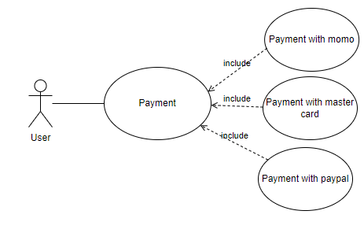

*Figure 40: UC User Payment*

|  |  |  |  |
| --- | --- | --- | --- |
| **USE CASE - USER_11** | | | |
| **Use Case No.** | USER_11 | **Use Case Version** | 2.0 |
| **Use Case Name** | Payment | | |
| **Author** | ThanhDat | | |
| **Date** | 20/06/2021 | **Priority** | Normal |
| **Actor:**   * The user.   **Summary:**   * Allows users pay the order when purchase items.   **Goal:**   * The users pay the orders successfully.   **Triggers:**   * The user put the items on the cart then they will pay it .   **Preconditions:**   * There is at least 1 item in the cart.   **Post Conditions:**   * **Success:** The product is purchased & completed payment. * **Fail**: System show error messages.   **Main Success Scenario:**   |  |  |  | | --- | --- | --- | | **Step** | **Actor Action** | **System Response** | | 1 | The users add items to cart | The cart appears items just add | | 2 | The user click Check out button | The check out display | | 3 | The user enter address, phone number | The information just enter will display on each box | | 4 | The users can click Place Order button or PayPal to payment | The system appears the successful alert & send email confirm to user |   **Alternative Scenario:** N/A  **Exceptions:**   |  |  |  | | --- | --- | --- | | **No** | **Cause** | **System Response** | | 1 |  | The system shows the message Please check your internet connection when the internet is lost. | | 2 | Cart is empty |  |   **Relationships:** N/A.  **Business Rules:**   * Must successfully purchase at least one product. | | | |

*Table 26: <User> Payment*

* + - 1. **Admin**
         1. **<Admin > Login**

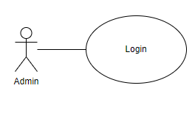

*Figure 41: UC Admin Login*

|  |  |  |  |
| --- | --- | --- | --- |
| **USE CASE - ADMIN_01** | | | |
| **Use Case No.** | ADMIN_01 | **Use Case Version** | 2.0 |
| **Use Case Name** | Login | | |
| **Author** | ThanhHoai | | |
| **Date** | 20/06/2021 | **Priority** | Normal |
| **Actor:**   * The admin.   **Summary:**   * Allows the admin to login to the system.   **Goal:**   * The admin can login to the system.   **Triggers:**   * The admin clicks Login button on the login screen.   **Preconditions:**   * The admin needs to enter the correct password & id number   **Post Conditions:**   * **Success:** The admin is redirected to the home screen. * **Fail**: System show error messages.   **Main Success Scenario:**   |  |  |  | | --- | --- | --- | | **Step** | **Actor Action** | **System Response** | | 1 | The admin needs access to the login page | The login page is displayed | | 2 | The admin enters the id & password | The id & password is displayed of each the textbox | | 3 | The admin clicks on the Login button | The home screen is displayed |   **Alternative Scenario:** N/A  **Exceptions:**   |  |  |  | | --- | --- | --- | | **No** | **Cause** | **System Response** | | 1 | The internet is lost | The system shows the message Please! Check your internet connection | | 2 | Any box is empty | The system shows the message  Please! Fill in your full information |   **Relationships:** N/A  **Business Rules:**   * Email: must not be empty * Password: must not be empty | | | |

*Table 27: <Admin> Login*

* + - * 1. **<Admin> Logout**

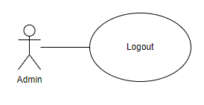

*Figure 42: UC Admin Logout*

|  |  |  |  |
| --- | --- | --- | --- |
| **USE CASE - ADMIN_02** | | | |
| **Use Case No.** | ADMIN_02 | **Use Case Version** | 2.0 |
| **Use Case Name** | Logout | | |
| **Author** | ThanhHoai | | |
| **Date** | 20/06/2021 | **Priority** | Normal |
| **Actor:**   * The admin.   **Summary:**   * Allows the admin to log out to the system.   **Goal:**   * The admin can log out to the system.   **Triggers:**   * The admin clicks Logout button on the any screen.   **Preconditions:**   * The admin logged into the system successfully.   **Post Conditions:**   * **Success:** The admin logout to the system successfully. * **Fail**: System show error messages.   **Main Success Scenario:**   |  |  |  | | --- | --- | --- | | **Step** | **Actor Action** | **System Response** | | 1 | The admin clicks on the Log out button | The login screen is displayed |   **Alternative Scenario:** N/A  **Exceptions:**   |  |  |  | | --- | --- | --- | | **No** | **Cause** | **System Response** | | 1 | The internet is lost | The system shows the message Please! Check your internet connection |   **Relationships:** N/A  **Business Rules: N/A** | | | |

*Table 28: <Admin> Logout*

* + - * 1. **<Admin> Add Category**

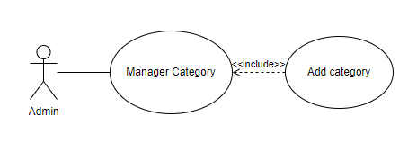

*Figure 43: UC Admin Add Category*

|  |  |  |  |
| --- | --- | --- | --- |
| **USE CASE - ADMIN_03** | | | |
| **Use Case No.** | ADMIN_03 | **Use Case Version** | 2.0 |
| **Use Case Name** | Add Category | | |
| **Author** | ThanhDat | | |
| **Date** | 20/06/2021 | **Priority** | Normal |
| **Actor:**   * The admin.   **Summary:**   * Allows the admin can create new category.   **Goal:**   * The admin creates new category on the system.   **Triggers:**   * The admin clicks the plus icon button on the category screen.   **Preconditions:**   * The admin logged into the system successfully.   **Post Conditions:**   * **Success:** The system will have the new category. * **Fail**: The system display error messages.   **Main Success Scenario:**   |  |  |  | | --- | --- | --- | | **Step** | **Actor Action** | **System Response** | | 1 | The admin clicks the Category button on the sidebar | The category screen is displayed | | 2 | The admin clicks the plus icon button on category screen | The creation popup is displayed | | 3 | The admin enters the information on a form |  | | 4 | The admin clicks on the OK button | The new category is created successfully |   **Alternative Scenario:** N/A  **Exceptions:**   |  |  |  | | --- | --- | --- | | **No** | **Cause** | **System Response** | | 1 | The internet is lost | The system shows the message Please! Check your internet connection | | 2 | This name already exists | The system shows the message  Name already exists | | 3 | Any box is empty | The system shows the message  Please! Fill in your full information |   **Relationships:** N/A  **Business Rules:**   * The length of character must not exceed 50 characters. | | | |

*Table 29: <Admin> Add Category*

* + - * 1. **<Administrator> Update Category**

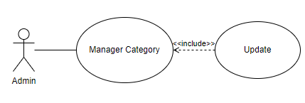

*Figure 44: UC Admin Update Category*

|  |  |  |  |
| --- | --- | --- | --- |
| **USE CASE - ADMIN_04** | | | |
| **Use Case No.** | ADMIN_04 | **Use Case Version** | 2.0 |
| **Use Case Name** | Update Category | | |
| **Author** | ThanhDat | | |
| **Date** | 20/06/2021 | **Priority** | Normal |
| **Actor:**   * The admin.   **Summary:**   * Allows the admin can update category.   **Goal:**   * The admin updates category on the system.   **Triggers:**   * The admin clicks the update icon button on the category screen.   **Preconditions:**   * The admin logged into the system successfully.   **Post Conditions:**   * **Success:** The system will update the category. * **Fail**: The system display error messages.   **Main Success Scenario:**   |  |  |  | | --- | --- | --- | | **Step** | **Actor Action** | **System Response** | | 1 | The admin clicks the Category button on the sidebar | The category screen is displayed | | 2 | The admin clicks the edit icon button on category screen | The update popup is displayed | | 3 | The admin enters the information to update on a form |  | | 4 | The admin clicks on the OK button | The category is updated successfully |   **Alternative Scenario:** N/A  **Exceptions:**   |  |  |  | | --- | --- | --- | | **No** | **Cause** | **System Response** | | 1 | The internet is lost | The system shows the message Please! Check your internet connection | | 2 | This name already exists | The system shows the message  Name already exists | | 3 | Any box is empty | The system shows the message  Please! Fill in your full information |   **Relationships:** N/A  **Business Rules:**   * The length of the character must not exceed 50 characters. | | | |

*Table 30: <Admin> Update Category*

* + - * 1. **<Admin> Block Category**

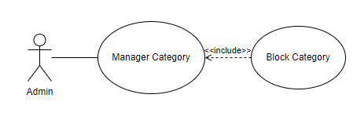

*Figure 45: UC Admin Block Category*

|  |  |  |  |
| --- | --- | --- | --- |
| **USE CASE - ADMIN_05** | | | |
| **Use Case No.** | ADMIN_05 | **Use Case Version** | 2.0 |
| **Use Case Name** | Block Category | | |
| **Author** | ThanhDat | | |
| **Date** | 20/06/2021 | **Priority** | Normal |
| **Actor:**   * The admin.   **Summary:**   * Allows the admin can block category.   **Goal:**   * The admin block category on the system.   **Triggers:**   * The admin clicks the selection active button on the category screen.   **Preconditions:**   * The admin logged into the system successfully.   **Post Conditions:**   * **Success:** The system will block the category. * **Fail**: The system display error messages.   **Main Success Scenario:**   |  |  |  | | --- | --- | --- | | **Step** | **Actor Action** | **System Response** | | 1 | The admin clicks the Category button on the sidebar | The category screen is displayed | | 2 | The admin clicks the selection active button and chose a UnActive. | The block popup is displayed | | 3 | The admin clicks on the OK button | The category block successfully |   **Alternative Scenario:** N/A  **Exceptions:**   |  |  |  | | --- | --- | --- | | **No** | **Cause** | **System Response** | | 1 | The internet is lost | The system shows the message Please! Check your internet connection |   **Relationships:** N/A  **Business Rules:**   * The length of character must not exceed 50 characters. | | | |

*Table 31: <Admin> Block Category*

* + - * 1. **<Admin> Unblock Category**

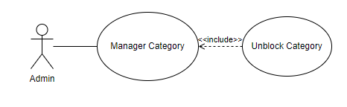

*Figure 46: UC Admin Unblock Category*

|  |  |  |  |
| --- | --- | --- | --- |
| **USE CASE - ADMIN_05** | | | |
| **Use Case No.** | ADMIN_05 | **Use Case Version** | 2.0 |
| **Use Case Name** | Unblock Category | | |
| **Author** | ThanhDat | | |
| **Date** | 20/06/2021 | **Priority** | Normal |
| **Actor:**   * The admin.   **Summary:**   * Allows the admin can unblock category.   **Goal:**   * The admin unblock category on the system.   **Triggers:**   * The admin clicks the selection Unactive button on the category screen.   **Preconditions:**   * The admin logged into the system successfully.   **Post Conditions:**   * **Success:** The system will unblock the category. * **Fail**: The system display error messages.   **Main Success Scenario:**   |  |  |  | | --- | --- | --- | | **Step** | **Actor Action** | **System Response** | | 1 | The admin clicks the Category button on the sidebar | The category screen is displayed | | 2 | The admin clicks the selection active button and chose anActive. | The unblock popup is displayed | | 3 | The admin clicks on the OK button | The category block successfully |   **Alternative Scenario:** N/A  **Exceptions:**   |  |  |  | | --- | --- | --- | | **No** | **Cause** | **System Response** | | 1 | The internet is lost | The system shows the message Please! Check your internet connection |   **Relationships:** N/A  **Business Rules:**   * The length of character must not exceed 50 characters. | | | |

*Table 32: <Admin > unblock Category*

* + - * 1. **<Admin> Add Product**

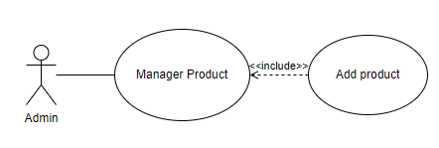

*Figure 47: UC Admin Add Product*

|  |  |  |  |
| --- | --- | --- | --- |
| **USE CASE - ADMIN_07** | | | |
| **Use Case No.** | ADMIN_07 | **Use Case Version** | 2.0 |
| **Use Case Name** | Add Product | | |
| **Author** | ThanhHoai | | |
| **Date** | 20/06/2021 | **Priority** | Normal |
| **Actor:**   * The admin.   **Summary:**   * Allows the admin can create new product.   **Goal:**   * The admin creates new product on the system.   **Triggers:**   * The admin clicks the plus icon button on the product screen.   **Preconditions:**   * The admin logged into the system successfully.   **Post Conditions:**   * **Success:** The system will have the new product. * **Fail**: The system display error messages.   **Main Success Scenario:**   |  |  |  | | --- | --- | --- | | **Step** | **Actor Action** | **System Response** | | 1 | The admin clicks the Product button on the sidebar | The product screen is displayed | | 2 | The admin clicks the plus icon button on product screen | The creation popup is displayed | | 3 | The admin enters the information on a form |  | | 4 | The admin clicks on the OK button | The new product is created successfully |   **Alternative Scenario:** N/A  **Exceptions:**   |  |  |  | | --- | --- | --- | | **No** | **Cause** | **System Response** | | 1 | The internet is lost | The system shows the message Please! Check your internet connection | | 2 | This name already exists | The system shows the message  Name already exists | | 3 | Any box is empty | The system shows the message  Please! Fill in your full information |   **Relationships:** N/A  **Business Rules:**   * The length of the character must not exceed 50 characters. | | | |

*Table 33: <Admin> Add Product*

* + - * 1. **<Admin> Update Product**

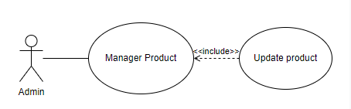

*Figure 48: UC Admin Update Product*

|  |  |  |  |
| --- | --- | --- | --- |
| **USE CASE - ADMIN_8** | | | |
| **Use Case No.** | ADMIN_8 | **Use Case Version** | 2.0 |
| **Use Case Name** | Update Product | | |
| **Author** | ThanhHoai | | |
| **Date** | 20/06/2021 | **Priority** | Normal |
| **Actor:**   * The admin.   **Summary:**   * Allows the admin can update product.   **Goal:**   * The admin updates product on the system.   **Triggers:**   * The admin clicks the edit icon button on the product screen.   **Preconditions:**   * The admin logged into the system successfully.   **Post Conditions:**   * **Success:** The system will update the product. * **Fail**: The system display error messages.   **Main Success Scenario:**   |  |  |  | | --- | --- | --- | | **Step** | **Actor Action** | **System Response** | | 1 | The admin clicks the Product button on the sidebar | The product screen is displayed | | 2 | The admin clicks the edit icon button on product screen | The update popup is displayed | | 3 | The admin enters the information to update on a form |  | | 4 | The admin clicks on the OK button | The product is updated successfully |   **Alternative Scenario:** N/A  **Exceptions:**   |  |  |  | | --- | --- | --- | | **No** | **Cause** | **System Response** | | 1 | The internet is lost | The system shows the message Please! Check your internet connection | | 2 | This name already exists | The system shows the message  Name already exists | | 3 | Any box is empty | The system shows the message  Please! Fill in your full information |   **Relationships:** N/A  **Business Rules:**   * The length of the character must not exceed 50 characters. | | | |

*Table 34: <Admin> Update Product*

* + - * 1. **<Admin> Block Product**

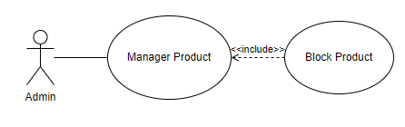

*Figure 49: UC Admin Block Product*

|  |  |  |  |
| --- | --- | --- | --- |
| **USE CASE - ADMIN_09** | | | |
| **Use Case No.** | ADMIN_05 | **Use Case Version** | 2.0 |
| **Use Case Name** | Block Product | | |
| **Author** | ThanhHoai | | |
| **Date** | 20/06/2021 | **Priority** | Normal |
| **Actor:**   * The admin.   **Summary:**   * Allows the admin can block product.   **Goal:**   * The admin block product on the system.   **Triggers:**   * The admin clicks the selection active button on the product screen.   **Preconditions:**   * The admin logged into the system successfully.   **Post Conditions:**   * **Success:** The system will block the produt. * **Fail**: The system display error messages.   **Main Success Scenario:**   |  |  |  | | --- | --- | --- | | **Step** | **Actor Action** | **System Response** | | 1 | The admin clicks the Product button on the sidebar | The product screen is displayed | | 2 | The admin clicks the selection active button and chose a UnActive. | The block popup is displayed | | 3 | The admin clicks on the OK button | The product block successfully |   **Alternative Scenario:** N/A  **Exceptions:**   |  |  |  | | --- | --- | --- | | **No** | **Cause** | **System Response** | | 1 | The internet is lost | The system shows the message Please! Check your internet connection |   **Relationships:** N/A  **Business Rules:**The length of character must not exceed 50 characters. | | | |

*Table 35: <Admin> Block product*

* + - * 1. **<Admin> Unblock Product**

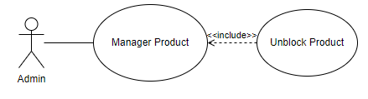

*Figure 50: UC Admin Unblock Product*

|  |  |  |  |
| --- | --- | --- | --- |
| **USE CASE - ADMIN_10** | | | |
| **Use Case No.** | ADMIN_10 | **Use Case Version** | 2.0 |
| **Use Case Name** | Unblock Product | | |
| **Author** | ThanhHoai | | |
| **Date** | 20/06/2021 | **Priority** | Normal |
| **Actor:**   * The admin.   **Summary:**   * Allows the admin can unblock product.   **Goal:**   * The admin unblock product on the system.   **Triggers:**   * The admin clicks the selection Unactive button on the product screen.   **Preconditions:**   * The admin logged into the system successfully.   **Post Conditions:**   * **Success:** The system will unblock the product. * **Fail**: The system display error messages.   **Main Success Scenario:**   |  |  |  | | --- | --- | --- | | **Step** | **Actor Action** | **System Response** | | 1 | The admin clicks the product button on the sidebar | The product screen is displayed | | 2 | The admin clicks the selection active button and chose anActive. | The unblock popup is displayed | | 3 | The admin clicks on the OK button | The product block successfully |   **Alternative Scenario:** N/A  **Exceptions:**   |  |  |  | | --- | --- | --- | | **No** | **Cause** | **System Response** | | 1 | The internet is lost | The system shows the message Please! Check your internet connection |   **Relationships:** N/A  **Business Rules:**   * The length of character must not exceed 50 characters. | | | |

*Table 36: <Admin> Unblock Product*

* + - * 1. **<Admin> Import Goods**

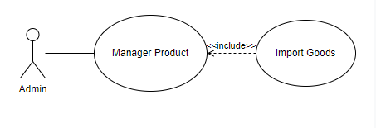

*Figure 51: UC Admin Import Goods*

|  |  |  |  |
| --- | --- | --- | --- |
| **USE CASE - ADMIN_11** | | | |
| **Use Case No.** | ADMIN_11 | **Use Case Version** | 2.0 |
| **Use Case Name** | Import Goods | | |
| **Author** | ThanhHoai | | |
| **Date** | 20/06/2021 | **Priority** | Normal |
| **Actor:**   * The admin.   **Summary:**   * Allows the admin can add more product quantity.   **Goal:**   * The admin adds more product quantity on the system.   **Triggers:**   * The admin clicks the plus icon button on the warehouse screen.   **Preconditions:**   * The admin logged into the system successfully.   **Post Conditions:**   * **Success:** The system will have more product quantity. * **Fail**: The system display error messages.   **Main Success Scenario:**   |  |  |  | | --- | --- | --- | | **Step** | **Actor Action** | **System Response** | | 1 | The admin clicks the Warehouse button on the sidebar | The Warehouse screen is displayed | | 2 | The admin clicks the plus icon button on warehouse screen | The add popup is displayed | | 3 | The admin enters to add the quantity |  | | 4 | The admin clicks on the OK button | The more products is added successfully |   **Alternative Scenario:** N/A  **Exceptions:**   |  |  |  | | --- | --- | --- | | **No** | **Cause** | **System Response** | | 1 | The internet is lost | The system shows the message Please! Check your internet connection | | 2 | This name already exists | The system shows the message  Name already exists | | 3 | Any box is empty | The system shows the message  Please! Fill in your full information |   **Relationships:** N/A  **Business Rules: N/A** | | | |

*Table 37: <Admin> Import Goods*

* + - * 1. **<Admin> Change Order Status**

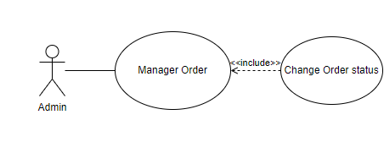

*Figure 52: UC Admin Change Order Status*

|  |  |  |  |
| --- | --- | --- | --- |
| **USE CASE - ADMIN_12** | | | |
| **Use Case No.** | ADMIN 12 | **Use Case Version** | 2.0 |
| **Use Case Name** | Change Order Status | | |
| **Author** | ThanhDat | | |
| **Date** | 20/06/2021 | **Priority** | Normal |
| **Actor:**   * The admin.   **Summary:**   * Allows the admin can change the order.   **Goal:**   * The admin changes the order on the system.   **Triggers:**   * The admin clicks the Show button on the order screen.   **Preconditions:**   * The admin logged into the system successfully.   **Post Conditions:**   * **Success:** The system will change the order. * **Fail**: The system show error messages.   **Main Success Scenario:**   |  |  |  | | --- | --- | --- | | **Step** | **Actor Action** | **System Response** | | 1 | The admin clicks the Order button on the sidebar | The order screen is displayed | | 2 | The admin clicks the show button on order screen | The toggling is displayed | | 3 | The admin switch status |  | | 4 | The admin clicks on the Accept button | The status of order is changed successfully |   **Alternative Scenario:** N/A  **Exceptions:**   |  |  |  | | --- | --- | --- | | **No** | **Cause** | **System Response** | | 1 | The internet is lost | The system shows the message Please! Check your internet connection |   **Relationships:** N/A  **Business Rules:**   * The length of the character must not exceed 50 characters. | | | |

*Table 38: <Admin> Change Order Status*

* + - * 1. **<Admin> Delete Order**

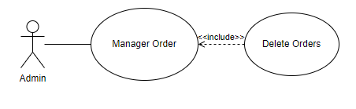

*Figure 53: UC Admin Delete Order*

|  |  |  |  |
| --- | --- | --- | --- |
| **USE CASE - ADMIN_13** | | | |
| **Use Case No.** | ADMIN_13 | **Use Case Version** | 2.0 |
| **Use Case Name** | Delete Order | | |
| **Author** | ThanhDat | | |
| **Date** | 20/06/2021 | **Priority** | Normal |
| **Actor:**   * The admin.   **Summary:**   * Allows the admin can delete the order.   **Goal:**   * The admin deletes order on the system.   **Triggers:**   * The admin clicks the delete icon button in the toggling at the order screen.   **Preconditions:**   * The admin logged into the system successfully.   **Post Conditions:**   * **Success:** The system will delete the order. * **Fail**: The system show error messages.   **Main Success Scenario:**   |  |  |  | | --- | --- | --- | | **Step** | **Actor Action** | **System Response** | | 1 | The admin clicks the Order button on the sidebar | The order screen is displayed | | 2 | The admin clicks the Show button on right of each the order | The toggling is displayed | | 2 | The admin clicks the delete icon button below | The delete popup is dispalyed | | 3 | The admin clicks on the OK button | The order deleted successfully |   **Alternative Scenario:** N/A  **Exceptions:**   |  |  |  | | --- | --- | --- | | **No** | **Cause** | **System Response** | | 1 | The internet is lost | The system shows the message Please! Check your internet connection |   **Relationships:** N/A  **Business Rules:**   * The length of character must not exceed 50 characters. | | | |

*Table 39: <Admin> Delete Order*

* + - * 1. **<Admin> View Detailed Order**

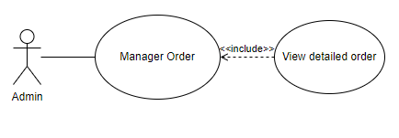

*Figure 54: UC View detailed order*

|  |  |  |  |
| --- | --- | --- | --- |
| **USE CASE - ADMIN_14** | | | |
| **Use Case No.** | ADMIN_14 | **Use Case Version** | 2.0 |
| **Use Case Name** | View Detailed Order | | |
| **Author** | ThanhDat | | |
| **Date** | 20/06/2021 | **Priority** | Normal |
| **Actor:**   * The admin.   **Summary:**   * Allows the admin can view the detailed Order.   **Goal:**   * The admin views the detailed Order.   **Triggers:**   * The admin clicks the Orders on the order screen..   **Preconditions:**   * The admin logged into the system successfully.   **Post Conditions:**   * **Success:** The system will view the statistical page. * **Fail**: The system show error messages.   **Main Success Scenario:**   |  |  |  | | --- | --- | --- | | **Step** | **Actor Action** | **System Response** | | 1 | The admin clicks the Orders on the screen | The detailed order screen is displayed |   **Alternative Scenario:** N/A  **Exceptions:**   |  |  |  | | --- | --- | --- | | **No** | **Cause** | **System Response** | | 1 | The internet is lost | The system shows the message Please! Check your internet connection |   **Relationships:** N/A  **Business Rules:**   * The length of the character must not exceed 50 characters. | | | |

*Table 40: <Admin> View Detailed Order.*

* + - * 1. **<Admin> View Statistical Page**

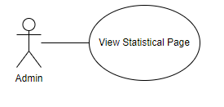

*Figure 55: UC View Statistical Page*

|  |  |  |  |
| --- | --- | --- | --- |
| **USE CASE - ADMIN_15** | | | |
| **Use Case No.** | ADMIN_15 | **Use Case Version** | 2.0 |
| **Use Case Name** | View Statistical Page | | |
| **Author** | ThanhDat | | |
| **Date** | 20/06/2021 | **Priority** | Normal |
| **Actor:**   * The admin.   **Summary:**   * Allows the admin can view the statistical page.   **Goal:**   * The admin views the statistical page.   **Triggers:**   * The admin clicks the Dashboard button on the home screen.   **Preconditions:**   * The admin logged into the system successfully.   **Post Conditions:**   * **Success:** The system will view the statistical page. * **Fail**: The system show error messages.   **Main Success Scenario:**   |  |  |  | | --- | --- | --- | | **Step** | **Actor Action** | **System Response** | | 1 | The admin clicks the Dashboard button on the sidebar | The home screen is displayed |   **Alternative Scenario:** N/A  **Exceptions:**   |  |  |  | | --- | --- | --- | | **No** | **Cause** | **System Response** | | 1 | The internet is lost | The system shows the message Please! Check your internet connection |   **Relationships:** N/A  **Business Rules:**   * The length of the character must not exceed 50 characters. | | | |

*Table 41: <Admin> View Statistical Page*

* + - * 1. **<Admin> Add Panel**

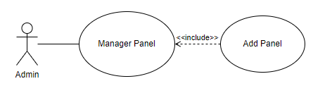

*Figure 56: UC Add Panel*

|  |  |  |  |
| --- | --- | --- | --- |
| **USE CASE - ADMIN_16** | | | |
| **Use Case No.** | ADMIN_16 | **Use Case Version** | 2.0 |
| **Use Case Name** | Add Panel | | |
| **Author** | ThanhHoai | | |
| **Date** | 20/06/2021 | **Priority** | Normal |
| **Actor:**   * The admin.   **Summary:**   * Allows the admin can add advertising panel.   **Goal:**   * The admin add advertising panel.   **Triggers:**   * The admin clicks the plus icon button on the Admin screen.   **Preconditions:**   * The admin logged into the system successfully.   **Post Conditions:**   * **Success:** The system will have the new product. * **Fail**: The system display error messages.   **Main Success Scenario:**   |  |  |  | | --- | --- | --- | | **Step** | **Actor Action** | **System Response** | | 1 | The admin clicks the plus icon button on Admin screen | The creation popup is displayed | | 2 | The admin insert panel in form |  | | 3 | The admin clicks on the OK button | The new panel is created successfully |   **Alternative Scenario:** N/A  **Exceptions:**   |  |  |  | | --- | --- | --- | | **No** | **Cause** | **System Response** | | 1 | The internet is lost | The system shows the message Please! Check your internet connection |   **Relationships:** N/A  **Business Rules:**   * The length of the character must not exceed 50 characters. | | | |

*Table 42: <Admin> View Add Panel*

* + - * 1. **<Admin> Delete Panel**

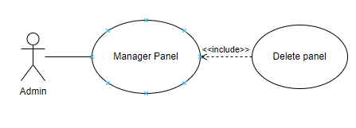

*Figure 82: UC Delete Panel*

|  |  |  |  |
| --- | --- | --- | --- |
| **USE CASE - ADMIN_17** | | | |
| **Use Case No.** | ADMIN_17 | **Use Case Version** | 2.0 |
| **Use Case Name** | Delete Panel | | |
| **Author** | ThanhHoai | | |
| **Date** | 20/06/2021 | **Priority** | Normal |
| **Actor:**   * The admin.   **Summary:**   * Allows the admin can delete advertising panel.   **Goal:**   * The admin delete advertising panel.   **Triggers:**   * The admin clicks the icon X of Panel on the Admin screen.   **Preconditions:**   * The admin logged into the system successfully.   **Post Conditions:**   * **Success:** The system will have the new product. * **Fail**: The system display error messages.   **Main Success Scenario:**   |  |  |  | | --- | --- | --- | | **Step** | **Actor Action** | **System Response** | | 1 | The admin clicks the icon X of Panel button on Admin screen | Display the question if you want to delete the panel | | 2 | The admin clicks on the OK button | The panel is delete successfully |   **Alternative Scenario:** N/A  **Exceptions:**   |  |  |  | | --- | --- | --- | | **No** | **Cause** | **System Response** | | 1 | The internet is lost | The system shows the message Please! Check your internet connection |   **Relationships:** N/A  **Business Rules:**   * The length of the character must not exceed 50 characters. | | | |

*Table 43: <Admin> Delete Panel*

* 1. **Non – Functional Requirements**
* Fast response time for logged in users, the average response time for logged in users after entering username and password as well as the page results displayed should not exceed five seconds and the maximum response time is fifteen seconds.
* Can be used by multiple users at the same time
* Usability, page makes user easy and enjoyable to use, efficient to use, easy to use and a consistent look and feel can help improve usability like Efficient to Use, Ease of Use, Best Interface shop
* Information security & Reliability, passwords are encrypted and saved straight to the database
* Performance requirements, this section lists the performance requirements to be expected from an online shopping cart application
  + User can add an item to cart in less than five seconds.
  + Users can view information about an item in less than 5 seconds.
  + User can check items in cart

**CHAPTER 4: SYSTEM DESIGN**

4. 1. **System architecture**

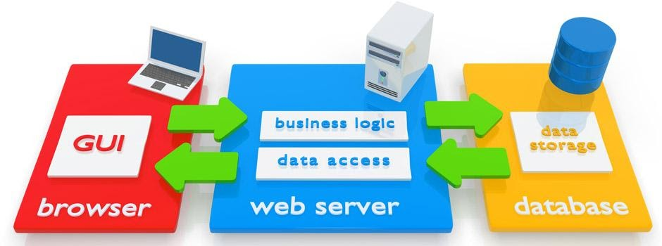

*Figure 57: Website Architecture*



*Figure 58: System architecture*

* 1. **Class Diagram**

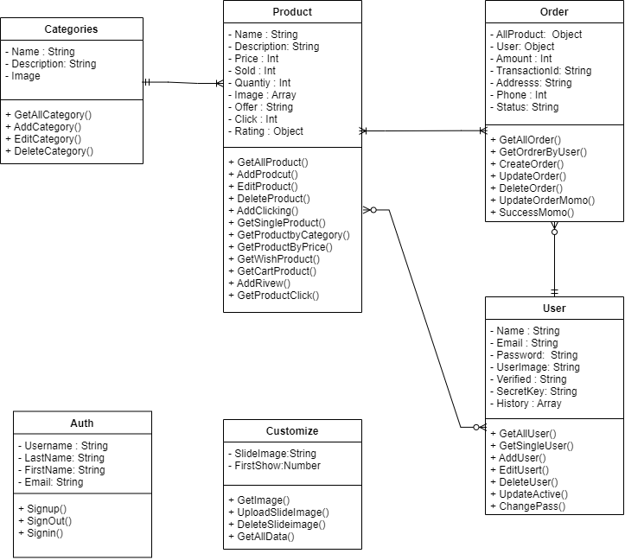

*Figure 59: Class Diagram*

* 1. **Sequence Diagram**

1. 3. 1. **<SD001> SearchProductByName**

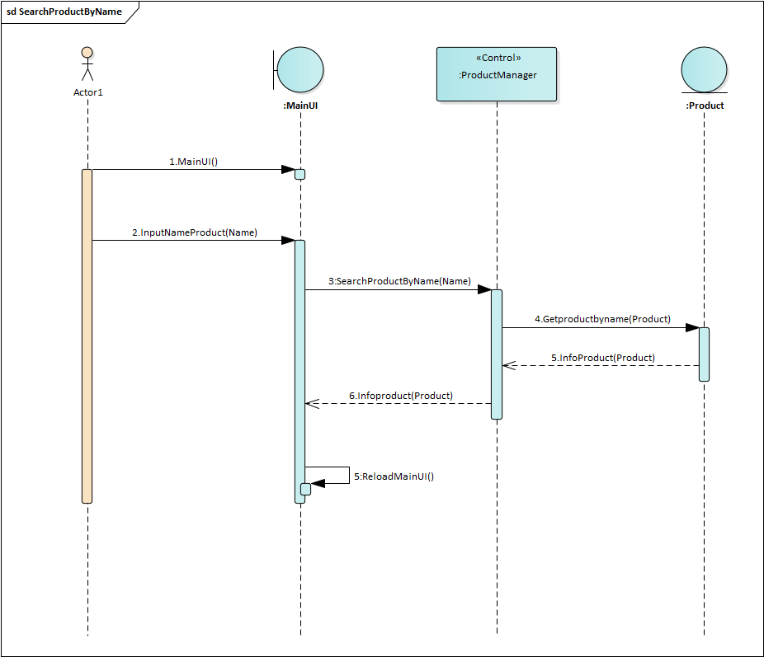

*Figure 60: SD SearchProductByName*

* + 1. **<SD002> Login**

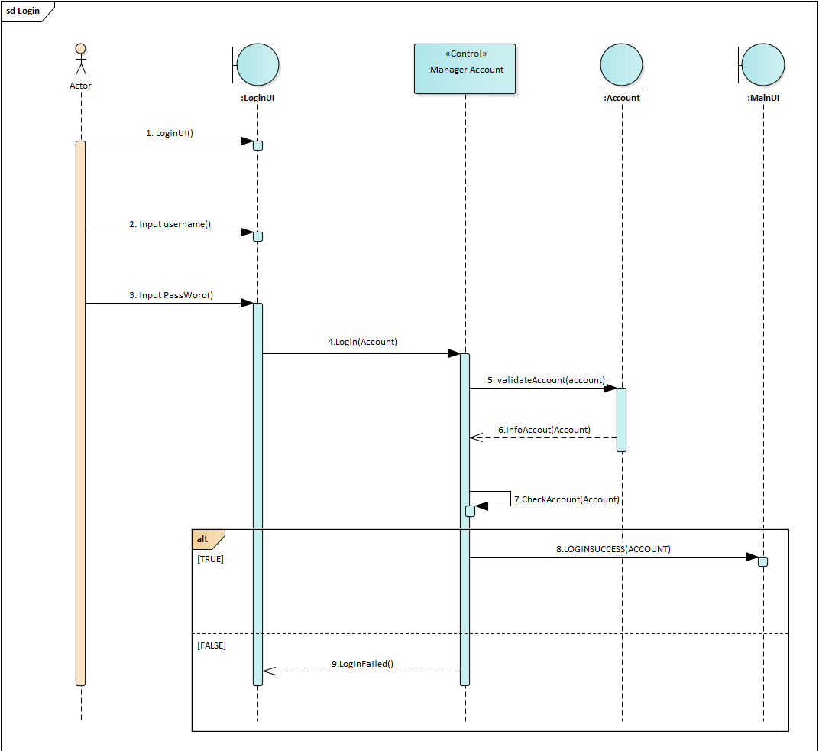

*Figure 61: SD Login*

* + 1. **<SD003> ViewDetailProduct**

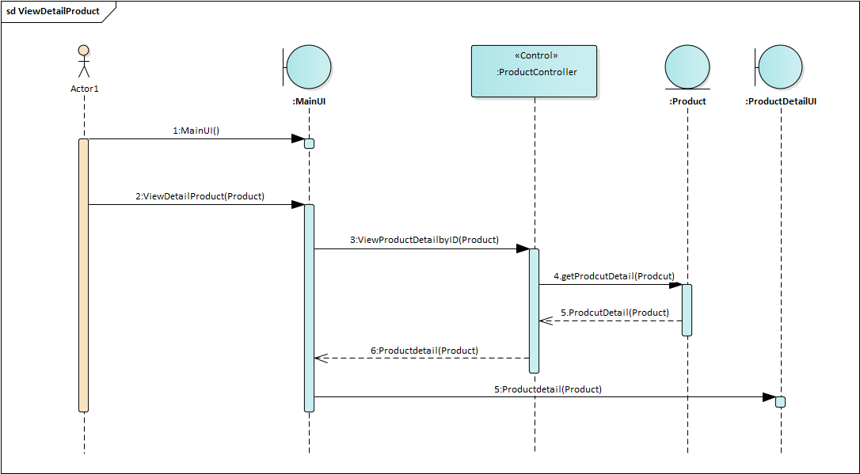

*Figure 62: SD ViewDetailProduct*

* + 1. **<SD004> Register**

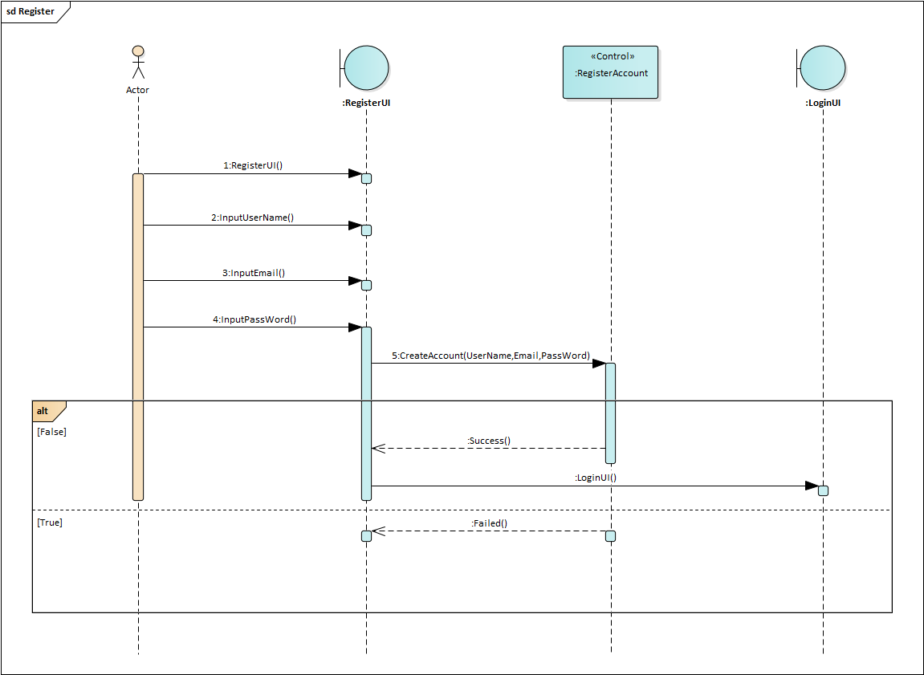

*Figure 63: SD Register*

* + 1. **<SD005> AddProductToCart**

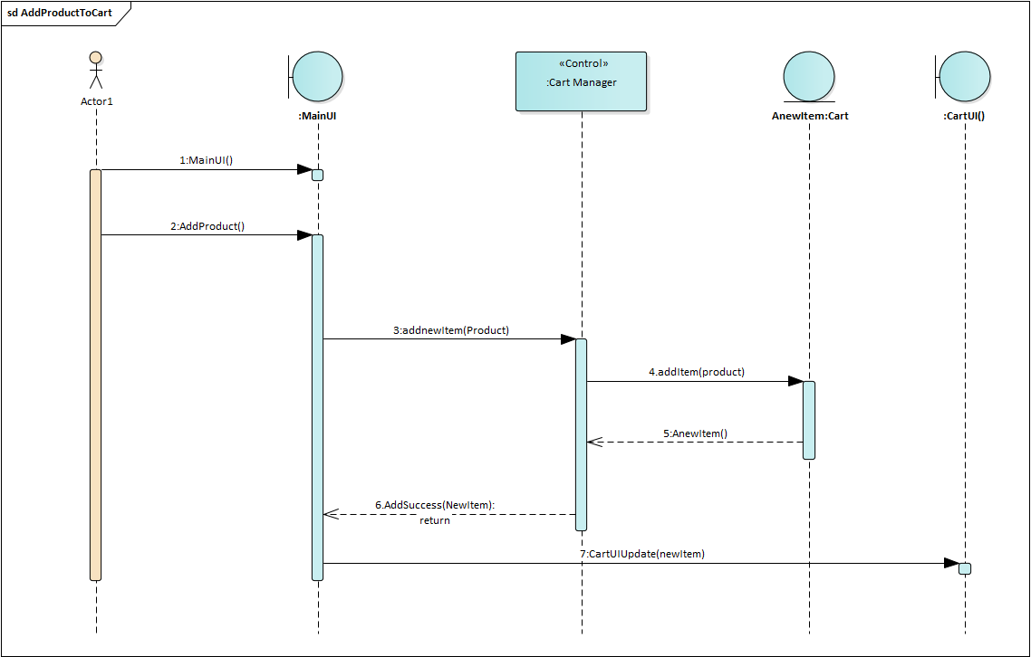

*Figure 64: SD AddproductToCart*

* + 1. **<SD006> ViewCart**

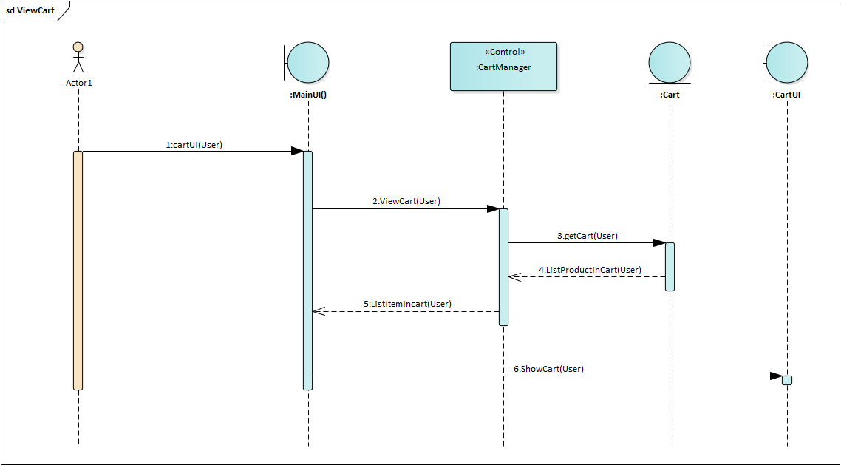

*Figure 65: SD ViewCart*

* + 1. **<SD007> ViewOrder**

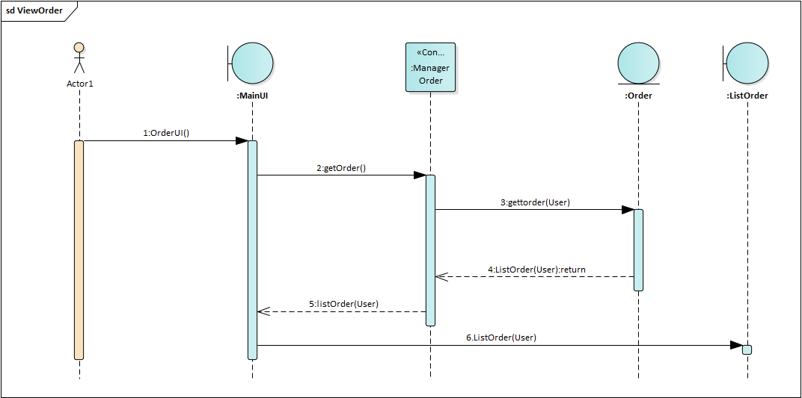

*Figure 66: SD ViewOrder*

* + 1. **<SD008> UpdateOrder**

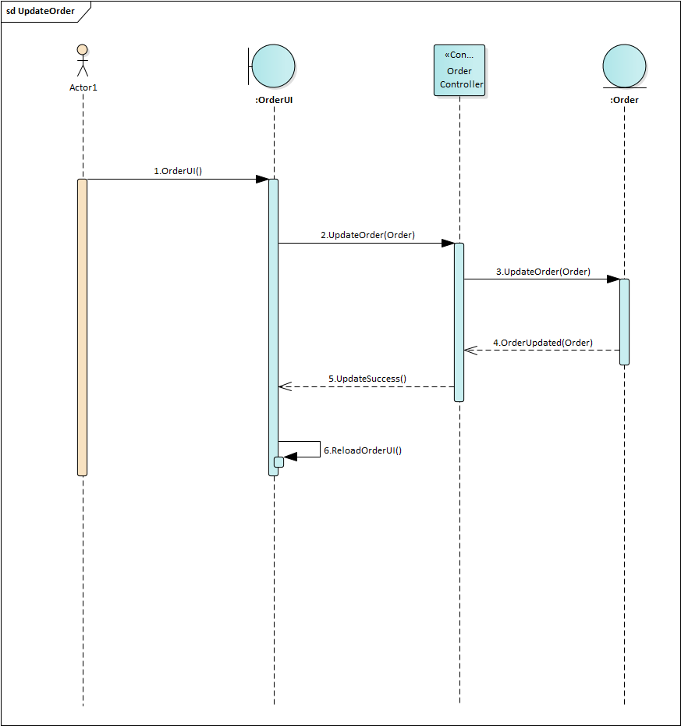

*Figure 67: SD UpdateOrder*

* + 1. **<SD009> DeleteProductInCart**

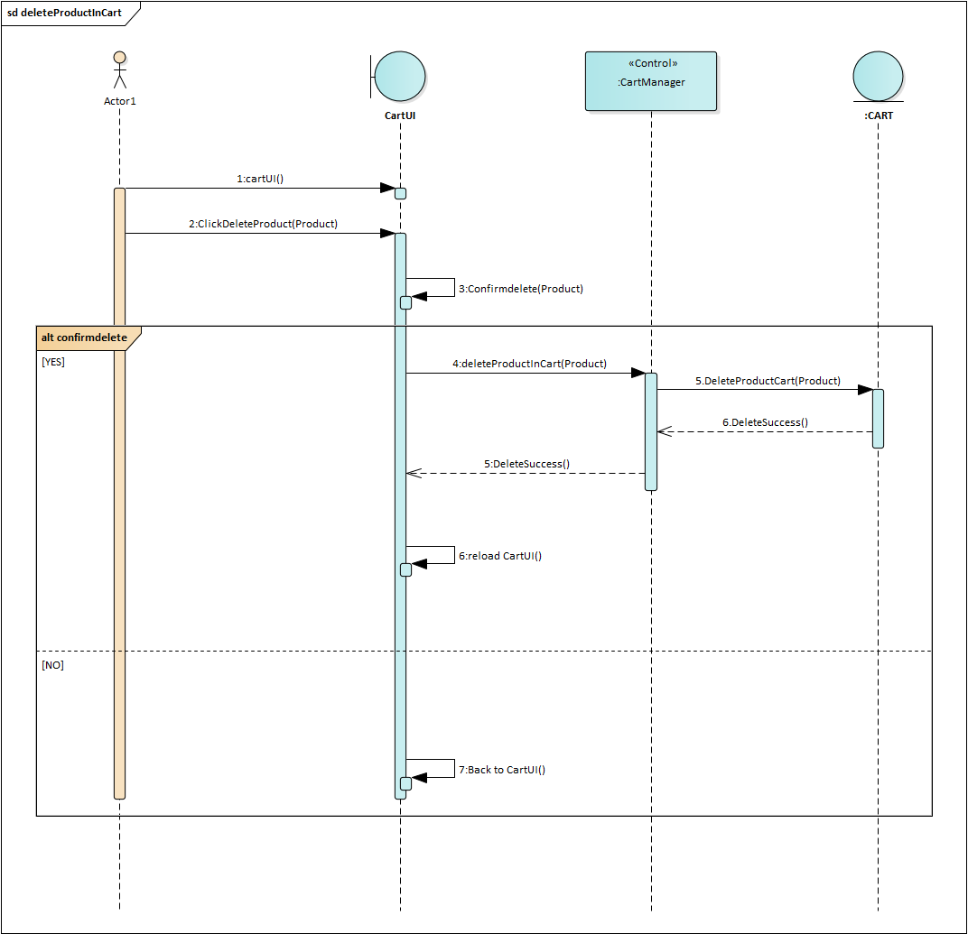

*Figure 68: SD DeleteProductInCart*

* + 1. **<SD010> ChangePassword**

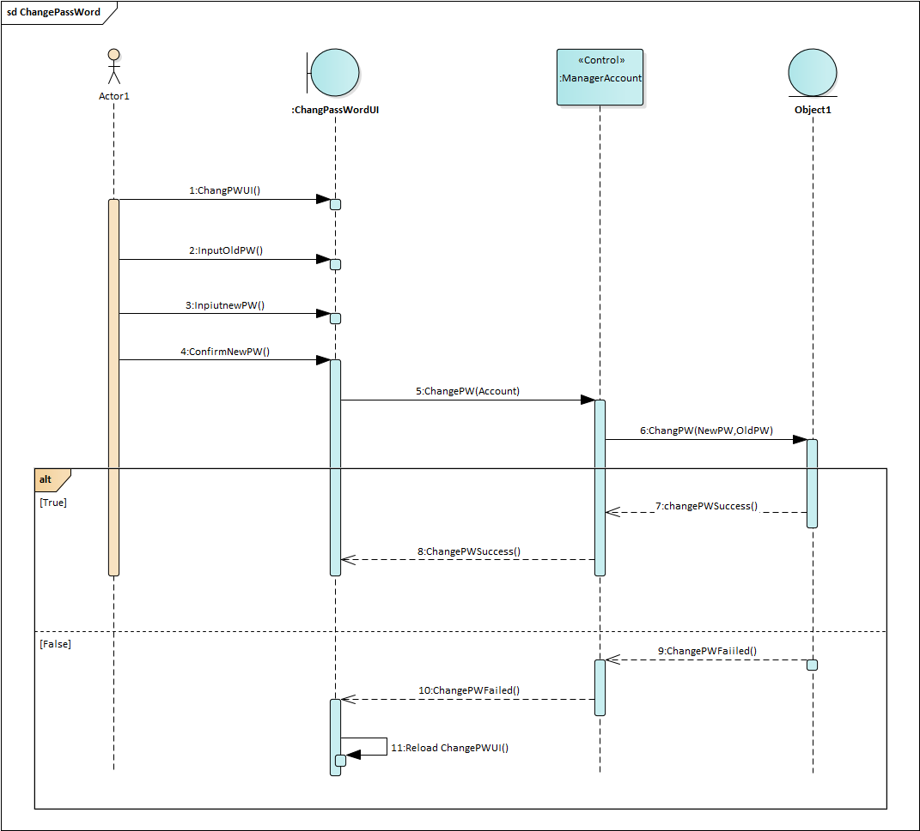

*Figure 69: SD ChangePassword*

* + 1. **<SD011> Payment**

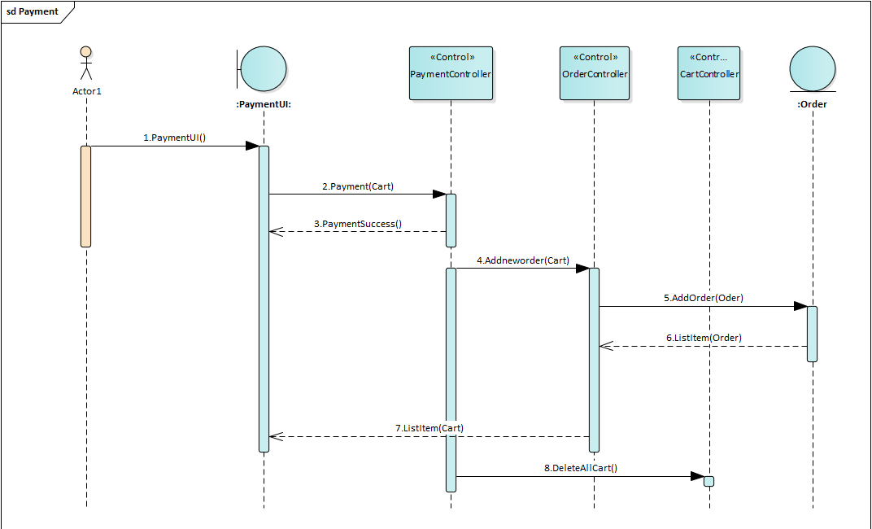

*Figure 70: SD Payment*

* + 1. **<SD012> ViewInfomationProfile**

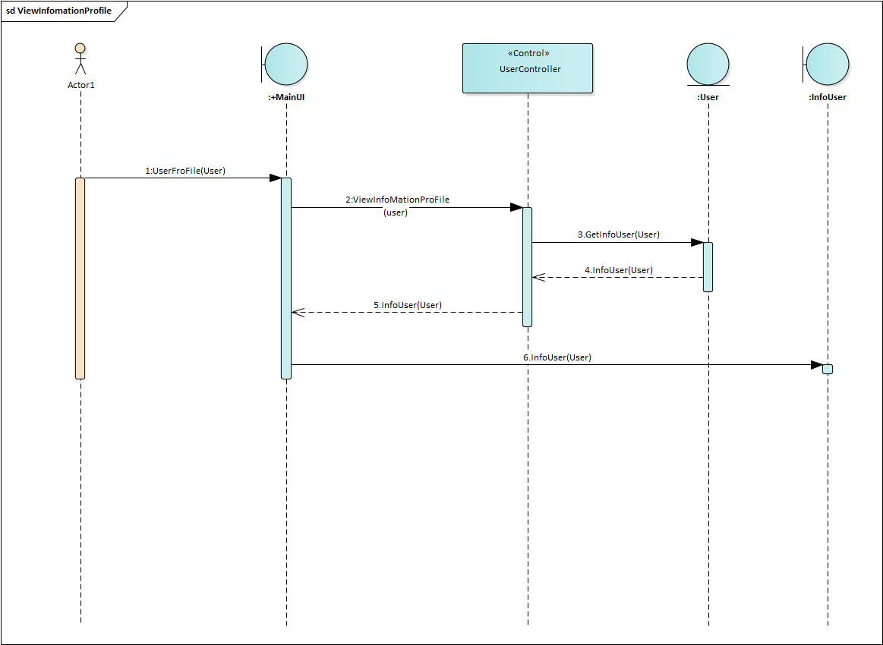

*Figure 71: SD ViewInformationProfile*

* + 1. **<SD013> DeleteCategory**

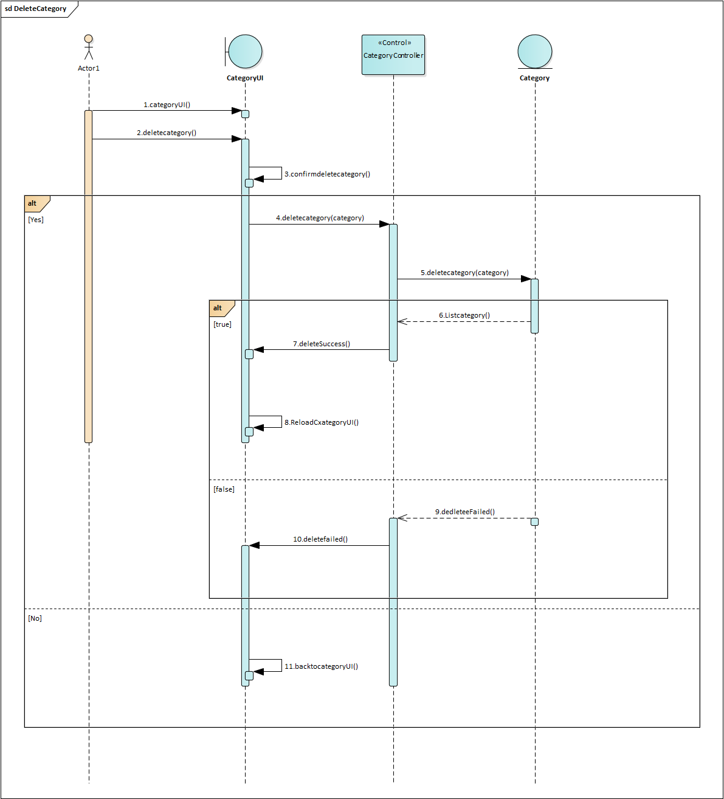

*Figure 72: SD DeleteCategory*

* + 1. **<SD014> AddProduct**

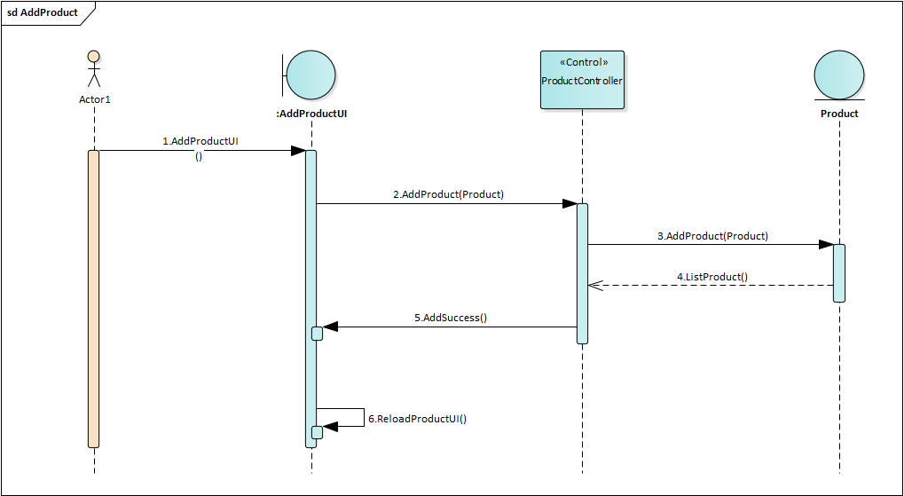

*Figure 73: SD AddProduct*

* + 1. **<SD015> DeleteProduct**

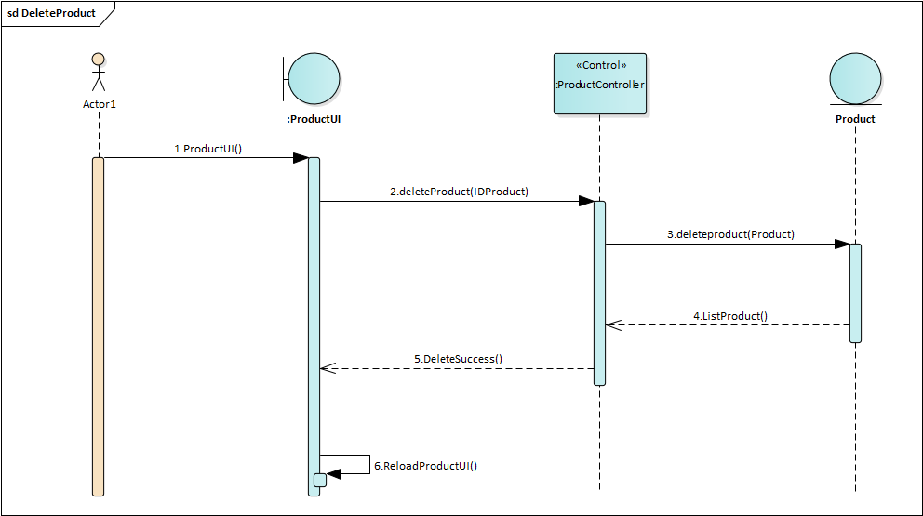

*Figure 74: SD DeleteProduct*

* + 1. **<SD016> UpdateProduct**

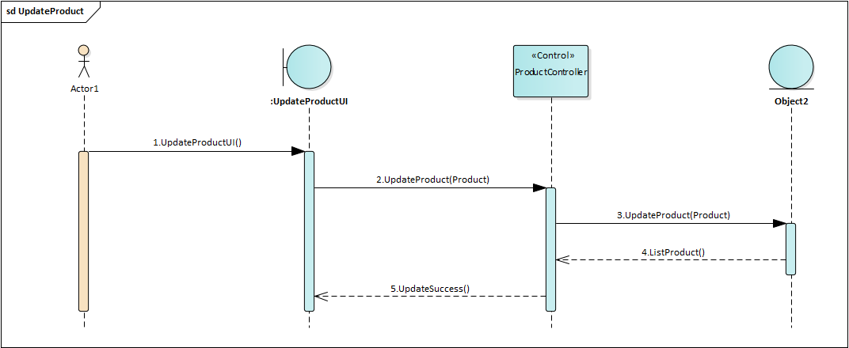

*Figure 75: SD UpdateProduct*

* + 1. **<SD017> AddCategory**

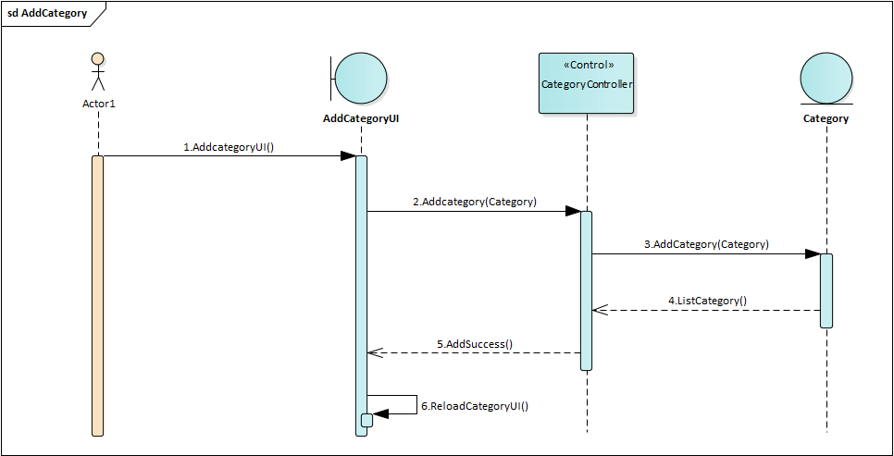

*Figure 76: SD AddCategory*

* + 1. **<SD018> UpdateCategory**

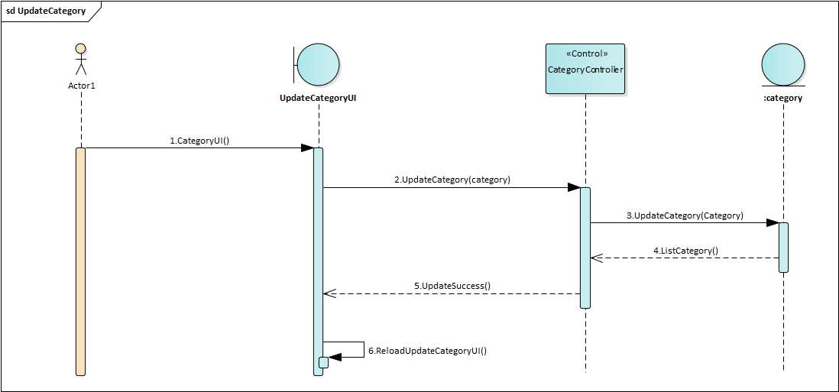

*Figure 77: SD UpdateCategory*

* + 1. **<SD019> UpdateInfomation**

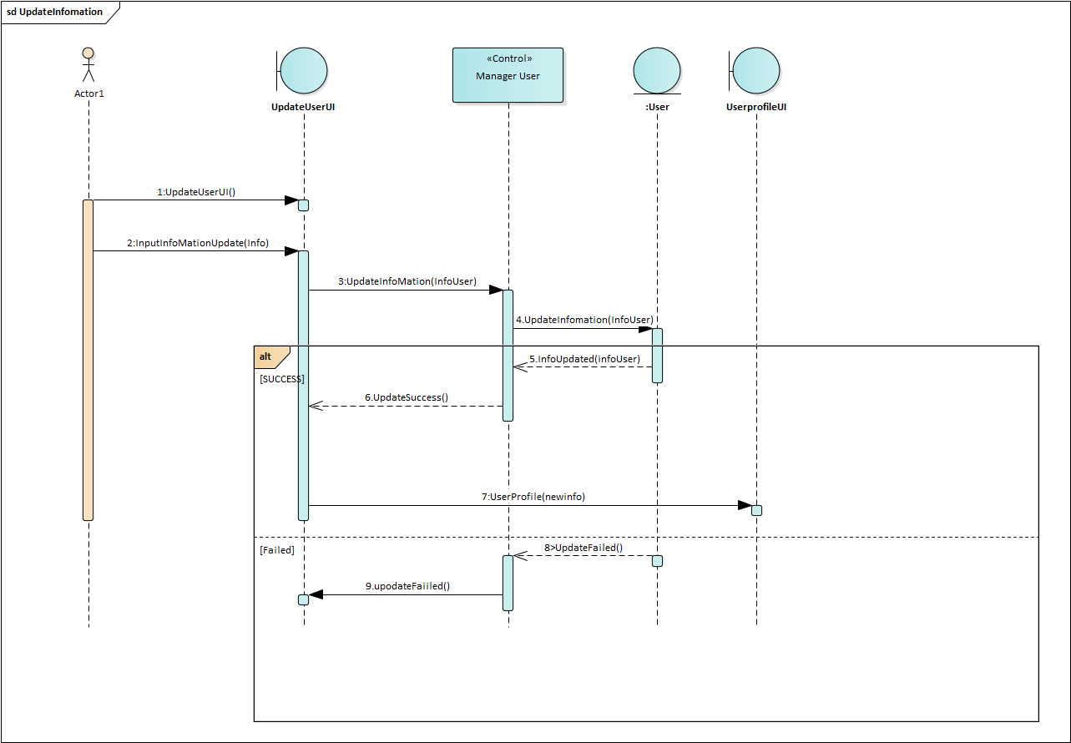

*Figure 78: SD UpdateInfomation*

* + 1. **<SD020> FilterByCategory**

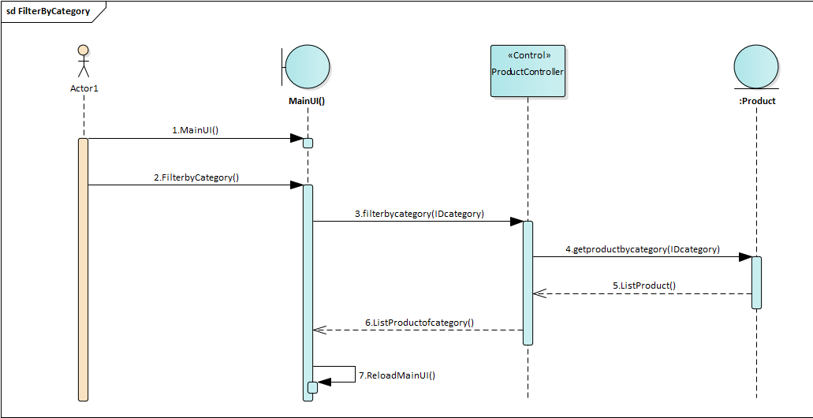

*Figure 79: SD FilterByCategory*

* + 1. **<SD021> FilterByPrice**

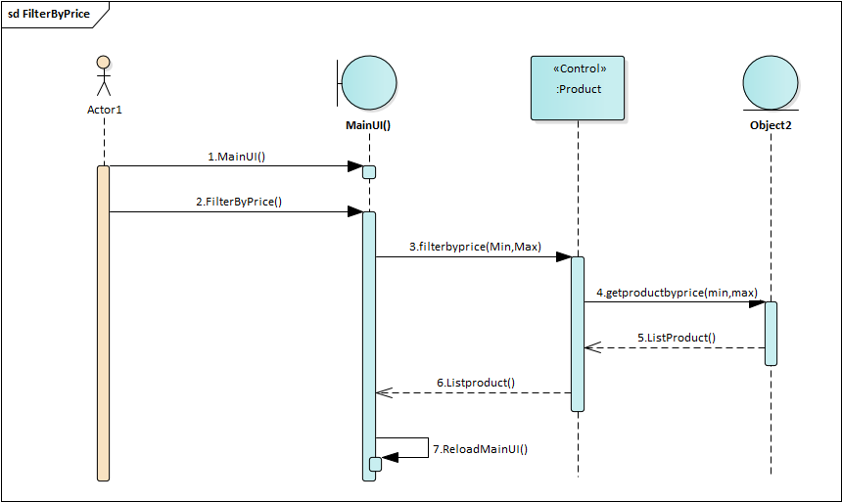

*Figure 80: SD FilterByPrice*

* 1. **Entity Relationship Diagram**
  2. 1. **ERD**

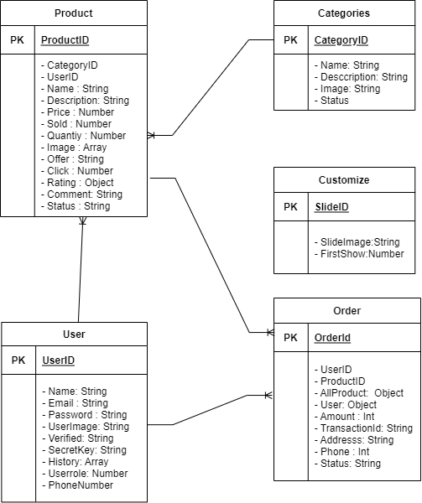

*Figure 81: Entity Relationship Diagram*

* + 1. **Database Description**
       1. **Product Table**

|  |  |  |  |
| --- | --- | --- | --- |
| **Ordinary numbers** | Attribute | Type | Descriptions |
| 1 | ProductId | String | Id of product |
| 2 | CategoryId | string | Id of category |
| 3 | UserId | String | Id of user |
| 4 | Name | String | Name of category |
| 5 | Price | Number | Price of product |
| 6 | Description | String | Description of product |
| 7 | Sold | Number | Quantity sold of product |
| 8 | Rating | Number | Rating of product |
| 9 | Quantity | Number | The total price of that product is purchased |
| 10 | Image | Array | Image of product |
| 11 | Comment | String | The product’s quantity review |
| 12 | Status | String | Status Active or Unactive of product |
| 13 | Offer | Number | Suggested price of product |

*Table 44: Product Table*

* + - 1. **User Table**

|  |  |  |  |
| --- | --- | --- | --- |
| **Ordinary numbers** | Attribute | Type | Descriptions |
| 1 | UserId | string | Id of user |
| 2 | Name | String | Name of user |
| 3 | Password | String | Password of user account |
| 4 | Email | String | Email of user |
| 5 | UserImage | String | Image profile of user |
| 6 | Userrole | String | Role of user |
| 7 | PhoneNumber | String | Phone number of user |
| 8 | SecretKey | String | SecretKey of User |
| 9 | History | Array | History of user in Website |
| 10 | Verified | String | Status of User |

*Table 45: User Table*

* + - 1. **Category Table**

|  |  |  |  |
| --- | --- | --- | --- |
| **Ordinary numbers** | Attribute | Type | Descriptions |
| 1 | CategoryId | string | Id of category |
| 2 | Name | String | Name of category |
| 3 | Description | String | Description of category |
| 4 | Image | String | Image of category |
| 5 | Status | String | Status of category |

*Table 46: Category Table*

* + - 1. **Order Table**

|  |  |  |  |
| --- | --- | --- | --- |
| **Ordinary numbers** | Attribute | Type | Descriptions |
| 1 | OrderId | string | Id of order |
| 2 | ProductId | String | Id of product |
| 3 | Amount | Number | Id of user |
| 4 | TransactionId | String | Id of transaction |
| 5 | Address | String | Delivery address |
| 6 | Phone | Number | Phone number of customers order |
| 9 | status | String | Status of  order |

*Table 47: Order Table*

* + - 1. **Customize Table**

|  |  |  |  |
| --- | --- | --- | --- |
| **Ordinary numbers** | Attribute | Type | Descriptions |
| 1 | SlideId | String | Id of Silde |
| 2 | SlideImage | String | Image of slide |
| 3 | FirstSlide | Number | Id of user |

*Table 48: Statistical Table*

* 1. **Activity Diagram**
  2. 1. **Activity Diagram Buy Product**



*Figure 82: Activity diagram - Buy Product*

* + 1. **Activity Diagram Check Order**



*Figure 83: Activity diagram – Check Order*

* + 1. **Activity Diagram Add Product**



*Figure 84: Activity diagram – Add Product*

* + 1. **Activity Diagram Update Product**



*Figure 85: Activity diagram – Update Product*

* + 1. **Activity Diagram Delete Product**



*Figure 86: Activity diagram – Delete Product*

* 1. **Screen Interface**

2. 1. 1. **Administrator Interface**
         1. **<AI001> Login Page**

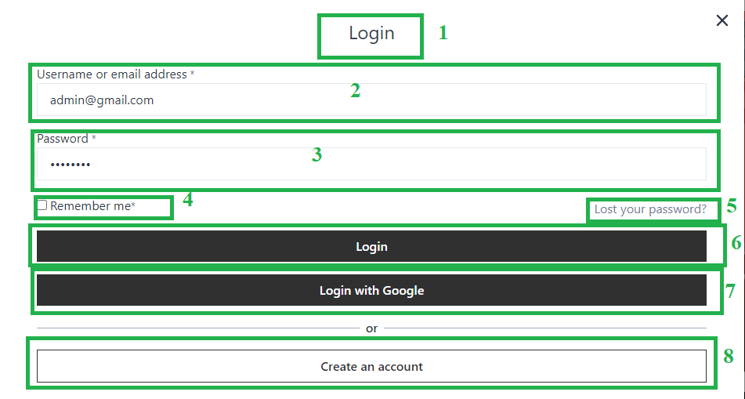

*Figure 87: Administrator - Login Page*

|  |  |  |  |
| --- | --- | --- | --- |
| **Ordinary numbers** | Name | Type | Descriptions |
| 1 | Title | Label | Display name of modal |
| 2 | User | Input | To enter user name |
| 3 | Password | Input | To enter password |
| 4 | Check Remember | Checkbox | Remember the password for next login |
| 5 | Lost your Password | Link | Forgot password |
| 6 | Login | Button | Login with Account |
| 7 | Login with google | Button | Login with google |
| 8 | Create Account | Button | Create new account |

*Table 49: <AI> Login Page*

* + - 1. **<AI002> Dashboard Page**

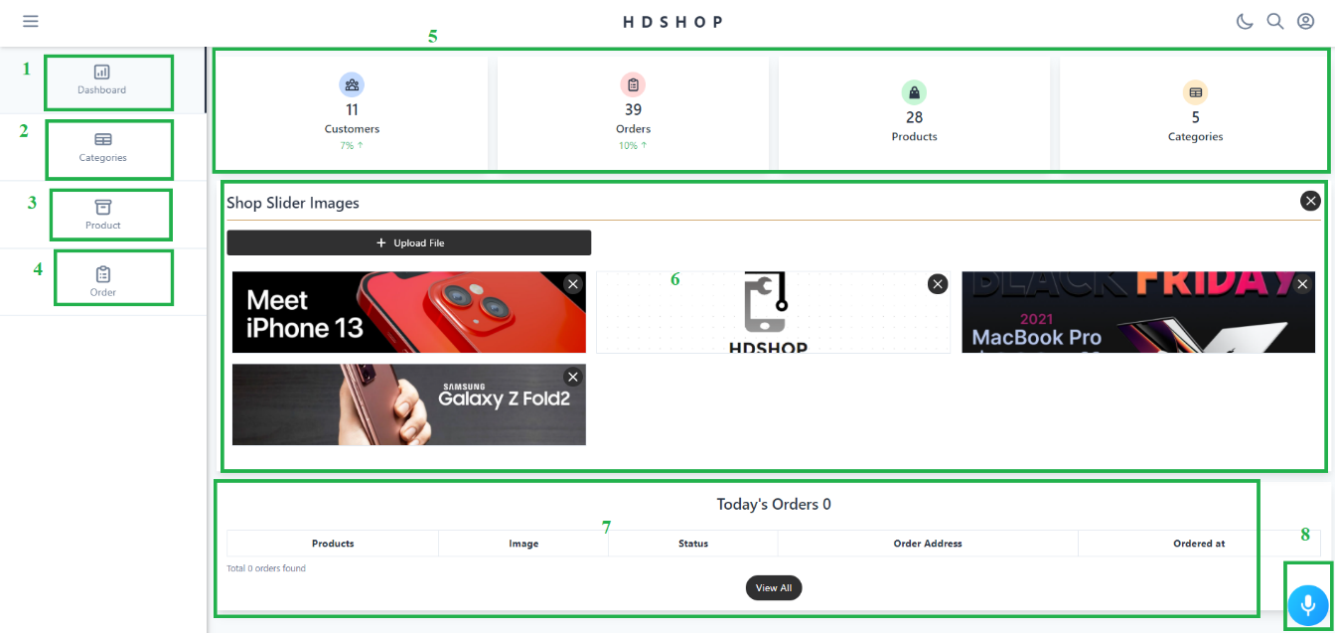

*Figure 88: Administrator - Dashboard Page*

|  |  |  |  |
| --- | --- | --- | --- |
| **Ordinary numbers** | Name | Type | Descriptions |
| 1 | Dashborad | Link | Click on it to dashboard screen display |
| 2 | Category | Link | Click on it to category screen display |
| 3 | Prodcut | Link | Click on it to product screen display |
| 4 | Order | Link | Click on it to Order screen display |
| 5 | Statistics | Table | Page statistics |
| 6 | Slide Panel | Button | Add or delete Slilde of advertisement panel |
| 7 | Statistics today | Table | Statistics all order today |
| 8 | Voice assistant | Button | Click on it to use voice assistant |

*Table 50: <AI> Dashboard Page*

* + - 1. **<AI003> Category Page**

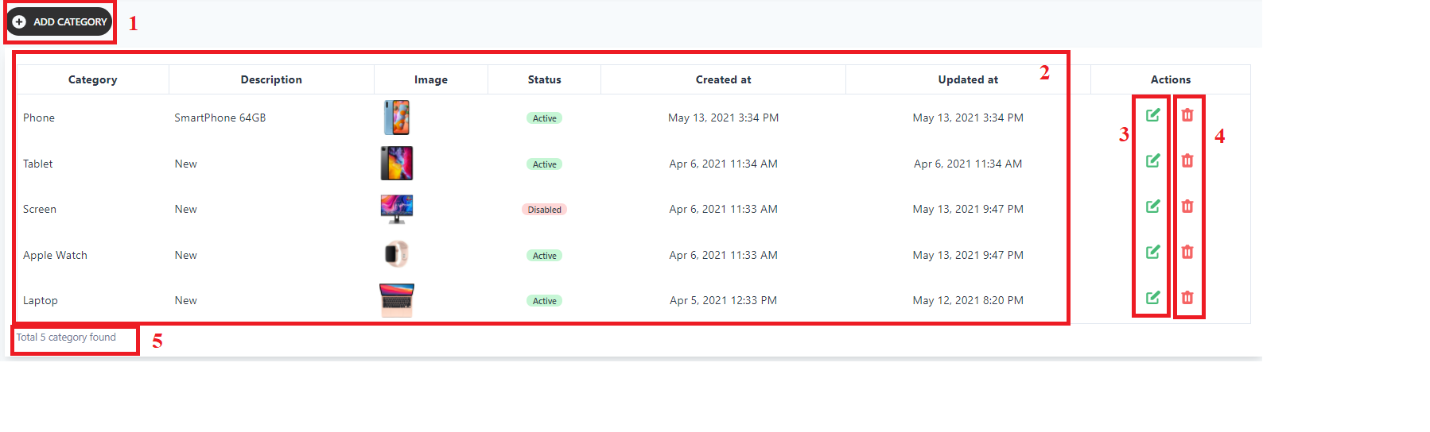

*Figure 89: Administrator - Category Page*

|  |  |  |  |
| --- | --- | --- | --- |
| **Ordinary numbers** | Name | Type | Descriptions |
| 1 | Add new category | Button | Add a new category |
| 2 | List of category | Table | List all category |
| 3 | Edit Category | Button | To Edit Category |
| 4 | Delete Category | Button | To delete Category |
| 5 | Total category | Text | Show number of all category |

*Table 51: <AI> Category Page*

* + - 1. **<AI004> Product Page**

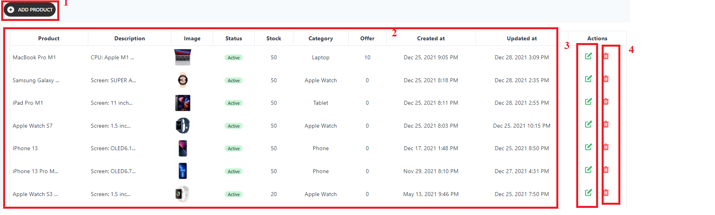

*Figure 90: Administrator - Product Page*

|  |  |  |  |
| --- | --- | --- | --- |
| **Ordinary numbers** | Name | Type | Descriptions |
| 1 | Add new product | Button | Add a new product |
| 2 | List of product | Table | List all product |
| 3 | Edit product | Button | To Edit product |
| 4 | Delete product | Button | To delete product |
| 5 | Total product | Text | Show number of all product |

*Table 52: <AI> Product Page*

* + - 1. **<AI005> Order Page**

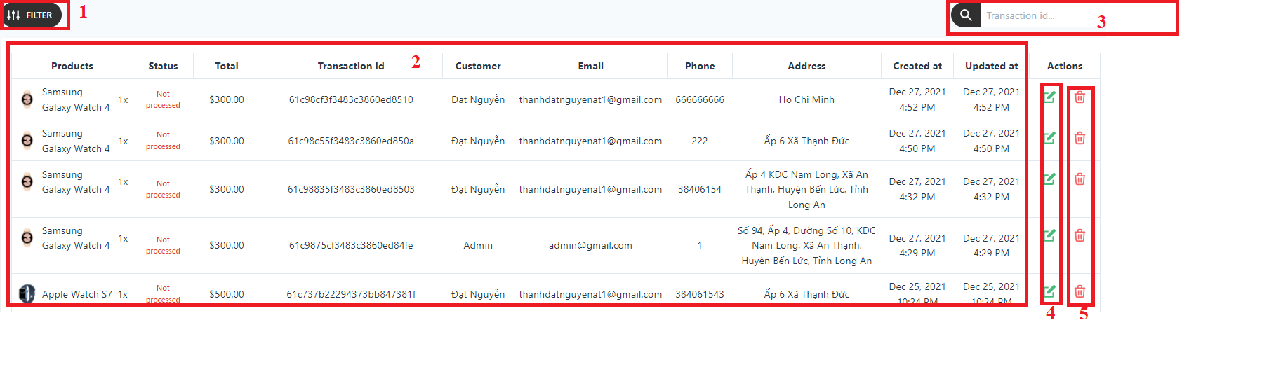

*Figure 91: Administrator - Order Page*

|  |  |  |  |
| --- | --- | --- | --- |
| **Ordinary numbers** | Name | Type | Descriptions |
| 1 | Filter Order | Selection Button | Filter Order |
| 2 | List of order | Table | List all order |
| 3 | Search order | SearchButton | Search order by transactionId |
| 4 | Edit status | Button | To edit status of orders |
| 5 | Delete Product | Button | To delete order |

*Table 53: <AI> Order Page*

* + - 1. **<AI006> Add Category Page**

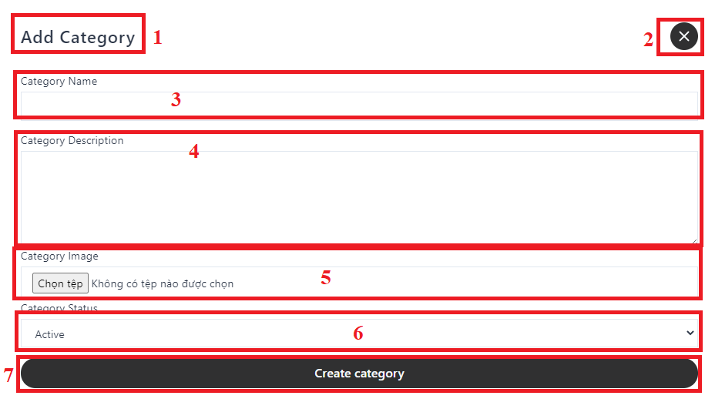

*Figure 92: Administrator – Add Category Page*

|  |  |  |  |
| --- | --- | --- | --- |
| **Ordinary numbers** | Name | Type | Descriptions |
| 1 | Add Category | Lable | Name modal Add Category |
| 2 | Close | Button | Close modal |
| 3 | Category name | Input | Insert name category |
| 4 | Category description | Input | Insert name category |
| 5 | Category image | Button | Add image for category |
| 6 | Category Status | Selection | Select status of category |
| 7 | Create category | Button | Create category |

*Table 54: <AI> Add Category Page*

* + - 1. **<AI007> Add Product Page**

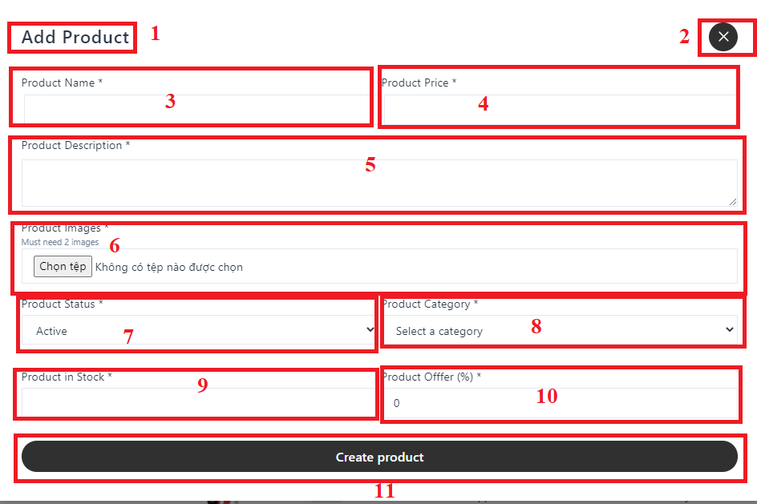

*Figure 93: Administrator – Add Product Page*

|  |  |  |  |
| --- | --- | --- | --- |
| **Ordinary numbers** | Name | Type | Descriptions |
| 1 | Add Product | Lable | Name modal Add Product |
| 2 | Close | Button | Close modal |
| 3 | Product name | Input | Insert name product |
| 4 | Product price | Input | Insert price product |
| 5 | Product description | Input | Insert description product |
| 6 | Product image | Button | Add image for product |
| 7 | Product Status | Selection | Select status for product |
| 8 | Product category | Selection | Select category of product |
| 9 | Product in stock | Input | Insert number of product in stock |
| 10 | Product offer | Input | Insert discount percentage of the product |

*Table 55: <AI> Add Product Page*

* + - 1. **<AI008> Update Order Page**

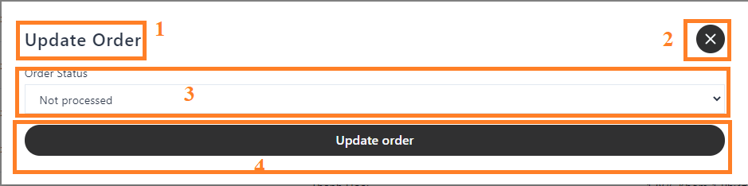

*Figure 94: Administrator – Update Order Page*

|  |  |  |  |
| --- | --- | --- | --- |
| **Ordinary numbers** | Name | Type | Descriptions |
| 1 | Update Order | Lable | Name modal Update Order |
| 2 | Close | Button | Close modal |
| 3 | Order status | Selection | Select status of order |
| 4 | Update order | Input | Update order |

*Table 56: <AI>* *Update Order Page*

* + 1. **User Interface**
       1. **<UI001> Home Page 01**

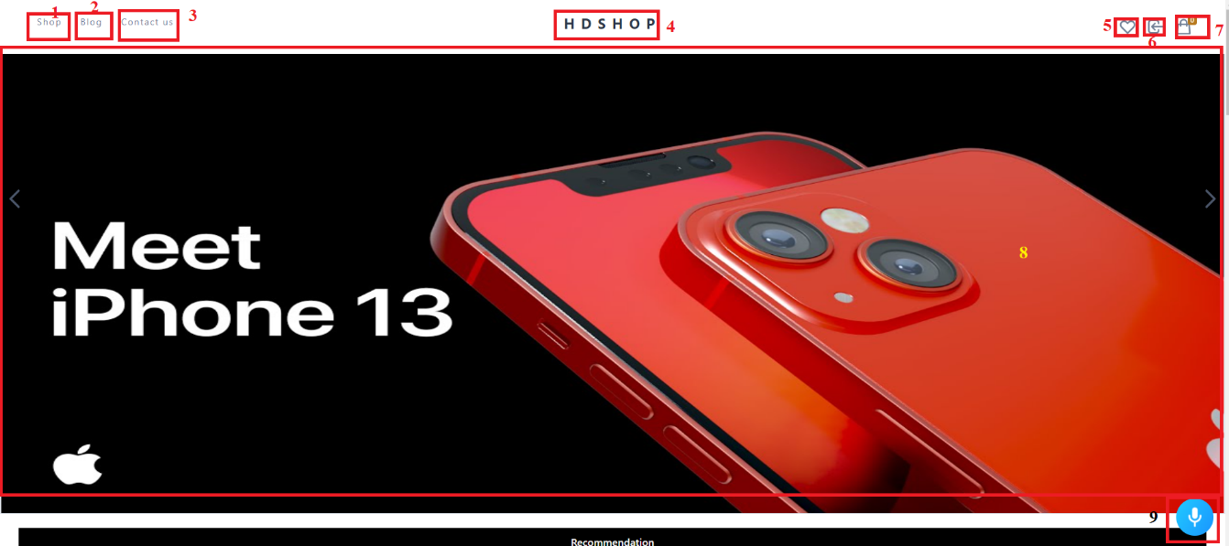

*Figure 95: User - Home Page 01*

|  |  |  |  |
| --- | --- | --- | --- |
| **Ordinary numbers** | Name | Type | Descriptions |
| 1 | Shop | Li tag | Click on it to the home screen displays |
| 2 | Blog | Li tag | Click on it to the about us screen displays |
| 3 | Contact us | Li tag | Click on it to the contact us screen displays |
| 4 | Web logo | Image | Show the shop’s logo |
| 5 | Wishlist | icon | Click on it to the wishlish screen display |
| 6 | Login | Icon | Click on it to the login screen display |
| 7 | Cart icon | Icon | Click on it to the cart to items displays |
| 8 | Advertising panel | Image | Show advertising panel |
| 9 | Voice assistant | Buton | Click on it to use voice assistant |

*Table 57: <UI> Home Page 01*

* + - 1. **<UI002> Home Page 02**

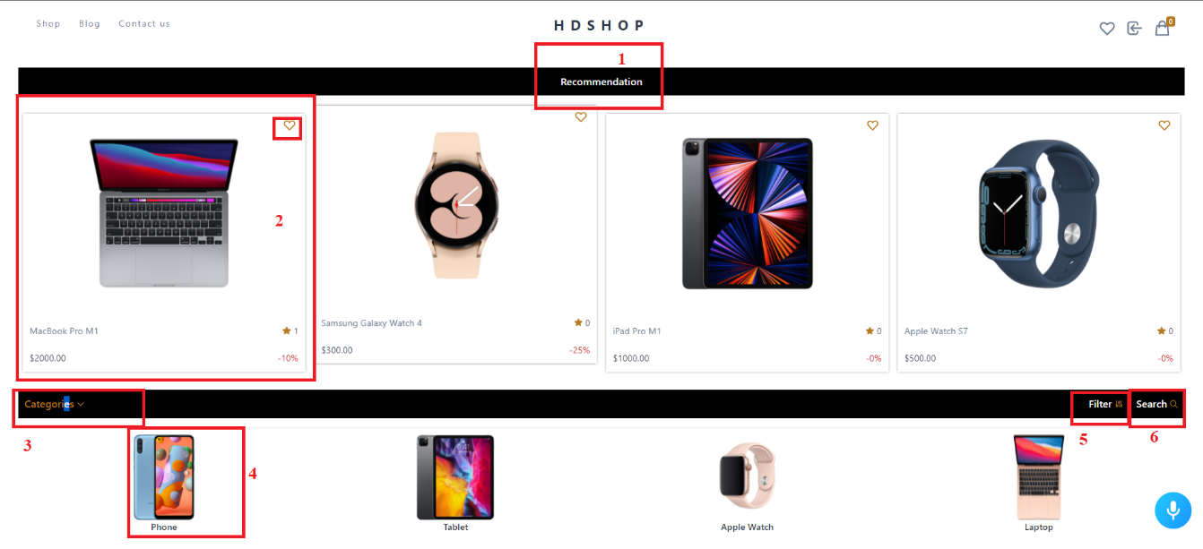

*Figure 96: User - Home Page 02*

|  |  |  |  |
| --- | --- | --- | --- |
| **Ordinary numbers** | Name | Type | Descriptions |
| 1 | Recommendation | Label | Recomen product for user |
| 2 | Cart product | Cart | Click on it to the detailed product screen displays |
| 3 | Filter by category | Button | Filter product by category |
| 4 | Category | Image | Click on it to the category product screen display |
| 5 | Filter by price | Button | Show scrollbar to filter by price |
| 6 | Search icon | Icon | Show input for insert name products to look for |

*Table 58: <UI> Home Page 02*

* + - 1. **<UI003> Login Page**



*Figure 97: User – Login page*

|  |  |  |  |
| --- | --- | --- | --- |
| **Ordinary numbers** | Name | Type | Descriptions |
| 1 | Title | Label | Display name of modal |
| 2 | User | Input | To enter user name |
| 3 | Password | Input | To enter password |
| 4 | Check Remember | Checkbox | Remember the password for next login |
| 5 | Lost your Password | Link | Forgot password |
| 6 | Login | Button | Login with Account |
| 7 | Login with google | Button | Login with google |
| 8 | Create Account | Button | Create new account |

*Table 59: <UI> Login Page*

* + - 1. **<UI004> Register Page**

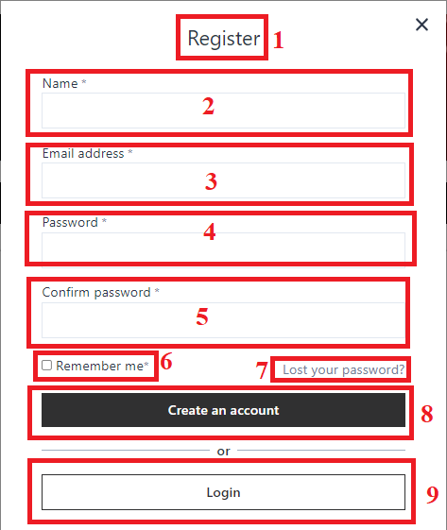

*Figure 98: User – Register Page*

|  |  |  |  |
| --- | --- | --- | --- |
| **Ordinary numbers** | Name | Type | Descriptions |
| 1 | Register | Label | Display name of modal |
| 2 | Name | Input | Input the name |
| 3 | Email | input | Input the email |
| 4 | Password | Input | Input the password |
| 5 | Confirm password | Input | Input the confirm password |
| 6 | Remember | Checkbox | Check on to remember password for next login |
| 7 | Lost your password | Button | Click on to the forget pass word screen display |
| 8 | Create Account | Button | Click on to Register Account |
| 9 | Login | Button | Create on to Login screen display |

*Table 60: <UI> Register Page*

* + - 1. **<UI005> Details Product Page**

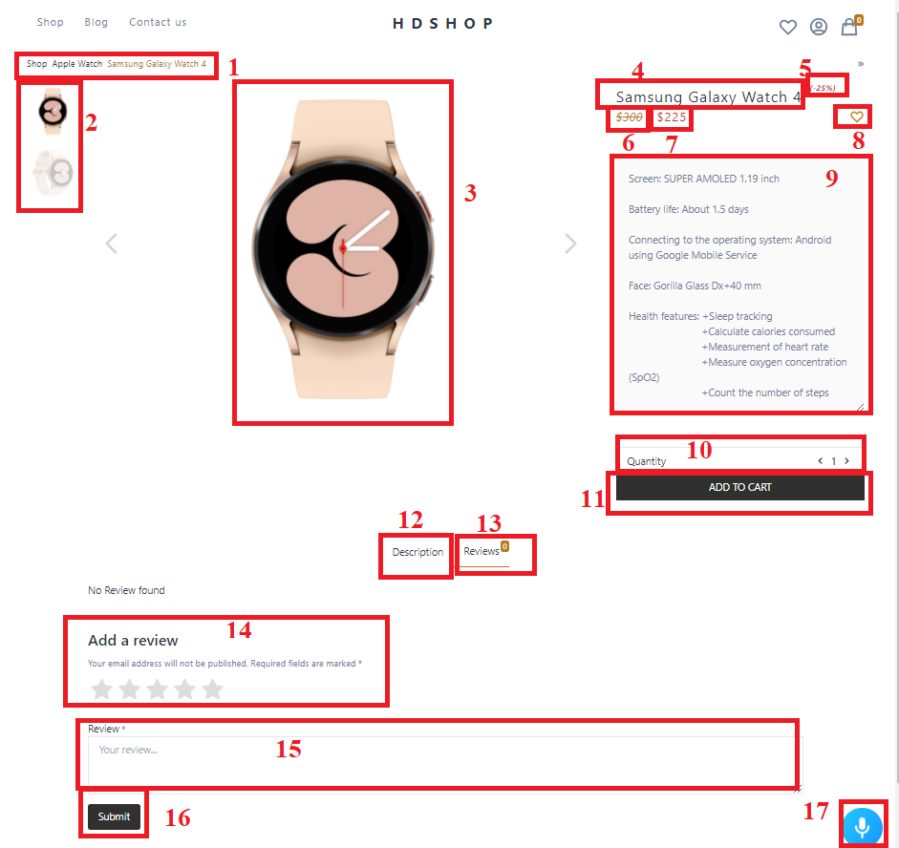

*Figure 99: User - Details Product Page*

|  |  |  |  |
| --- | --- | --- | --- |
| **Ordinary numbers** | Name | Type | Descriptions |
| 1 | Product path | Link | Path of product |
| 2 | All Image Product | Array Image | All image of produt |
| 3 | Image product | Image | Image show product |
| 4 | Name | Label | Name of product |
| 5 | Discount percent | Label | Number of discout percent |
| 6 | Cost | Lable | Cost of product |
| 7 | Price | Label | Price of product |
| 8 | Wish product | Image | Click on to add product in wishlist |
| 9 | Detail | String | Detail of product |
| 10 | Quantity | Button | Quantity change |
| 11 | Add to cart | Button | Click on to add product to cart |
| 12 | Description | Button | Click on to show description of product |
| 13 | Review | Button | Click on to show all review of product |
| 14 | Start icon | Icon | Choose the number of stars to rate the product |
| 15 | Review | Input | Insert review in to Input |
| 16 | Submit | Button | Submit review |
| 17 | Voice assistant | Button | Click on to use voice assitstant |

*Table 61: <UI> Details Product Page*

* + - 1. **<UI006> Cart Page**

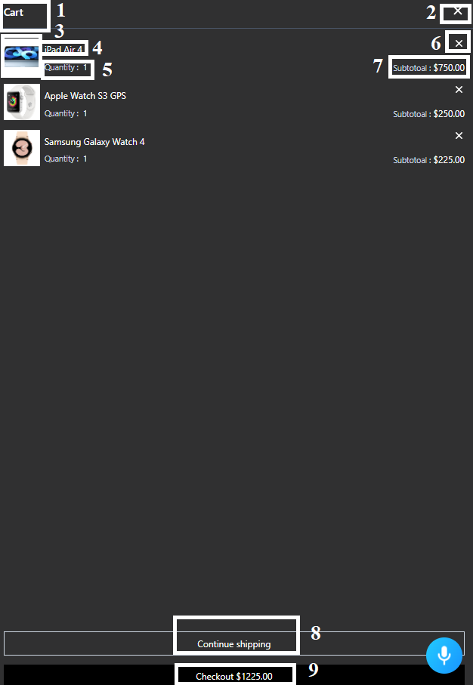

*Figure 100: User - Cart Page*

|  |  |  |  |
| --- | --- | --- | --- |
| **Ordinary numbers** | Name | Type | Descriptions |
| 1 | Title | Label | Display name of modal |
| 2 | Close | Button | Click on it to close cart |
| 3 | Image product | Image | Image of product |
| 4 | Name | Label | Name of product |
| 5 | Quantity | Lable | Quantity of product in cart |
| 6 | Delete icon | Icon | Click on it to remove product from cart |
| 7 | Subtotal | Label | Total money of product |
| 8 | Continue Shopping | Button | Click on it to shop screen display |
| 9 | Checkout | Button | Show total money all product in cart and click on it to checkout |

*Table 62: <UI> Cart Page*

* + - 1. **<UI007> Checkout Page 01**

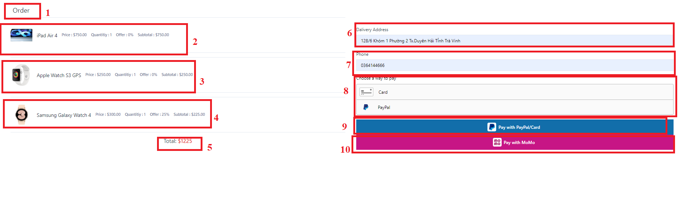

*Figure 101: User - Checkout Page 01*

|  |  |  |  |
| --- | --- | --- | --- |
| **Ordinary numbers** | Name | Type | Descriptions |
| 1 | Title | Label | Display name of modal |
| 2 | Product 1 in cart | Object | Detail product 1 in cart |
| 3 | Product 2 in cartt | Object | Detail product 2 in cart |
| 4 | Product 3 in cart | Object | Detail product 3 in cart |
| 5 | Total | Label | Displays the total price of order |
| 6 | Address | Input | Insert delivery address |
| 7 | Phone | Input | Insert phone number |
| 8 | Choose a way to pay | Button | Click on it to Fill in payment card information |
| 9 | Pay | Button | Proceed to the payment |
| 10 | Pay with momo | Button | Payment with momo |

*Table 63: <UI> Checkout Page*

* + - 1. **<UI008> My Order Page**

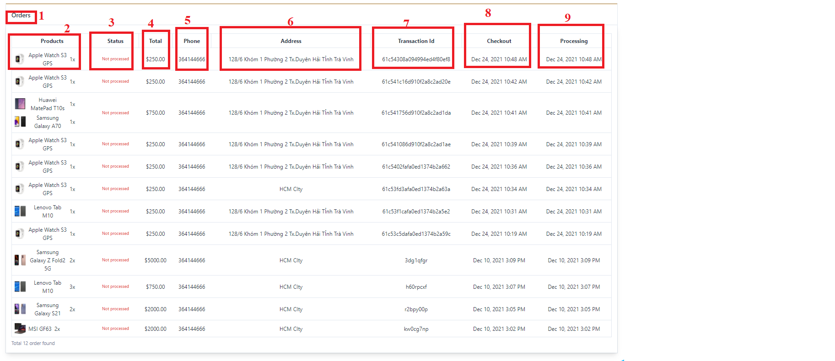

*Figure 102: User - My Order Page*

|  |  |  |  |
| --- | --- | --- | --- |
| **Ordinary numbers** | Name | Type | Descriptions |
| 1 | Title | Label | Display name of modal |
| 2 | Product | Object | Product in order |
| 3 | Status | Label | Status of product |
| 4 | Total | Lable | Total products |
| 5 | Phone | Label | Phone number |
| 6 | Address | Label | Address delivery |
| 7 | TransactionId | Label | TransactionId of order |
| 8 | Checkout | Date | Date check out |
| 9 | Processing | Date | Date processing |

*Table 64: <UI> My Order Page*

* + - 1. **<UI009> Wishlist Page**

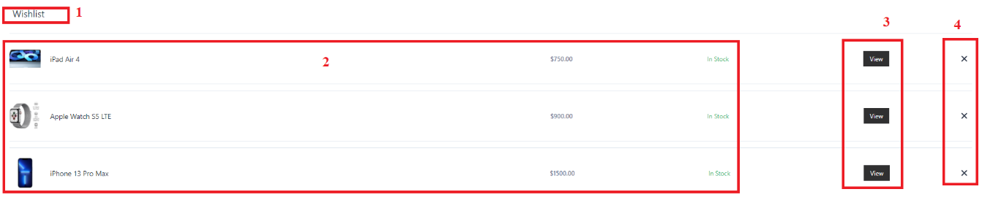

*Figure 103: User - Wishlist Page*

|  |  |  |  |
| --- | --- | --- | --- |
| **Ordinary numbers** | Name | Type | Descriptions |
| 1 | Title | Label | Display name of modal |
| 2 | Product | Object | All product in wishlist |
| 3 | View | Button | Click on it to detail product screen display |
| 4 | Remove | button | Click on it to remove product from wishlist |

*Table 65: <UI> Wishlist Page*

* + - 1. **<UI010> Information Page**

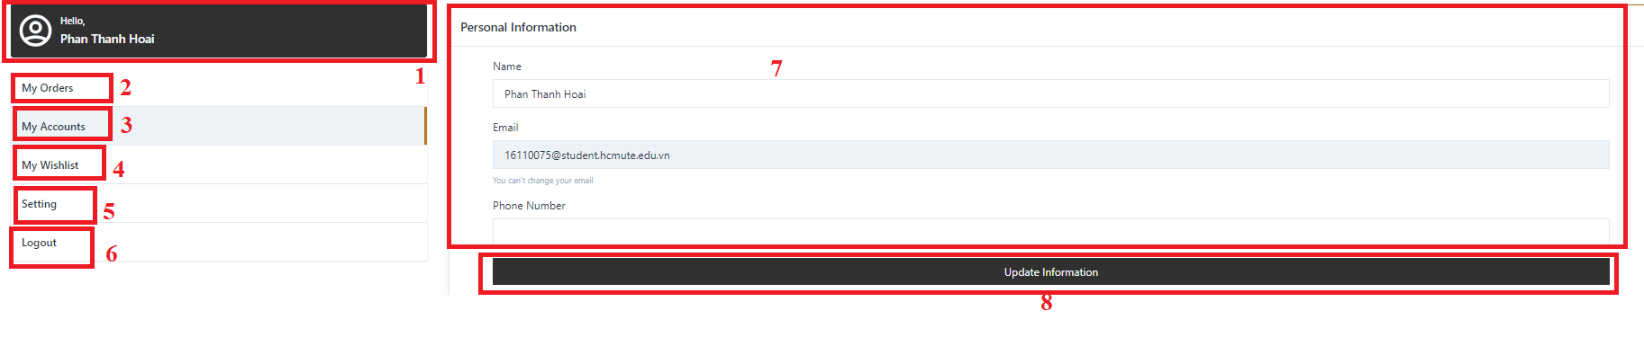

*Figure 104: User - Infomation Page*

|  |  |  |  |
| --- | --- | --- | --- |
| **Ordinary numbers** | Name | Type | Descriptions |
| 1 | Profile | Card | Profile of user |
| 2 | MyOrder | Button | Click on it to My order Screen display |
| 3 | MyAccount | Button | Click on it to My account Screen display |
| 4 | My wishlist | Button | Click on it to My wishlist Screen display |
| 5 | Setting | Button | Click on it to Setting account Screen display |
| 6 | Logout | Button | Click on it to logout account |
| 7 | Information | Input | Click on it to edit information of user |
| 8 | Update | Button | Click on it to submit update infomation |

*Table 66: <UI> Infomation Page*

**CHAPTER 5: IMPLEMENT AND TESTING**

1. 1. **Tools in Project**

|  |  |
| --- | --- |
| **Tool** | **Name** |
| **Environment** | NodeJS |
| **IDE** | PostMan |
| Visual Studio Code |
| **Database** | MongoDB (NoSQL) |
| **Source control** | Github |
| **Modelling tools** | Draw.io, Enterprise Architect |
| **Voice Assistant** | Alan.app |

*Table 67: Tools in Project*

* 1. **Technology in Project**

|  |  |
| --- | --- |
| **Back-End** | * ExpressJS |
| **Front-End** | * ReactJS * Redux |
| **Database** | * MongoDB Alas |
| **Services** | * PayPal (Payment gateway) * Momo( Payment gateway) * Viscard( Payment gateway) |
| **Orther** | * Alan AI ( Voice assistant) |

*Table 68: Technology in Project*

* 1. **Setup**
* Clone project from github.
* Install npm: cmd npm install
* Run Project: cmd npm start
  1. **Testing**

|  |  |  |  |
| --- | --- | --- | --- |
| **Test Case No. Test** | **Test-Case Short Description** | **Expected Result** | **Actual Result** |
| TC01 | Login/Authentication interface for the Admin | As expected | Pass |
| TC02 | Login/Authentication interface for the users | As expected | Pass |
| TC03 | Admin can create new category | As expected | Pass |
| TC04 | Admin can update category | As expected | Pass |
| TC05 | Admin can delete category | As expected | Pass |
| TC06 | Admin can create new product | As expected | Pass |
| TC07 | Admin can update product | As expected | Pass |
| TC08 | Admin can delete product | As expected | Pass |
| TC09 | Admin can block product | As expected | Pass |
| TC10 | Admin can unblock product | As expected | Pass |
| TC11 | Admin can change status order | As expected | Pass |
| TC12 | Admin can delete status order | As expected | Pass |
| TC13 | Admin can send email to customer | As expected | Pass |
| TC14 | Admin can view statistical | As expected | Pass |
| TC15 | Admin can unblock user | As expected | Pass |
| TC16 | SA can create new admin | As expected | Pass |
| TC17 | SA can update admin | As expected | Pass |
| TC18 | SA can delete admin | As expected | Pass |
| TC19 | SA can block admin | As expected | Pass |
| TC20 | SA can unblock admin | As expected | Pass |
| TC21 | User can add to cart | As expected | Pass |
| TC22 | User can add to wishlist | As expected | Pass |
| TC23 | User can filter product by category | As expected | Pass |
| TC24 | User can filter product by keyword | As expected | Pass |
| TC25 | User can filter product by price | As expected | Pass |
| TC26 | User can view details product | As expected | Pass |
| TC27 | User can comment product | As expected | Pass |
| TC28 | User can order tracking product | As expected | Pass |
| TC29 | User can place order | As expected | Pass |
| TC30 | User can payment by Paypal | As expected | Pass |
| TC31 | Use can send email to Admin | As expected | Pass |
| TC32 | User can receive e-invoice. | As expected | Pass |
| TC33 | User can payment by Visacard | As expected | Pass |
| TC34 | User can payment by Momo | As expected | Pass |
| TC35 | User can open cart by voice assistant | As expected | Pass |
| TC36 | User can close cart by voice assistant | As expected | Pass |
| TC37 | User can search product by voice assistant | As expected | Pass |
| TC38 | User can filter product by category voice assistant | As expected | Pass |
| TC39 | User can view detail product by voice assistant | As expected | Pass |
| TC40 | User can add product by voice assistant | As expected | Pass |
| TC41 | User can checkout by voice assistant | As expected | Pass |

*Table 69: Test Case*

**CHAPTER 6: CONCLUSION**

6. 1. **Result**

In general, we have achieved 100% of the initial goals. Through self-study and research, we have learned more about the process of building an application, how to use tools that support programming, how to analyze databases, about problem-solving.

* Operate and proficiently use React & Redux
* Using NoSQL is MongoDB
* Know that how to integrate technologies to build an application that runs on a color website.
* Furthermore, help us improve our skills and experience more.

Source: https://github.com/DatNguyen15/Web-Shop-Ec

* 1. **Strengths**
* Supports phone interface
* User-friendly interface, easy to use
* Users can easily filter and select products
* Makes the orders quickly
* Create voice assistant by Alan AI.
* Use multiple online payment methods like momo, paypal, visacard
  1. **Drawbacks**
* There are many service packages with high costs, so we can't buy them to apply to the website
* Lack of deep knowledge and practical knowledge of applied technology
* Website not optimized
  1. **Future Works**
* Create more functions for the website, for example: Create games to accumulate points, recommend products using Artificial intelligence technology
* Build Google Maps API to direct users to the nearest store
* Website security
* Website optimization

With the above development directions, we believe that in the future the application will help users have better experiences, save costs, time and money, thereby improving the quality of life.

**REFERENCES**

The website about Technology Stack

[1] <https://mixpanel.com/topics/what-is-a-technology-stack/>

The website about MERN Stack

[2]<https://wikitia.com/index.php?title=MERN_(solution_stack)&mobileaction=toggle_view_desktop>

The website about set up MongoDB

[3] <https://www.mongodb.com/try#community>

The website about MongoDB

[4] <https://www.mongodb.com/what-is-mongodb>

The website about set up Express

[5] <https://developer.mozilla.org/en-US/docs/Learn/Server-side/Express_Nodejs/Introduction>

The website about set up Express

[6] <https://www.besanttechnologies.com/what-is-expressjs>

The website about Express

[7] <https://skillcrush.com/blog/what-is-react-js/#what>

The website about set up PayPal

[8] <https://www.businessinsider.com/how-to-set-up-a-paypal-account>

[9] <https://www.conversationdesigninstitute.com/courses/alan-ai.html>

[10] <https://atpcare.vn/vi-momo-la-gi-tai-sao-can-phai-dung-vi-momo/>

Video YouTube:

1. Link video guide MERN Stack

<https://www.youtube.com/watch?v=tvdFYmJEaw4&list=PLB_Wd4-5SGAYsxD4JGaVdXll3PnoyI-AM&fbclid=IwAR3Jg-FG9kKM0_NHKnla8eCDYc_xVKM-4Nhh_cBklCYIwjqwcZRuRR5UzzY>

1. Link video build Alan AI

<https://www.youtube.com/watch?v=4xwruFAvEHA&t=1462s>